UNITED STATES
SECURITIES AND EXCHANGE COMMISSION
Washington, D.C. 20549

SCHEDULE 14A

Proxy Statement Pursuant to Section 14(a) of the
Securities Exchange Act of 1934
(Amendment No. )

Filed by the Registrant ☑ Filed by a party other than the Registrant ☐

Check the appropriate box:

☐ Preliminary Proxy Statement

☐ Confidential, for Use of the Commission Only (as permitted by Rule 14a-6(e)(2))

☑ Definitive Proxy Statement

☐ Definitive Additional Materials

☐ Soliciting Material Pursuant to §240.14a-12

ARTISAN PARTNERS ASSET MANAGEMENT INC.
(Name of Registrant as Specified In Its Charter)

(Name of Person(s) Filing Proxy Statement, if Other Than The Registrant)

Payment of Filing Fee (Check the appropriate box):

☑ No fee required.

☐ Fee computed on table below per Exchange Act Rules 14a-6(i)(1) and 0-11.

(1) Title of each class of securities to which transaction applies:
(2) Aggregate number of securities to which transaction applies:
(3) Per unit price or other underlying value of transaction computed pursuant to Exchange Act Rule 0-11 (set
forth the amount on which the filing fee is calculated and state how it was determined):
(4) Proposed maximum aggregate value of transaction:
(5) Total fee paid:
☐ Fee paid previously with preliminary materials.

☐ Check box if any part of the fee is offset as provided by Exchange Act Rule 0-11(a)(2) and identify the filing for which the offsetting
fee was paid previously. Identify the previous filing by registration statement number, or the Form or Schedule and the date of its filing.

(1) Amount Previously Paid:
(2) Form, Schedule or Registration Statement No.:
(3) Filing Party:
(4) Date Filed:



April 17, 2026

Dear Stockholder:
On behalf of the Board of Directors of Artisan Partners Asset Management Inc., we cordially invite you to participate in the 2026 Annual Meeting of Stockholders, which will be held virtually on Wednesday, June 3, 2026 at 11:00 a.m. Central Time. The matters to be considered by stockholders at the Annual Meeting, as well as instructions for accessing the virtual meeting platform online, are described in detail in the accompanying materials.
Representatives from our Board of Directors and certain of our executive officers, as well as representatives from our independent registered public accounting firm, will be available at the Annual Meeting to respond to appropriate questions from stockholders.
Information about how to access and review our proxy statement and 2025 Annual Report on Form 10-K is included in the Notice of Internet Availability of Proxy Materials that you will receive in the mail. The notice also explains how you may submit your vote.
Whether or not you plan to attend the Annual Meeting, please submit your vote at your earliest convenience. Thank you for your continued support as a stockholder of Artisan Partners.

Sincerely,
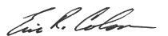
Eric R. Colson
Chair of the Board

i

Notice of 2026 Annual Meeting of Stockholders

Date and Time |  |  | Record Date |  |  |  |  |  | Virtual Meeting
Wednesday,  June 3, 2026  11:00 a.m. Central Time |  |  | Stockholders of record as of the close of business on April 9, 2026 are entitled to attend, and vote at, the Annual Meeting. |  |  |  |  |  | The Annual Meeting will be held virtually at edge.media-server.com/mmc/p/mddmoibn.
PROPOSALS |  |  |  |  |  | BOARD VOTING  RECOMMENDATION
1 |  |  | The election of nine directors to serve until the 2027 annual meeting of stockholders |  |  | FOR  each nominee
2 |  |  | An advisory vote to approve the compensation of our named executive officers |  |  | FOR
3 |  |  | The ratification of the appointment of PricewaterhouseCoopers LLP as our independent registered public accounting firm for the fiscal year ending December 31, 2026 |  |  | FOR

Stockholders will also transact such other business as may properly come before the Annual Meeting or any adjournment or postponement thereof. We encourage you to read this proxy statement and submit your proxy or voting instructions as soon as possible. You may vote your shares by Internet or, if you received printed proxy materials, by mailing the completed proxy card. Please refer to the section "How do I vote?” for detailed voting instructions.

By Order of the Board of Directors,
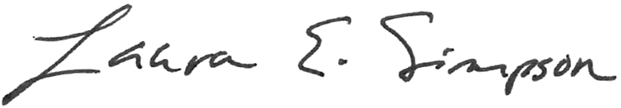
Laura E. Simpson
Corporate Secretary
Milwaukee, Wisconsin
April 17, 2026
Important Notice Regarding the Availability of Proxy Materials for the Stockholder Meeting to be held virtually on Wednesday, June 3, 2026, at 11:00 a.m. Central Time. Our proxy statement and 2025 Annual Report on Form 10-K are available at www.astproxyportal.com/ast/18158.

ii

Table of Contents
GENERAL INFORMATION |  |  | 1
Matters to be voted on at the Annual Meeting |  |  | 1
QUESTIONS AND ANSWERS ABOUT THE PROXY MATERIALS AND ANNUAL MEETING |  |  | 2
PROPOSAL 1: ELECTION OF DIRECTORS |  |  | 5
Recommendation of the Board |  |  | 6
Director Nominees |  |  | 6
BOARD COMPOSITION AND LEADERSHIP |  |  | 10
Director Independence |  |  | 10
Board Leadership Structure |  |  | 10
Committees of the Board |  |  | 10
Board and Committee Meetings |  |  | 12
Compensation Committee Interlocks and Insider Participation |  |  | 12
Director Compensation |  |  | 12
CORPORATE GOVERNANCE AND SUSTAINABILITY |  |  | 14
Corporate Governance Guidelines |  |  | 14
Board Effectiveness |  |  | 14
Code of Business Conduct |  |  | 14
Insider Trading Policy |  |  | 14
Board Oversight of Risk Management |  |  | 14
Nomination of Directors |  |  | 15
Stockholder Proposals and Director Nominations for the 2027 Annual Meeting |  |  | 16
Communications with the Board |  |  | 17
Sustainability |  |  | 17
EXECUTIVE OFFICERS |  |  | 17
COMPENSATION DISCUSSION AND ANALYSIS |  |  | 20
EXECUTIVE COMPENSATION TABLES |  |  | 43
PROPOSAL 2: ADVISORY VOTE TO APPROVE NAMED EXECUTIVE OFFICER COMPENSATION |  |  | 54
Recommendation of the Board |  |  | 54
SECURITY OWNERSHIP OF CERTAIN BENEFICIAL OWNERS AND MANAGEMENT |  |  | 55
RELATIONSHIPS AND RELATED PARTY TRANSACTIONS |  |  | 58
Transactions in Connection with our IPO |  |  | 58
Indemnification Agreements |  |  | 62
Investments in our Funds |  |  | 62
Review and Approval of Transactions with Related Persons |  |  | 63
AUDIT COMMITTEE REPORT |  |  | 63
PROPOSAL 3: RATIFICATION OF THE APPOINTMENT OF PRICEWATERHOUSECOOPERS LLP FOR THE FISCAL YEAR ENDING DECEMBER 31, 2026 |  |  | 65
Recommendation of the Board |  |  | 65
Fees Paid to the Independent Registered Public Accounting Firm |  |  | 65
Policy on Audit Committee Pre-Approval of Audit and Non-Audit Services |  |  | 66
ADDITIONAL INFORMATION |  |  | 66

iii

Artisan Partners Asset Management Inc.
875 E. Wisconsin Avenue, Suite 800
Milwaukee, Wisconsin 53202
Proxy Statement

General Information
We are providing you this proxy statement in connection with the solicitation of proxies by our Board of Directors to be voted at the 2026 Annual Meeting of Stockholders (the “Annual Meeting”) and at any adjournment or postponement thereof. The Annual Meeting will be held virtually on Wednesday, June 3, 2026, at 11:00 a.m. Central Time. The Annual Meeting can be accessed by visiting edge.media-server.com/mmc/p/mddmoibn, where you will be able to listen to the meeting live and vote online. Please note this is the only means of accessing the Annual Meeting and only stockholders as of the record date will be able to access the Annual Meeting.
Representatives from our Board of Directors, certain of our executive officers, and representatives from our independent registered public accounting firm will be available at the Annual Meeting to respond to appropriate questions from stockholders.
We provide our stockholders with access to proxy materials on the Internet instead of mailing a printed copy of the materials to each stockholder. On or about April 17, 2026, we will mail to our stockholders a Notice of Internet Availability of Proxy Materials containing instructions on how to access this proxy statement and our 2025 Annual Report on Form 10-K online. The notice also provides instructions on how to vote online and how to request a printed set of proxy materials.
As used in this proxy statement, “Company” refers to Artisan Partners Asset Management Inc. and, unless the context otherwise requires, its consolidated subsidiaries.

MATTERS TO BE VOTED ON AT THE ANNUAL MEETING
Proposal |  |  | Board Recommendation |  |  | Vote Required
Election of Directors |  |  | FOR  each nominee |  |  | Plurality of the votes present in person or by proxy
Advisory Vote to Approve Named Executive Officer Compensation |  |  | FOR |  |  | Majority of the votes present in person or by proxy
Ratification of the Appointment of PricewaterhouseCoopers LLP as our Independent Registered Public Accounting Firm for the Fiscal Year Ending December 31, 2026 |  |  | FOR |  |  | Majority of the votes present in person or by proxy

1

Questions and Answers About the Proxy Materials and Annual Meeting

Why did I receive a notice in the mail regarding the Internet availability of proxy materials instead of a printed set of materials?
We provide access to our proxy materials over the Internet under the Securities and Exchange Commission’s “notice and access” rules. Information about how to access and review our proxy materials is included in the notice you received in the mail. The notice also explains how you may submit your vote over the Internet. You will not receive printed copies of our proxy materials unless you request them by following the instructions on the notice.
If you own shares of stock in more than one account—for example, in a joint account with your spouse and in your individual brokerage account—you may receive more than one notice. To vote all of your shares, please follow the instructions provided on each notice you receive.

What information does the notice contain?
The notice provides information about:
▪the date, time and virtual format of the Annual Meeting;
▪the proposals to be voted on at the Annual Meeting and our Board’s recommendation with regard to each item;
▪the website where our proxy materials can be viewed;
▪instructions on how to request a paper copy of the proxy materials; and
▪instructions on how to vote by Internet, by mail or during the virtual Annual Meeting.

What proposals will be voted on at the Annual Meeting?
There are three proposals to be considered and voted on at the Annual Meeting.
▪The election of nine directors to serve until the 2027 annual meeting of stockholders
▪An advisory vote to approve named executive officer compensation
▪The ratification of the appointment of PricewaterhouseCoopers LLP as our independent registered public accounting firm for the fiscal year ending December 31, 2026
Our Board is not aware of any other matters to come before the Annual Meeting. If any other matter should be properly presented for consideration at the Annual Meeting or any adjournment or postponement thereof, the persons named as proxies will vote the shares represented by all valid proxy cards in accordance with their best judgment.

How does the Board recommend I vote?
Our Board recommends that you vote:
▪FOR each of the nominees for election to the Board;
▪FOR the approval of named executive officer compensation; and
▪FOR the ratification of the appointment of PricewaterhouseCoopers LLP as our independent registered public accounting firm for the fiscal year ending December 31, 2026.

2

What shares can be voted at the Annual Meeting?
All holders of our common stock at the close of business on April 9, 2026 (the “Record Date”) are entitled to vote in connection with the Annual Meeting. On that day, we had the following numbers of shares outstanding:
Class A common stock |  |  | 70,993,257
Class B common stock |  |  | 1,147,029
Class C common stock |  |  | 8,917,476
Total shares of common stock |  |  | 81,057,762
Each share of Class A, Class B and Class C common stock entitles its holder to one vote. The holders of each class of our common stock will vote together as a single class on all matters presented to stockholders.
Pursuant to our stockholders agreement, a three-member stockholders committee, currently consisting of Jason A. Gottlieb (Chief Executive Officer and President), Eric R. Colson (Executive Chair and Chair of the Board) and Charles J. Daley, Jr. (Executive Vice President, Chief Financial Officer and Treasurer), has an irrevocable proxy to vote all of the shares of Class B common stock and those shares of Class A common stock that we have granted to, and are held by, our employees. Those shares that are subject to the stockholders agreement represented approximately 9.2% of the combined voting power of our common stock as of the Record Date, though the percentage of shares actually voted by the stockholders committee in connection with the Annual Meeting may be less than 9.2%. For more information on our stockholders agreement and stockholders committee, see “Relationships and Related Party Transactions—Transactions in Connection with our IPO—Stockholders Agreement”.

How do I hold my stock?
Most of our stockholders hold shares as beneficial owner through a broker or other nominee rather than directly in their own name on the records of our transfer agent. There are distinctions between shares held of record and those owned beneficially, which are highlighted below.
▪Stockholder of Record. If you hold stock that is registered directly in your name on the records of our transfer agent, Equiniti Trust Company, LLC, you are a stockholder of record.
▪Beneficial Owner. If you hold stock in an account through a broker, bank or similar institution, you are considered a beneficial owner of shares held in street name.

How do I vote?
If you are a stockholder of record, you may vote in one of three ways.
▪By Internet. Go to www.astproxyportal.com/ast/18158 and follow the instructions for Internet voting. You will need the control number located on your notice or proxy card, as applicable. Internet voting is available 24 hours a day. If you choose to vote by Internet, you do not need to return a proxy card. To be valid, your vote by Internet must be received by 11:59 p.m. ET, on June 2, 2026.
▪By Mail. If you request a printed copy of the proxy materials, you will receive a proxy card. You may then vote by signing, dating and mailing the proxy card in the envelope provided. To be valid, your vote by mail must be received by 11:59 p.m. ET, on June 2, 2026.
▪Virtually at the Annual Meeting. You may vote at the Annual Meeting. (See “How can I attend and vote my shares at the virtual Annual Meeting?” below.)
If you are the beneficial owner of shares held in street name, you will receive voting instructions from the institution holding your shares. The availability of telephone or Internet voting will depend upon that
3

particular institution’s voting processes. You may also attend and vote at the Annual Meeting if you register in advance. See “How can I attend and vote my shares at the virtual Annual Meeting?” below.

How many votes must be present to transact business at the Annual Meeting?
To conduct business at the Annual Meeting, a majority of the votes entitled to be cast must be present or represented by proxy at the virtual meeting. This is called a quorum. Abstentions will be counted as present and entitled to vote for purposes of establishing a quorum.

If I submit a proxy by Internet or mail, how will my shares be voted?
If you properly submit your proxy by Internet or mail and do not subsequently revoke your proxy, your shares will be voted in accordance with your instructions.
If you sign, date and return a proxy card but do not give voting instructions, your shares will be voted:
▪FOR each of the nominees for election to the Board;
▪FOR the approval of named executive officer compensation; and
▪FOR the ratification of the appointment of PricewaterhouseCoopers LLP as our independent registered public accounting firm for the fiscal year ending December 31, 2026.

If I am the beneficial owner of shares held in street name and do not provide voting instructions, can my broker still vote my shares?
If you hold shares in street name and do not provide specific voting instructions, your broker may vote your shares with respect to the ratification of the appointment of PricewaterhouseCoopers LLP as our independent registered public accounting firm because this is considered a “routine” matter. However, the other proposals are considered “non-routine” matters, which means that your broker may not vote your shares on these proposals without receiving voting instructions from you.
When your broker submits its proxy on routine matters, but does not vote on other matters, a broker non-vote occurs with respect to those matters not voted upon.

What is the vote required for each proposal?
With respect to the election of directors, a plurality of the votes cast by the holders of the shares present virtually or represented by proxy and entitled to vote on the matter is required for the election of each of the nine nominees. This means that the nine nominees receiving the highest number of votes will be elected regardless of whether the number of votes received by any such nominee constitutes a majority of the number of votes cast. All of the other proposals require the affirmative vote of the holders of a majority of the shares present or represented by proxy at the Annual Meeting and entitled to vote on the matter.
Abstentions will be counted as shares entitled to vote and therefore will have the effect of negative votes with respect to each proposal requiring a majority vote. Broker non-votes will not be counted as shares entitled to vote with respect to the election of directors and the advisory vote on our named executive officers’ compensation and therefore will have no effect on the voting results.

How can I attend and vote my shares at the virtual Annual Meeting?
If you are a stockholder of record on the Record Date, you can attend as well as vote at the virtual Annual Meeting by visiting edge.media-server.com/mmc/p/mddmoibn and entering the meeting password and the control number listed on your Notice Regarding the Availability of Proxy Materials.
If you are the beneficial owner of shares held in street name and would like to attend and vote at the virtual Annual Meeting, you must register in advance. To register, you must obtain a legal proxy from the
4

institution holding your shares. You must then submit a request for registration to Equiniti Trust Company, LLC by: (1) email to proxy@equiniti.com; (2) facsimile to 718.765.8730, or (3) mail to Equiniti Trust Company, LLC, Attn: Proxy Tabulation Department, 1110 Centre Pointe Curve, Suite 101, Mendota Heights, MN 55120. Requests for registration must be labeled as “Legal Proxy” and received by Equiniti Trust Company, LLC no later than 5:00 p.m. ET on June 2, 2026. Please contact your broker for more information.

How can I change my vote or revoke a proxy?
If you are a stockholder of record, you may change your vote or revoke a proxy at any time prior to the virtual Annual Meeting by submitting a written notice of revocation or a proxy bearing a later date to the attention of the Company’s Corporate Secretary at 875 East Wisconsin Avenue, Suite 800, Milwaukee, WI 53202, no later than the deadline specified on the notice or proxy card, or by voting at the virtual Annual Meeting.
If you are the beneficial owner of shares held in street name, you may change your vote or revoke a proxy in accordance with the instructions provided by the institution through which you hold your shares.

Will I be able to ask questions during the virtual Annual Meeting?
Stockholders will be able to transmit questions through the virtual meeting website. The Company will answer appropriate questions during the meeting or by following up with a stockholder if the stockholder provides contact information when transmitting the question through the virtual meeting website.

How can I obtain technical support during the virtual Annual Meeting?
If you encounter any difficulties accessing the virtual meeting webcast, please refer to the “Application Help” link available on the log in page.

Where and when will the voting results be available?
We will file the official voting results on a Form 8-K within four business days following the Annual Meeting. If the final results are not available at that time, we will provide preliminary voting results in the Form 8-K and final results in an amendment to the Form 8-K when they become available.

Who pays for the expenses of this proxy solicitation?
We will pay all expenses incurred in connection with the solicitation of proxies.

Proposal 1: Election of Directors
Under our amended and restated bylaws, our Board sets the number of directors who may serve on the Board. The size of our Board is currently set at nine directors. On the recommendation of the Governance and Sustainability Committee, each of our nine current directors is nominated for re-election for a one-year term expiring at our 2027 annual meeting of stockholders. Each director will hold office until his or her successor is duly elected and qualified or until the director’s earlier resignation or removal.
Proxies cannot be voted for a greater number of individuals than the nine nominees named in this proxy statement. Holders of proxies solicited by this proxy statement will vote the proxies received by them as directed or, if no direction is made, for the election of the Board’s nine nominees. If any nominee is unable or declines to serve at the time of the Annual Meeting, the proxy holders may vote for a nominee designated by the Board to fill the vacancy. The Board may also determine to leave the vacancy temporarily unfilled or reduce the size of the Board in accordance with our amended and restated bylaws.
Under the terms of our stockholders agreement, our stockholders committee is required to vote the shares subject to the agreement for the election of each of Mr. Barger and Mr. Colson. Under the agreement, we
5

are required to use our best efforts to elect Mr. Barger and Mr. Colson, which efforts must include soliciting proxies for, and recommending that our stockholders vote in favor of, the election of each.

RECOMMENDATION OF THE BOARD
The Board recommends that you vote FOR the election of each of the nominees.

DIRECTOR NOMINEES

Independence  ▪The Board has appointed a Lead Independent Director  ▪Seven of the nine members of the Board are independent under the NYSE listing standards  ▪All directors serving on the Audit, Compensation and Governance and Sustainability Committees are independent  ▪Independent directors meet regularly without management present |  |  |  |  |  |  |  |  |  |  |  |  |  |  | Tenure  ▪Appropriate mix of short- and long-tenured directors  ▪One independent director has served on the Board or in an advisory role since our founding  ▪Two independent directors joined the Board in connection with our 2013 IPO  ▪Four independent directors have joined in the last six years

Knowledge, Experience and Skills of Our Directors
89% Executive Leadership |  |  |  |  |  | 89% International Business |  |  |  |  |  | 78% Risk Management & Compliance
100% Investment Management Industry |  |  |  |  |  | 44% Human Capital Management |  |  |  |  |  | 33% Information Technology Matters
100% Financial Management & Reporting |  |  |  |  |  | 67% Sustainability Matters |  |  |  |  |  | 44% Government & Regulatory Matters
The names of our director nominees and their ages, positions and biographies are set forth below.
Name |  |  | Age |  |  | Position with the Company
Jennifer A. Barbetta |  |  | 53 |  |  | Independent Director
Matthew R. Barger |  |  | 68 |  |  | Independent Director
Kane Brenan |  |  | 57 |  |  | Independent Director
Eric R. Colson |  |  | 57 |  |  | Chair of the Board, Executive Chair
Peter B. Crawford |  |  | 57 |  |  | Independent Director
Stephanie G. DiMarco |  |  | 68 |  |  | Lead Independent Director
Jason A. Gottlieb |  |  | 56 |  |  | Director, President and Chief Executive Officer
Jeffrey A. Joerres |  |  | 66 |  |  | Independent Director
Saloni S. Multani |  |  | 47 |  |  | Independent Director

6

 |  |  |  |  |  | Ms. Barbetta has served on our Board and on the Governance and Sustainability Committee since October 2020. She also serves on the Compensation Committee. She is currently a managing director and chief operating officer at TA Associates. Prior to joining TA Associates in 2022, she was a senior managing director and chief operating officer at Starwood Capital Group. Prior to joining Starwood in 2019, she was a partner and managing director at Goldman Sachs. Ms. Barbetta spent more than 23 years at Goldman Sachs where she served in a variety of leadership roles within Goldman Sachs Asset Management. She currently serves on the Dean’s Advisory Council for the Villanova School of Business.  Through her substantial experience in the investment management industry, Ms. Barbetta brings strong leadership skills as well as deep knowledge of operational and strategic matters to the Board.
 |  |  |  |  |  | Mr. Barger has served on our Board since February 2013. Mr. Barger is chair of the Governance and Sustainability Committee and also serves on the Audit Committee. He is president and chief investment officer of Intellectual Capital Partners, LLC, and he has been a senior advisor at Hellman & Friedman LLC (“H&F”) since 2007. Prior to 2007, he served in a number of roles at H&F, including managing general partner and chairman of the investment committee. Mr. Barger was a member of the advisory committee of Artisan Partners Holdings from January 1995 to the completion of our initial public offering in March 2013. Prior to joining H&F, Mr. Barger was an associate in the corporate finance department of Lehman Brothers Kuhn Loeb.  Mr. Barger’s expertise in the investment management industry and his broad experience in public and private directorships, finance, corporate strategy and business development provide valuable insight to the Board.
 |  |  |  |  |  | Mr. Brenan has served on our Board and the Compensation Committee since January 2026. He is chief executive officer of TIFF Investment Management, a role he has held since 2020. Prior to joining TIFF in 2020, Mr. Brenan spent more than 20 years at Goldman Sachs in a variety of leadership roles, most recently as partner, global head and co-chief investment officer of the Global Solutions Portfolio Group. Previously, Mr. Brenan was a corporate mergers and acquisitions lawyer at Cravath, Swaine & Moore.  Mr. Brenan’s extensive investment management leadership and operational experience provides the Board with valuable perspective on strategic decision-making and risk management.
7

 |  |  |  |  |  | Mr. Colson has been executive chair and chair of the board of Artisan Partners Asset Management since June 2025, prior to which he served as chief executive officer and a director of Artisan Partners Asset Management from March 2011. Mr. Colson served as president of Artisan Partners Asset Management from March 2011 to January 2021 and as chairman of the Board from August 2015 to August 2021. He was a director of Artisan Partners Funds, Inc. from November 2013 to December 2022. Mr. Colson served as chief executive officer of Artisan Partners from January 2010 to June 2025. Before serving as Artisan Partners’ chief executive officer, Mr. Colson served as chief operating officer for investment operations from March 2007 through January 2010. Mr. Colson has been a managing director of Artisan Partners since he joined the firm in January 2005.  Mr. Colson’s experience as our chief executive officer and in his other prior roles makes him well qualified to serve as chair of the Board. Our Board values his extensive knowledge of our business and the investment management industry, which provides valuable continuity of leadership.
 |  |  |  |  |  | Mr. Crawford has served on our Board since July 2025 and is currently chair of the Audit Committee. He served as managing director and advisor at Charles Schwab from October 2024 through June 2025, after serving as chief financial officer from May 2017 until he retired from the role in October 2024. Prior to serving as chief financial officer, he held a number of leadership roles with the firm. Mr. Crawford joined Charles Schwab in 2001, after serving as an engagement manager at McKinsey & Company. He currently serves as an operating advisor of CD&R.  Through his substantial experience in the financial services industry, Mr. Crawford brings strong leadership skills as well as deep knowledge of operational and strategic matters to the Board.
 |  |  |  |  |  | Ms. DiMarco has served on our Board since February 2013 and as lead independent director since June 2025. She is also a member of the Governance and Sustainability Committee. Previously, she served as Independent Chair of the Board from August 2021 to June 2025. Ms. DiMarco founded Advent Software, Inc. in June 1983 and served Advent in various capacities over time, including as chair of its board of directors, chief executive officer and chief financial officer. She currently serves on the advisory board of the College of Engineering at the University of California Berkeley and the board of directors of Summer Search, a non-profit organization. She is a member of several private company boards and is an advisor to NYCA, a venture capital firm. She is a former member of the board of trustees of the University of California Berkeley Foundation, a former advisory board member of the Haas School of Business at the University of California Berkeley and a former trustee of the San Francisco Foundation where she chaired the investment committee.  Ms. DiMarco’s extensive experience in technological developments for the investment management industry provides useful insight to our Board and her management experience as a founder, officer and director of Advent provide perspective on the management and operations of a public company.
8

 |  |  |  |  |  | Jason A. Gottlieb has been chief executive officer and a director of Artisan Partners Asset Management since June 2025 and has served as president of Artisan Partners Asset Management since January 2021. From February 2017 to January 2021, he served as executive vice president of Artisan Partners Asset Management. Mr. Gottlieb joined Artisan Partners in October 2016 as a managing director and the chief operating officer of investments. Prior to joining the firm, Mr. Gottlieb was a partner and managing director at Goldman Sachs where he was a leader in Goldman Sachs’ Alternative Investment & Manager Selection Group and a portfolio manager on the Goldman Sachs Multi-Manager Alternatives Fund.  Mr. Gottlieb’s experience as our president and in his prior roles makes him well qualified to serve as a member of the Board. Our Board values his substantial experience in the investment management industry, his proven track record of leadership and his extensive knowledge of and strategic contributions to our business.
 |  |  |  |  |  | Mr. Joerres has served on our Board since February 2013 and is also chair of the Compensation Committee. Mr. Joerres was executive chairman and chairman of the board of directors of ManpowerGroup until his retirement in December 2015. From April 1999 until May 2014, he served as chief executive officer of ManpowerGroup. Mr. Joerres currently serves on the boards of directors of ConocoPhillips and Western Union. He is also past chairman and director of the Federal Reserve Bank of Chicago, a former director of Johnson Controls International plc, and a former trustee of the U.S. Council for International Business.  Our Board values Mr. Joerres’s global operating and leadership experience and his innovative approach to optimizing human capital. In addition, his substantial experience on public company boards enables him to provide guidance to our Board with respect to the management and operations of a public company.
 |  |  |  |  |  | Ms. Multani has served on our Board since August 2021 and is also a member of the Audit Committee. Ms. Multani is currently a partner at Galvanize Climate Solutions, a climate-focused investment firm based in San Francisco. Between December 2016 and April 2020, Ms. Multani focused on investing in companies in the sustainability ecosystem, working with Three Cairns Group, a family office and Congruent Ventures, an early stage venture firm. During 2016, Ms. Multani served as a consultant at Hellman & Friedman LLC, after having also worked there from 2006 to 2012. Between her time at Hellman & Friedman, Ms. Multani was a partner and investment team member at SPO Partners, a specialty long-only investment firm. She began her career in 2000 as an analyst at Blackstone.  Ms. Multani brings substantial experience with investment management operations to the Board, as well as a deep knowledge of sustainability and climate-focused investing. In addition, her extensive financial and accounting experience strengthens our Board through her understanding of accounting principles, financial reporting rules and regulations, and internal controls.
We believe that our directors collectively have the skills and experience to oversee and guide our business. Each director has the integrity, business judgment and collegiality that are among the essential characteristics for membership on our Board. Additionally, each director is a committed and engaged member of the Board. Our directors bring highly developed skills and substantial knowledge in, among other areas, finance, business operations, corporate strategy and business development. In addition, members of our Board have had a great diversity of experiences and bring to our Board a wide variety of perspectives that enhance their ability to provide direction to the Company. They have had wide-ranging
9

leadership experience and extensive involvement across a range of industries and in the investment management and financial services industries in particular.

Board Composition and Leadership

DIRECTOR INDEPENDENCE
Our Corporate Governance Guidelines provide that a majority of our directors must satisfy the criteria for independence under the NYSE listing standards and not have any material relationship with the Company.
Our Board has determined that each of Jennifer A. Barbetta, Matthew R. Barger, Kane Brenan, Peter B. Crawford, Stephanie G. DiMarco, Jeffrey A. Joerres and Saloni S. Multani are independent directors. In addition, Tench Coxe, who was a director until his term on the Board expired at our 2025 Annual Meeting on June 4, 2025, had previously been determined by the Board to be independent. The Board presently consists of nine directors, seven of whom are independent.

BOARD LEADERSHIP STRUCTURE
Our Board believes there is no single, generally accepted approach to providing board leadership and that given the dynamic and competitive environment in which we operate, the right board leadership structure may change over time as circumstances warrant. The Board will discuss and consider the matter from time to time as circumstances change and, subject to our amended and restated bylaws, has the flexibility to modify our Board leadership structure as it deems appropriate.
Mr. Colson currently serves as Chair of the Board and Ms. DiMarco serves as Lead Independent Director.
The powers and responsibilities of each Board leadership role include:
Role |  |  |  |  |  | Principal Responsibilities
Chair of the Board |  |  |  |  |  | ▪Authority to call meetings of the Board  ▪Authority to call special meetings of stockholders  ▪Preside over meetings of directors and stockholders  ▪Assist with the development of Board meeting agendas in collaboration with the Lead Independent Director and CEO
Lead Independent Director |  |  |  |  |  | ▪Preside over Board meetings in the absence of the Chair  ▪Preside over executive sessions of independent directors and brief the CEO and Executive Chair on issues arising in executive session  ▪Assist with the development of Board meeting agendas in collaboration with the Chair and CEO  ▪Ensure the quality, quantity and timeliness of information provided to the Board  ▪Act as principal liaison between the independent directors and executive management  ▪Upon the request of executive management, consult and communicate with the Company’s stockholders and other stakeholders

The Board believes this leadership structure is the most appropriate structure for the Company at this time because it promotes an effective balance between the Board’s independent oversight of the business and management’s day-to-day operational leadership.

COMMITTEES OF THE BOARD
The Board conducts its business through meetings of the Board and its committees. The Board has three standing committees: the Audit Committee, the Compensation Committee and the Governance and Sustainability Committee. Each committee operates in accordance with a written charter, which is approved by the Board. The charters are available on our website at www.apam.com.
10

The current members and chairs of the committees are:
Director |  |  | Audit  Committee |  |  | Compensation Committee |  |  | Governance and Sustainability Committee
Jennifer A. Barbetta |  |  |  |  |  | X |  |  | X
Matthew R. Barger |  |  | X |  |  |  |  |  | Chair
Kane Brenan |  |  |  |  |  | X
Eric R. Colson
Peter B. Crawford |  |  | Chair
Stephanie G. DiMarco |  |  |  |  |  |  |  |  | X
Jason A. Gottlieb
Jeffrey A. Joerres |  |  |  |  |  | Chair
Saloni S. Multani |  |  | X
 |  |  | 100% Independent |  |  | 100% Independent |  |  | 100% Independent
Audit Committee
The Audit Committee is a separately-designated standing audit committee established in accordance with Section 3(a)(58)(A) of the Securities Exchange Act of 1934, as amended. It is comprised solely of directors who meet the independence requirements under the NYSE listing standards and the Exchange Act, and who are “financially literate” under the NYSE rules. The Board has determined that each member of the Audit Committee has “accounting or related financial management expertise” and qualifies as an “audit committee financial expert”. The Audit Committee assists the Board in fulfilling its oversight responsibilities with respect to, among other matters:
▪the integrity and quality of our financial statements;
▪our compliance with legal and regulatory requirements;
▪the independent auditor’s qualifications, independence and performance; and
▪our internal audit function.
Governance and Sustainability Committee
The Governance and Sustainability Committee is comprised solely of directors who meet the independence requirements under the NYSE listing standards. The responsibilities of the Governance and Sustainability Committee include:
▪making recommendations to the Board regarding the selection of candidates for service on the Board and the suitability of proposed nominees as directors;
▪periodically reviewing the Company’s Corporate Governance Guidelines and recommending changes to the Board, as needed;
▪overseeing the evaluation of the Board and its committees; and
▪overseeing the Company’s approach to sustainability matters that are significant to the Company.
Compensation Committee
Each member of the Compensation Committee is independent under the NYSE listing standards. Among other things, the Compensation Committee:
▪reviews and approves, or makes recommendations to our Board with respect to, the compensation of our executive officers;
11

▪oversees and makes recommendations to our Board with respect to incentive compensation plans; and
▪makes recommendations to our Board with respect to director compensation.

BOARD AND COMMITTEE MEETINGS
During 2025, our Board held five meetings, the Audit Committee held eight meetings, the Compensation Committee held six meetings and the Governance and Sustainability Committee held six meetings. As a matter of policy, it is expected that all directors should make every effort to attend meetings of the Board and meetings of the committees of which they are members. During 2025, each director attended at least 75% of the aggregate number of meetings of the Board and meetings of the committees of which he or she was a member.
Executive sessions of our independent directors are generally held in connection with each regularly scheduled Board meeting. Our lead independent director presides over the executive sessions of independent directors.
We encourage all of our directors to attend our annual meetings of stockholders. Six of our seven directors serving at the time attended the 2025 annual meeting.

COMPENSATION COMMITTEE INTERLOCKS AND INSIDER PARTICIPATION
The members of the Compensation Committee during fiscal year 2025 were Jennifer A. Barbetta, Tench Coxe (until June 4, 2025), Stephanie G. DiMarco (beginning June 4, 2025), and Jeffrey A. Joerres (Chair). Each member of the Compensation Committee during 2025 was an independent director under the rules of the NYSE and our Corporate Governance Guidelines. None of the members of the Compensation Committee was an officer or employee of the Company during 2025. During 2025, none of our executive officers served on the board of directors or compensation committee of a company that has or had an executive officer serving on our Board.
In connection with our initial public offering, we entered into agreements with the limited partners of Artisan Partners Holdings. Information about the agreements, and transactions thereunder, are more fully discussed in “Relationships and Related Party Transactions—Transactions in Connection with our IPO”. Members of our Compensation Committee from time to time invest in the firm’s investment vehicles, including mutual funds, Artisan-sponsored private funds or Artisan-branded collective investment trusts. These transactions are more fully discussed in “Relationships and Related Party Transactions—Investments in our Funds.”

DIRECTOR COMPENSATION
The Compensation Committee is responsible for periodically reviewing non-employee director compensation and recommending changes, if appropriate, to the full Board. In connection with this review, the Compensation Committee considers information provided by McLagan, our compensation consultant, including data regarding the total compensation paid to directors at peer companies, as well as information on the individual components of that compensation.
The objective of our director compensation program is to compensate our highly qualified non-employee directors for their time, efforts and contributions, and to attract highly qualified non-employee director candidates for potential future service on the Board. For fiscal year 2025, the director compensation program entitled non-employee directors to a cash component, designed to compensate directors for their service on the Board, and an equity component, designed to align the interests of the directors with those of the Company’s stockholders.
For 2025, the standard equity component of the Company’s director compensation program consisted of $125,000 of restricted stock units for each of the non-employee directors awarded under the Artisan Partners Asset Management Inc. 2023 Non-Employee Director Compensation Plan. Each outstanding
12

restricted stock unit entitles the holder to dividend equivalent rights on one outstanding share of Class A common stock. The shares of Class A common stock underlying the restricted stock units will be delivered on the earlier to occur of (i) a change in control of the Company and (ii) the termination of the director’s service on the Board.
During 2025, each of Ms. Barbetta, Mr. Barger, Ms. DiMarco, Mr. Joerres and Ms. Multani was entitled to receive a cash payment of $75,000, paid in four quarterly installments. Our independent Chair of the Board was entitled to receive an additional cash retainer of $125,000. The chair of our Audit Committee was entitled to receive an additional cash retainer of $50,000, and the chairs of each of the Compensation Committee and Governance and Sustainability Committee were entitled to receive an additional cash retainer of $40,000. Each of Ms. Barbetta, Mr. Barger, Ms. DiMarco, Mr. Joerres and Ms. Multani elected to receive the value of this cash compensation in the form of additional restricted stock units. As a result, an additional number of restricted stock units were granted to each of them in January 2025, the value of which equaled the amount of cash compensation to which each director was entitled. One-quarter of the units awarded to each director in lieu of cash compensation vested in each quarter of 2025.
Tench Coxe’s term on the Board expired at our 2025 Annual Meeting, which was held on June 4, 2025. For his service during 2025, Mr. Coxe received the equity component of the 2025 director compensation program, as well as a cash payment of $37,500, which represented the cash component prorated for his period of service on the Board. Upon his departure, his 54,227 restricted stock units were canceled and the Class A common shares underlying the restricted stock units were delivered to him.
Mr. Crawford was appointed to the Board effective July 2, 2025. For his service during 2025, Mr. Crawford received a cash payment of $37,500, which represented payment of the 2025 cash component of the director compensation program, prorated for his period of service on the Board.
All directors are reimbursed for reasonable out-of-pocket expenses incurred by them in connection with attending Board, committee and stockholder meetings, including those for travel, meals and lodging. These reimbursements are not reflected in the table below.
Mr. Gottlieb and Mr. Colson do not receive any additional compensation for serving on the Board.
The following table provides information concerning the 2025 compensation of each non-employee director who served in fiscal year 2025.
Name |  |  | Stock Awards ($) |  |  | Fees Paid in Cash ($)
Jennifer A. Barbetta (1) |  |  | 200,000 |  |  | —
Matthew R. Barger (2) |  |  | 240,000 |  |  | —
Tench Coxe (3) |  |  | 125,000 |  |  | 37,500
Peter B. Crawford (3) |  |  | — |  |  | 37,500
Stephanie G. DiMarco (4) |  |  | 325,000 |  |  | —
Jeffrey A. Joerres (5) |  |  | 240,000 |  |  | —
Saloni S. Multani (6) |  |  | 250,000 |  |  | —
(1) On December 31, 2025, Ms. Barbetta had 23,126 restricted stock units outstanding.
(2) On December 31, 2025, Mr. Barger had 68,135 restricted stock units outstanding.
(3) On December 31, 2025, each of Mr. Coxe and Mr. Crawford did not have any restricted stock units outstanding.
(4) On December 31, 2025, Ms. DiMarco had 78,604 restricted stock units outstanding.
(5) On December 31, 2025, Mr. Joerres had 68,135 restricted stock units outstanding.
(6) On December 31, 2025, Ms. Multani had 24,726 restricted stock units outstanding.

13

Corporate Governance and Sustainability

CORPORATE GOVERNANCE GUIDELINES
We have adopted Corporate Governance Guidelines that guide the Board on matters of corporate governance, including:
▪composition and leadership structure of the Board;
▪selection and retirement of directors;
▪obligations with respect to Board and committee meetings;
▪committees of the Board;
▪specific functions related to management succession, executive compensation, Board compensation and reviewing and approving significant transactions;
▪certain expectations related to, among other things, meeting attendance and participation, compliance with our Code of Business Conduct and other directorships;
▪evaluation of Board performance; and
▪Board access to management and independent advisors.
The Corporate Governance Guidelines are available on our website at www.apam.com.

BOARD EFFECTIVENESS
On an annual basis, the Board, through the Governance and Sustainability Committee, conducts a self-evaluation to assess the effectiveness of the Board and its committees. The evaluation solicits director feedback on a variety of substantive and procedural topics including, among others, the composition and structure of the Board and each committee. The results of the evaluation are then discussed by the full Board.

CODE OF BUSINESS CONDUCT
Our Board has adopted a Code of Business Conduct applicable to all directors, officers and employees of the Company to provide a framework for the highest standards of professional conduct and foster a culture of honesty and accountability. The code satisfies applicable SEC requirements and NYSE listing standards. The code is available on our website at www.apam.com.

INSIDER TRADING POLICY
We have adopted a Code of Ethics & Insider Trading Policy, applicable to our officers, employees and other individuals associated with us, and the Board has approved an insider trading policy applicable to its non-employee directors, which collectively govern the purchase, sale, and other dispositions of our securities by directors, officers and employees of the Company and are designed to promote compliance with insider trading laws, rules and regulations, and listing standards applicable to the Company. In addition, with regard to the Company’s trading in its own securities, it is the Company’s policy to comply with federal securities laws and applicable exchange listing requirements.

BOARD OVERSIGHT OF RISK MANAGEMENT
Our Board is responsible for overseeing management in the execution of its risk management responsibilities. In addition, an overall review of risk is inherent in the Board’s ongoing oversight of our business, long-term strategies and other matters presented to our Board. Our Board exercises its risk oversight responsibilities periodically as part of actions taken and matters reviewed during its meetings and also through the activities of its standing committees. While each committee addresses specific
14

components of enterprise risk within its purview, the Board has not delegated ultimate responsibility for risk oversight to any one committee. Rather, risk oversight is generally seen as the responsibility of the full Board.
Board/Committee |  |  | Primary Risk Areas of Focus
Full Board |  |  | Strategic, operational and execution risks in connection with the Company’s business operations and the operating environment.
Audit Committee |  |  | Risks related to financial matters (particularly financial reporting and accounting practices and policies), information and cyber security, and significant tax, legal and compliance matters.
Governance and Sustainability Committee |  |  | Risks associated with director independence, potential conflicts of interest, management and Board succession planning, overall Board effectiveness and sustainability.
Compensation Committee |  |  | Risks associated with compensation policies, plans and practices, including whether the compensation program provides appropriate incentives that do not encourage excessive risk taking.
Senior management is responsible for assessing and managing risk, including strategic, operational, human capital, investment, distribution, information and cyber security, regulatory, execution and sustainability risks on a day-to-day basis. Each year, an enterprise risk assessment is completed to identify and categorize firmwide risks by analyzing a variety of external and internal factors. Once categorized, new and existing risks are prioritized and risk responses are identified and reviewed. Senior management completes this enterprise risk assessment with and through the Artisan Risk and Integrity Committee, which consists of members of the Company’s senior leadership team including senior representation from the firm’s investment strategy, trading, operations, distribution, legal and internal audit functions. Senior management also consults with outside advisors and experts, as necessary, on risk assessment and risk management processes.
Senior management periodically presents information to the Board regarding the assessment and management of the Company’s risks and the Board provides oversight in connection with management’s efforts. We believe this division of risk management responsibilities provides a consistent and effective approach for identifying, managing and mitigating risks throughout the Company.

NOMINATION OF DIRECTORS
Our Corporate Governance Guidelines provide that the Governance and Sustainability Committee is responsible for identifying and selecting, or recommending for the Board’s selection, the nominees to stand for election to the Board and for recommending to the Board individuals to fill vacancies occurring between annual meetings of stockholders. The Governance and Sustainability Committee seeks new nominees for the position of independent director who satisfy the independence requirements under the NYSE listing standards. The Governance and Sustainability Committee also considers the following:
▪Judgment, expertise, skills and knowledge useful to the oversight of our business
▪Ability and willingness to commit the time and energy necessary to diligently carry out Board and committee responsibilities
▪Skills and personality that are complementary to the other directors in order to build a board that is comprehensive, effective and responsive to the needs of the Company
▪Diversity of viewpoints, background, experience and other demographics, including gender, age, race and ethnicity
15

The Governance and Sustainability Committee seeks to create a board of directors that consists of a diverse group of qualified individuals that function effectively as a group. Qualified candidates are those who, in the judgment of the Governance and Sustainability Committee, possess strong personal attributes and relevant business experience. Personal attributes include effective leadership qualities, a high standard of integrity and ethics, sound professional judgment, strong interpersonal skills, and a collaborative attitude. Experience and qualifications include professional experience with corporate boards, financial acumen, industry knowledge, diversity of viewpoints, and special business experience and expertise in an area relevant to the Company. When the Governance and Sustainability Committee reviews a potential new candidate, it will look specifically at the candidate’s qualifications in light of the needs of our Board and the Company at that time given the then current make-up of our Board.
In the event of a vacancy on the Board, the Governance and Sustainability Committee will seek to identify director candidates based on input received from a variety of sources, which may include the Board, management, search firms, and other third parties. During 2025, the Company used the services of a search firm to assist in the identification and evaluation of director candidates. The Governance and Sustainability Committee will also consider the Company’s obligations under the stockholders agreement to which the Company is a party when identifying, selecting or recommending nominees for the Board.
Once director candidates have been identified, the Governance and Sustainability Committee will evaluate each candidate in light of his or her qualifications and credentials, the extent to which the candidate would add to the diversity of our Board, and any additional factors that it deems necessary or appropriate. When a candidate has been selected, the Governance and Sustainability Committee will seek the approval of the full Board for the nomination of the candidate or the election of such candidate to fill a vacancy on the Board.
All of the nominees recommended for election at the Annual Meeting are current members of the Board. Based on the evaluation of each nominee’s satisfaction of the qualifications described above and their past performance as directors, the Governance and Sustainability Committee has recommended the nominees for election and the Board has approved such recommendation.
Our amended and restated bylaws establish procedures by which stockholders may recommend nominees to our Board. The Governance and Sustainability Committee will consider nominees recommended by stockholders and evaluate such candidates in the same manner as any other candidate. The Company did not receive any director nominees from stockholders for the Annual Meeting. Nominations for consideration at the Company’s 2027 annual meeting of stockholders must be submitted to the Company in writing with the information required by our amended and restated bylaws, in accordance with the procedures described below.

STOCKHOLDER PROPOSALS AND DIRECTOR NOMINATIONS FOR THE 2027 ANNUAL MEETING
Stockholders who, in accordance with the SEC’s Rule 14a-8, wish to submit a proposal for consideration at our 2027 annual meeting of stockholders and include that proposal in our 2027 proxy materials should submit their proposal by certified mail, return receipt requested, to Artisan Partners Asset Management Inc., c/o Corporate Secretary, 875 East Wisconsin Avenue, Suite 800, Milwaukee, Wisconsin 53202. Proposals must be received no later than December 18, 2026 and satisfy the requirements under applicable SEC Rules (including SEC Rule 14a-8) to be included in the proxy materials for the 2027 annual meeting.
Our amended and restated bylaws also establish an advance notice procedure for stockholders who wish to present a proposal, including any proposal for the nomination of a director for election, before an annual meeting of stockholders but do not intend for the proposal to be included in our proxy materials. For such a proposal to be properly brought before the 2027 annual meeting of stockholders, written notice of the proposal must be received by the Corporate Secretary at the address above, no earlier than February
16

3, 2027 and no later than March 5, 2027. Any such stockholder notice must contain the information required by, and be provided in the manner set forth in, our amended and restated bylaws. Our amended and restated bylaws are available on our website at www.apam.com. In addition to satisfying the foregoing requirements under our bylaws, to comply with the SEC’s universal proxy rules, shareholders who intend to solicit proxies in support of director nominees other than the Company’s nominees in connection with our 2027 annual meeting must also comply with any additional notice requirements set forth by Rule 14a-19 of the Exchange Act.

COMMUNICATIONS WITH THE BOARD
Stockholders or other interested parties wishing to contact the Board, the independent directors or any individual director may send correspondence to the address provided below.
Artisan Partners Asset Management Inc.
c/o Corporate Secretary
875 East Wisconsin Avenue, Suite 800
Milwaukee, WI 53202
Communications are distributed to the Board or to any individual director as appropriate.

SUSTAINABILITY
Our 2025 Corporate Sustainability Report describes our sustainability efforts related to our talent management, philanthropic efforts, business practices and environmental stewardship. Our 2025 Corporate Sustainability Report is available on our website at www.apam.com. The 2025 Corporate Sustainability Report is not part of this proxy statement and does not form any part of the material for the solicitation of proxies.

Executive Officers
The names of our executive officers and their ages, positions and biographies are set forth below. All executive officers are elected annually by the Board and serve at the discretion of the Board. To our knowledge, there are no family relationships among any of our directors or executive officers.
Name |  |  | Age |  |  | Position with the Company
Eric R. Colson |  |  | 57 |  |  | Chair of the Board, Executive Chair
Charles J. Daley, Jr. |  |  | 63 |  |  | Executive Vice President, Chief Financial Officer and Treasurer
Jason A. Gottlieb |  |  | 56 |  |  | Director, President and Chief Executive Officer
Christopher J. Krein |  |  | 54 |  |  | Executive Vice President and Head of Global Distribution
Eileen L. Kwei |  |  | 47 |  |  | Executive Vice President and Chief Administrative Officer
Gregory K. Ramirez |  |  | 55 |  |  | Executive Vice President and Head of Vehicle and Investor Operations
Samuel B. Sellers |  |  | 43 |  |  | Executive Vice President and Chief Operating Officer
Laura E. Simpson |  |  | 50 |  |  | Executive Vice President, Chief Legal Officer and Secretary

17

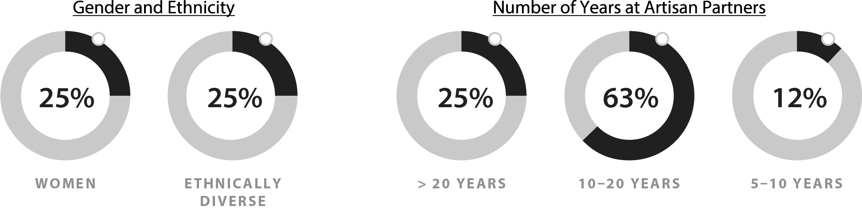
 |  |  |  |  |  | Eric R. Colson has been executive chair and chair of the board of Artisan Partners Asset Management since June 2025, prior to which he served as chief executive officer and a director of Artisan Partners Asset Management from March 2011. Mr. Colson served as president of Artisan Partners Asset Management from March 2011 to January 2021 and as chairman of the Board from August 2015 to August 2021. Mr. Colson served as the chief executive officer of Artisan Partners from January 2010 to June 2025. Prior to January 2010, Mr. Colson served as chief operating officer of investment operations from March 2007 through January 2010. Mr. Colson has been a managing director of Artisan Partners since he joined the firm in January 2005.
 |  |  |  |  |  | Charles J. Daley, Jr. has been executive vice president, chief financial officer and treasurer of Artisan Partners Asset Management since March 2011. He has served as the chief financial officer of Artisan Partners since August 2010 and has been a managing director since July 2010 when he joined the firm.
 |  |  |  |  |  | Jason A. Gottlieb has been chief executive officer and a director of Artisan Partners Asset Management since June 2025 and has served as president of Artisan Partners Asset Management since January 2021. From February 2017 to January 2021, he served as executive vice president of Artisan Partners Asset Management. Mr. Gottlieb joined Artisan Partners in October 2016 as a managing director and the chief operating officer of investments.
18

 |  |  |  |  |  | Christopher J. Krein has been executive vice president of Artisan Partners Asset Management and Artisan Partners’ head of Global Distribution since January 2020. Prior to becoming head of Global Distribution, Mr. Krein was responsible for institutional marketing and client service for the Artisan Developing World team. Mr. Krein has been a managing director of Artisan Partners since he joined the firm in September 2015.
 |  |  |  |  |  | Eileen L. Kwei has been executive vice president of Artisan Partners Asset Management and Artisan Partners’ chief administrative officer since January 2021. From February 2018 to January 2021, Ms. Kwei was responsible for institutional marketing and client service for the Artisan Credit team. Prior to February 2018, Ms. Kwei was a relationship manager for the Artisan Global Equity team. Ms. Kwei joined Artisan Partners in June 2013 and has been a managing director of Artisan Partners since 2018.
 |  |  |  |  |  | Gregory K. Ramirez has been executive vice president of Artisan Partners Asset Management since February 2016. From October 2013 to February 2016, he served as senior vice president and from April 2013 to October 2013 as assistant treasurer. Mr. Ramirez is currently head of vehicle and investor operations for Artisan Partners and serves as chair of the Artisan Risk and Integrity Committee. Mr. Ramirez was named a managing director of Artisan Partners in April 2003.
 |  |  |  |  |  | Samuel B. Sellers was appointed executive vice president of Artisan Partners Asset Management and Artisan Partners' chief operating officer in January 2023. From January 2021 to January 2023, Mr. Sellers was head of Investment Operations. Prior to January 2021, Mr. Sellers served as deputy general counsel. Mr. Sellers was named a managing director of Artisan Partners in January 2022.
 |  |  |  |  |  | Laura E. Simpson was appointed executive vice president, chief legal officer and secretary of Artisan Partners Asset Management in October 2023. Ms. Simpson was named general counsel of Artisan Partners in October 2022 and previously served as deputy general counsel from January 2015 to September 2022 and associate counsel from March 2011 to December 2014. Ms. Simpson was named a managing director of Artisan Partners in 2023.
19

Compensation Discussion and Analysis

EXECUTIVE SUMMARY
This Compensation Discussion and Analysis provides information about our executive compensation program, our 2025 business and financial results, and the compensation for our named executive officers (“NEOs”).
2025 Named Executive Officers
Name |  |  | Position
Jason A. Gottlieb |  |  | President and Chief Executive Officer 1
Eric R. Colson |  |  | Executive Chair 2
Charles J. Daley, Jr. |  |  | Executive Vice President, Chief Financial Officer and Treasurer
Christopher J. Krein |  |  | Executive Vice President and Head of Global Distribution
Eileen L. Kwei |  |  | Executive Vice President and Chief Administrative Officer
Samuel B. Sellers |  |  | Executive Vice President and Chief Operating Officer
1 Effective June 4, 2025, Mr. Gottlieb was appointed Chief Executive Officer and, in connection with the 2025 Annual Meeting of Stockholders, was elected to the Board.
2 Effective June 4, 2025, Mr. Colson transitioned from Chief Executive Officer to Executive Chair and Chair of the Board.
2025 Business and Financial Highlights
In 2025, we remained focused on maintaining the firm’s talent-driven business model and investment-focused culture. We explored potential new investment teams and talent across traditional and alternative asset classes. In the fourth quarter, we signed a definitive purchase agreement to acquire Grandview Property Partners, marking our expansion into private equity real estate. We also continued to partner with our investment teams to help them leverage our expanded capabilities in support of new product development and enhancements to existing offerings. We advanced our new distribution model and added distribution and marketing talent to strengthen our commercial capabilities.

The chart set forth below compares certain performance measures for 2025 against the same measures for 2024. Our 2025 financial results were strong, reflecting increases in assets under management and revenue.
Measure |  |  |  |  |  | 2025 |  |  |  |  |  | 2024 |  |  |  |  |  | Percentage Change 2025 v. 2024
Ending Assets Under Management (in billions) |  |  |  |  |  | $ | 179.9 |  |  |  |  | $ | 161.2 |  |  |  |  | 11.6%
Average Assets Under Management (in billions) |  |  |  |  |  | $ | 173.0 |  |  |  |  | $ | 160.2 |  |  |  |  | 8.0%
Net Client Cash Flows |  |  |  |  |  | $ | (12,662) |  |  |  |  | $ | (3,699) |  |  |  |  | (242.3)%
Revenue (in millions) |  |  |  |  |  | $ | 1,196.7 |  |  |  |  | $ | 1,111.8 |  |  |  |  | 7.6%
Weighted Average Management Fee |  |  |  |  |  | 69.3 bps |  |  |  |  |  | 69.5 bps |  |  |  |  |  | (0.3)%
Operating Margin |  |  |  |  |  | 33.4 |  | % |  |  |  | 33.0 |  | %
Adjusted Operating Margin* |  |  |  |  |  | 35.3 |  | % |  |  |  | 33.8 |  | %
Basic and Diluted Earnings per Share |  |  |  |  |  | $ | 4.05 |  |  |  |  | $ | 3.66
Adjusted EPS* |  |  |  |  |  | $ | 3.93 |  |  |  |  | $ | 3.55
*Adjusted measures are non-GAAP measures. See Annex A for non-GAAP reconciliations.

20

Executive Compensation Program Features
Our executive compensation program includes the following features that reflect sound corporate governance:
What we do |  |  |  |  |  | What we don't do
a |  |  | Align pay with performance; majority of compensation is performance based |  |  | r  r |  |  | Employment agreements  Bonus guarantees
a |  |  | Require that half of all equity awarded to NEOs includes career vesting conditions |  |  | r |  |  | Retirement income or pension plans other than the same 401(k) plan available to all employees
a |  |  | Utilize double-trigger change in control provisions on all restricted stock awarded to NEOs |  |  | r |  |  | Benefit plans or perquisites that cover only one or more of our executive officers
a |  |  | Maintain equity ownership guidelines requiring a significant amount of Company equity be held by executive officers |  |  | r  r |  |  | Allow for short sales or hedging of Company stock  “Golden parachute” tax gross ups
a |  |  | Maintain a clawback policy that complies with applicable law
a |  |  | Retain an independent compensation consultant
a |  |  | Impose restrictions on the pledging of Company stock
2025 Executive Compensation Overview
In March 2025, we announced that Jason Gottlieb, then President, would succeed Eric Colson as Chief Executive Officer, and that Mr. Colson would become Executive Chair, effective following the Company’s 2025 annual meeting of stockholders on June 4, 2025. At the annual meeting, Mr. Gottlieb was elected to the Board of Directors and Mr. Colson became Chair of the Board, succeeding Stephanie DiMarco, who transitioned to Lead Independent Director. The 2025 compensation of Mr. Colson and Mr. Gottlieb reflects this mid-year transition in roles and responsibilities, including Mr. Colson’s assumption of an active and engaged Executive Chair role.
The core elements of our NEOs’ compensation are cash-based salary, a performance-based cash award and long-duration equity awards, one-half of which contain career vesting provisions. For 2025, performance-based compensation comprised 95% of each of Mr. Gottlieb’s and Mr. Colson’s total compensation. For our other NEOs, performance-based compensation ranged from 88% to 90% of total compensation.
The following table shows the elements of compensation paid to our NEOs with respect to 2025, 2024 and 2023. The amounts in this table vary from the data and reporting conventions required by SEC rules in the Summary Compensation Table.
21

 |  |  |  |  |  |  |  |  |  |  |  |  |  |  |  |  |  | Performance-Based Compensation
 |  |  |  |  |  |  |  |  |  |  |  |  |  |  |  |  |  |  |  |  |  |  |  | Equity Awards
Name & Principal Position |  |  |  |  |  | Year |  |  |  |  |  | Salary |  |  |  |  |  | Cash Award |  |  |  |  |  | Standard Grant |  |  | Career Grant |  |  |  |  |  | Total Direct Compensation |  |  |  |  |  | Performance- Based as % of Total
Jason A. Gottlieb |  |  |  |  |  | 2025 |  |  |  |  |  | $ | 300,000 |  |  |  |  | $ | 3,570,000 |  |  |  |  | $ | 810,807 |  | $ | 810,807 |  |  |  |  | $ | 5,491,614 |  |  |  |  | 95 |  | %
Chief Executive Officer |  |  |  |  |  | 2024 |  |  |  |  |  | 300,000 |  |  |  |  |  | 3,400,000 |  |  |  |  |  | 774,200 |  |  | 774,200 |  |  |  |  |  | 5,248,400 |  |  |  |  |  | 94 |  | %
 |  |  |  |  |  | 2023 |  |  |  |  |  | 300,000 |  |  |  |  |  | 3,200,000 |  |  |  |  |  | 753,434 |  |  | 753,434 |  |  |  |  |  | 5,006,868 |  |  |  |  |  | 94 |  | %
Eric R. Colson |  |  |  |  |  | 2025 |  |  |  |  |  | 385,000 |  |  |  |  |  | 4,761,000 |  |  |  |  |  | 976,354 |  |  | 976,354 |  |  |  |  |  | 7,098,708 |  |  |  |  |  | 95 |  | %
Executive Chair |  |  |  |  |  | 2024 |  |  |  |  |  | 500,000 |  |  |  |  |  | 4,600,000 |  |  |  |  |  | 945,940 |  |  | 945,940 |  |  |  |  |  | 6,991,880 |  |  |  |  |  | 93 |  | %
 |  |  |  |  |  | 2023 |  |  |  |  |  | 500,000 |  |  |  |  |  | 4,000,000 |  |  |  |  |  | 753,434 |  |  | 753,434 |  |  |  |  |  | 6,006,868 |  |  |  |  |  | 92 |  | %
Charles J. Daley, Jr. |  |  |  |  |  | 2025 |  |  |  |  |  | 300,000 |  |  |  |  |  | 1,821,750 |  |  |  |  |  | 427,344 |  |  | 427,344 |  |  |  |  |  | 2,976,438 |  |  |  |  |  | 90 |  | %
Chief Financial Officer |  |  |  |  |  | 2024 |  |  |  |  |  | 300,000 |  |  |  |  |  | 1,735,000 |  |  |  |  |  | 408,247 |  |  | 408,247 |  |  |  |  |  | 2,851,494 |  |  |  |  |  | 89 |  | %
 |  |  |  |  |  | 2023 |  |  |  |  |  | 300,000 |  |  |  |  |  | 1,613,000 |  |  |  |  |  | 404,327 |  |  | 404,327 |  |  |  |  |  | 2,721,654 |  |  |  |  |  | 89 |  | %
Christopher J. Krein |  |  |  |  |  | 2025 |  |  |  |  |  | 300,000 |  |  |  |  |  | 1,725,250 |  |  |  |  |  | 501,610 |  |  | 501,610 |  |  |  |  |  | 3,028,470 |  |  |  |  |  | 90 |  | %
Head of Global Distribution |  |  |  |  |  | 2024 |  |  |  |  |  | 300,000 |  |  |  |  |  | 1,675,000 |  |  |  |  |  | 497,877 |  |  | 497,877 |  |  |  |  |  | 2,970,754 |  |  |  |  |  | 90 |  | %
 |  |  |  |  |  | 2023 |  |  |  |  |  | 300,000 |  |  |  |  |  | 1,650,000 |  |  |  |  |  | 444,524 |  |  | 444,524 |  |  |  |  |  | 2,839,048 |  |  |  |  |  | 89 |  | %
Eileen L. Kwei |  |  |  |  |  | 2025 |  |  |  |  |  | 300,000 |  |  |  |  |  | 1,512,000 |  |  |  |  |  | 353,035 |  |  | 353,035 |  |  |  |  |  | 2,518,070 |  |  |  |  |  | 88 |  | %
Chief Administrative Officer |  |  |  |  |  | 2024 |  |  |  |  |  | 300,000 |  |  |  |  |  | 1,340,000 |  |  |  |  |  | 348,523 |  |  | 348,523 |  |  |  |  |  | 2,337,046 |  |  |  |  |  | 87 |  | %
 |  |  |  |  |  | 2023 |  |  |  |  |  | 300,000 |  |  |  |  |  | 1,250,000 |  |  |  |  |  | 311,427 |  |  | 311,427 |  |  |  |  |  | 2,172,854 |  |  |  |  |  | 86 |  | %
Samuel B. Sellers 1 |  |  |  |  |  | 2025 |  |  |  |  |  | 300,000 |  |  |  |  |  | 1,648,500 |  |  |  |  |  | 344,065 |  |  | 344,065 |  |  |  |  |  | 2,636,630 |  |  |  |  |  | 89 |  | %
Chief Operating Officer
1 Mr. Sellers was not a NEO in 2024 or 2023.

▪Base salaries for our NEOs were unchanged for 2025, except for Mr. Colson, whose base salary was reduced from $500,000 to $300,000 effective upon his transition to Executive Chair in June 2025. The reduction reflects his change in role and day-to-day operational responsibilities following the CEO succession.
▪2025 performance-based incentive compensation (i.e., cash and equity awards) increased 5% for Mr. Gottlieb and 3% for Mr. Colson relative to 2024, reflecting, among other things, the successful mid-year leadership transition, progress made on the firm’s strategic priorities, and the continued growth of our assets under management and revenue. These positive developments were tempered by higher net client outflows in the aggregate during 2025, which contributed to a more measured increase in compensation. For our other NEOs who were also NEOs in 2024, performance-based compensation increased 2% to 9% year over year.

EXECUTIVE COMPENSATION PHILOSOPHY AND OBJECTIVES
Fundamental to our executive compensation program is the belief that, for the benefit of all our stakeholders, executive compensation should be tied to the firm’s purpose and the drivers of its long-term success. The firm’s purpose is—and has been since its founding—to generate and compound wealth over the long term for its clients.
To achieve our purpose, we must continue to thoughtfully grow our business over the long term while preserving a stable environment in which our talented investment professionals and associates can thrive. Maintaining our talent-driven business model and investment-focused culture is critical to generating sustainable, long-term outcomes for clients, which in turn is critical to generating sustainable long-term outcomes for stockholders.
22

Our executive compensation program is designed to keep executive officers oriented on the firm’s long-term success. Our Compensation Committee structures executive compensation over long time horizons and evaluates executive officers’ performance based on the quality and execution of the firm’s long-term strategic objectives and key priorities.
Predetermined formulas and quantitative targets are avoided because they all too often result in inhibiting innovation and engineering short-term financial results. Predetermined formulas could also limit the Compensation Committee’s ability to modify levels of performance-based compensation in response to rapidly changing market or economic conditions that are outside the firm’s control. |  |  |  |  |  | Our proven approach to executive compensation appropriately reflects our unique business model, history and culture. We avoid a “one-size-fits-all” approach in favor of a tailored executive compensation program that has consistently worked well for us.
The Compensation Committee’s approach to evaluating executive officers’ performance and determining the amount and mix of performance-based compensation reflects the following key principles, which are embedded within our annual executive compensation process.
Key Principles
1.The amount of performance-based compensation should initially be considered based on the accomplishment of strategic objectives and key priorities.
2.The amount of performance-based compensation should then be adjusted to reflect the firm’s financial and operating results.
3.The mix of equity and cash performance-based incentive plan compensation should serve to align executive officers’ interests with those of the firm’s clients, stockholders and key investment professionals.
4.Our approach to compensation should reflect Who We Are as a firm—a high value-added investment firm, designed for investment talent to thrive, and committed to thoughtful growth over the long term.

23

PROCESS FOR DETERMINING EXECUTIVE COMPENSATION
The Compensation Committee has established a comprehensive process for determining executive compensation as shown below and discussed in detail under “2025 Executive Compensation Process and Decisions”.
First Quarter |  |  | Second Quarter |  |  | Third Quarter |  |  | Fourth Quarter
▪Review strategic objectives and establish key priorities for year  ▪Confirm key measures used to assess the firm’s financial and operational performance for the year  ▪Approve aggregate and individual maximum amounts of performance-based compensation for the year  ▪Consider shareholder feedback |  |  | ▪Discuss status of strategic objectives and key priorities  ▪Review key measures over multiple time horizons to assess firm's performance  ▪Consider shareholder feedback |  |  | ▪Discuss status of strategic objectives and key priorities  ▪Review key measures over multiple time horizons to assess firm's performance  ▪Review say-on-pay result and consider shareholder feedback |  |  | ▪Discuss status of strategic objectives and key priorities  ▪Review key measures over multiple time horizons to assess firm's performance  ▪Consider McLagan's market analysis  ▪Consider shareholder feedback
▪Review executive officers' key accomplishments vis-à-vis strategic objectives and key priorities and consider amount of performance-based compensation
▪Review key measures used to assess performance of the firm and adjust performance-based compensation accordingly
▪Determine cash/equity mix of performance-based compensation
Role of the Board of Directors and Chief Executive Officer
Our Chief Executive Officer evaluates the performance of our other executive officers and makes recommendations to our Compensation Committee regarding the compensation of the executive management team. Our Compensation Committee, which is comprised solely of directors who qualify as independent under applicable SEC and NYSE rules, generally has ultimate responsibility for compensation decisions relating to all of our executive officers. Other members of the Board regularly attend and participate in meetings of the Compensation Committee, and the members of the Compensation Committee and Board regularly meet in executive session without management present. The decisions of the Compensation Committee are reported to the full Board and the full Board approves the annual long-term incentive award upon the recommendation of the Compensation Committee.
Role of the Independent Compensation Consultant
Our Compensation Committee has retained McLagan as its independent compensation consultant. McLagan provides the Compensation Committee with information on competitive pay levels for our executive officers vis-à-vis an executive reference group consisting of both public and private asset
24

management firms, as well as a proxy peer group. McLagan also provides the Compensation Committee with information about compensation trends in the investment management industry generally. The Compensation Committee considers the information provided by McLagan within the context of our differentiated philosophy and approach to executive compensation.
Our Compensation Committee has assessed the independence of McLagan pursuant to SEC rules and concluded that no conflict of interest exists that prevents McLagan from independently advising the Compensation Committee.
Peer Group Compensation Review
We do not seek to benchmark our executive compensation to that of our peers. Instead, the Compensation Committee regards peer group pay levels and performance information as a reasonable reference point and one of multiple perspectives considered when determining executive compensation.
Stockholder Feedback
As part of the Company’s ongoing commitment to stockholder outreach and transparency, we regularly engaged with stockholders during 2025 through individual investor calls and meetings and through participation in investor conferences. In 2025, we engaged our top active and passive institutional stockholders, representing, as of December 31, 2025, approximately 52% of our outstanding shares and approximately 60% of our publicly held Class A shares. Discussions that took place covered a variety of topics, including governance matters. No compensation-related concerns were raised during these engagements.

We also regularly engage with our employees, who collectively held approximately 9.2% of our outstanding common stock as of the Record Date. Additionally, we reach out to our Class C stockholders, who collectively held approximately 11.0% of our outstanding common stock as of the Record Date, on a quarterly basis.
We expect to continue to engage with all of our stockholders on a regular basis to foster an open dialogue about a variety of topics, including our executive compensation program. The Compensation Committee will continue to consider enhancements to the executive compensation program in the future based on the feedback we receive.
The Compensation Committee also considers the results of the Company’s advisory vote on compensation when determining the amount and form of compensation paid to the NEOs and the structure of the executive compensation program generally. At the 2025 annual meeting of stockholders, the advisory vote on executive compensation received stockholder support with approximately 97% of the votes cast in favor of our NEOs’ compensation, which informed the Compensation Committee’s decision to maintain a consistent overall approach to executive compensation. The Compensation Committee values this input from our stockholders.
Tax and Accounting Considerations
When it reviews compensation matters, our Compensation Committee considers the anticipated tax and accounting treatment of various payments and benefits to the Company and, when relevant, to its executive officers. The Compensation Committee believes that accounting and tax considerations are only one of many aspects of determining executive compensation and therefore such considerations should not unduly influence the overall design of the executive compensation program.

25

2025 EXECUTIVE COMPENSATION PROCESS AND DECISIONS
Establish 2025 Executive Compensation Framework ü
During the first quarter of 2025, the Compensation Committee and, with respect to the approval of the key priorities, the Board:
▪Determined that the aggregate maximum amount of executive officers’ performance-based compensation for 2025 would be 8% of Artisan’s 2025 adjusted operating income, further adjusted to add back long-term incentive compensation expense and executive performance-based cash awards.
▪Determined that the maximum performance-based incentive plan cash award for each executive officer would be 200% of their total 2024 performance-based compensation (cash and equity awards combined).
▪Agreed upon the key measures that would be used to assess the firm’s operating and financial performance for the year and over the long term, which continued to be as follows:
 |  |  | Long-Term Growth and Value Creation Measures |  |  |  |  |  | Stability and Predictability Measures
 |  |  | - AUM Growth |  |  |  |  |  | - Adjusted Operating Margin
 |  |  | - Revenue Growth |  |  |  |  |  | - Weighted Average Fee Rate
 |  |  | - Organic Growth |  |  |  |  |  | - Investment Performance
▪Approved a set of strategic objectives for the firm and key priorities for the members of the executive management team, as follows:
Investments |  |  | Business Management |  |  | Financials |  |  | Sustainability and Engagement
Strategic Objective:  ▪Maintain our talent-driven business model and investment-focused culture structured to ensure the alignment of, and resources for, the firm’s investment professionals. |  |  | Strategic Objective:  ▪Provide a distraction-free investment environment that allows our investment professionals to focus on delivering high value-added investment results. |  |  | Strategic Objective:  ▪Navigate short-term market volatility with our financial model that emphasizes variable expenses, healthy operating margins and fee levels reflective of our high value-added investments. |  |  | Strategic Objective:  ▪Promote and advance the wellbeing of the firm, both in terms of its business model and investment activities.
Key Priorities:  ▪Firmly establish Artisan Partners as a multi-asset investment platform with a full suite of investment capabilities.  ▪Expand talent alignment toolkit to address the needs of investment professionals at all stages of their careers.  ▪Assess investment strategies to identify opportunities to enhance relevancy, demand and duration. |  |  | Key Priorities:  ▪Successfully transition executive leadership, ensuring continuity for investment talent, clients and stockholders.  ▪Continue to develop the distribution structure for the wealth market and alternative investments.  ▪Design a repeatable acquisition model that can be leveraged to broaden the total addressable market of new teams and strategies. |  |  | Key Priorities:  ▪Continue to ensure alignment between our incremental investments in the business and our strategic priorities.  ▪Manage financial alignment to our business model with focus on our operating margin and fee rates. |  |  | Key Priorities:  ▪Continue to execute on the firm’s sustainability practices, while acknowledging the complex environments in which we operate globally.  ▪Enhance engagement with stakeholders to successfully communicate anticipated 2025 developments.
Strategic objectives are broad statements that reflect how the firm will achieve its purpose and further its long-term strategy for sustainable growth. The strategic objectives are shaped by Who We Are and our belief that steadfast adherence to our business and financial models will minimize risk and provide opportunities for long-term growth and value creation. Accordingly, the strategic objectives generally remain consistent year over year.
26

Key priorities address areas of opportunity and disruption that warrant management’s focus—whether for purposes of pursuing long-term value creation or managing risk. The key priorities are more tactical in nature and may have long time horizons, with progress towards goals evaluated on an annual basis. The key priorities were approved by the Board in January 2025 and subsequently communicated to the executive officers.
At each of its quarterly meetings in 2025, the Compensation Committee discussed the status of the key priorities and considered the key operating and financial measures year-to-date and over the long term to assess the Company’s business and financial performance.
Review Key Accomplishments and Consider Performance-Based Pay ü
At the end of the year, the Compensation Committee, together with the full Board, assessed the executive officers’ performance based on their continued adherence to the strategic objectives and their accomplishment of key priorities over both annual and long-term time horizons. The Board strongly believes that executive officers’ performance must be evaluated in terms of long-term value creation—not only short-term results. |  |  |  |  |  | Successful outcomes for clients and stockholders result from years of thoughtfully developing and evolving the business; then remaining patient and disciplined while growth is realized.
Key accomplishments relative to 2025 strategic objectives and key priorities consisted of the following:
Investments |  |  | Business Management |  |  | Financials |  |  | Sustainability and Engagement
Key Accomplishments  Consistent with our key priorities:  ▪Partnered with existing investment teams to leverage new capabilities and develop new solutions.  ▪Worked with investment team leaders to advance talent development and extend franchise duration.  ▪Evaluated potential new investment teams and talent across traditional and alternatives asset classes.  ▪Expanded alternative and private market capabilities with the acquisition of Grandview Property Partners.  ▪Continued assessment of investment teams, strategies and vehicles to ensure optimal alignment of resources. |  |  | Key Accomplishments  Consistent with our key priorities:  ▪Expanded our multi-asset platform across investments, operations and distribution.  ▪Successfully managed the executive leadership transition and fortified the Board and management team with additional high-caliber leaders.  ▪Onboarded and integrated additional distribution and marketing talent to strengthen our commercial capabilities.  ▪Established an acquisition framework to support efficient execution on future transactions. |  |  | Key Accomplishments  Consistent with our key priorities:  ▪Maintained focus on expense management resulting in an adjusted operating margin of 35.3%, compared to 33.8% in 2024. 1  ▪Maintained a weighted average fee rate of 69.3 bps, compared to 69.5 bps for 2024. 2  ▪Declared $3.87 of dividends per share with respect to 2025.  ▪Managed balance sheet to support continued investments in strategic growth initiatives.  ▪Closed on refinancing of Series G Senior Notes. |  |  | Key Accomplishments  Consistent with our key priorities:  ▪Continued to support investment teams’ sustainability practices with relevant data, research communications and guidance.  ▪Advanced a collaborative work environment and the engagement of associates through ongoing Artisan Unity efforts.  ▪Clearly communicated the executive leadership transition to stakeholders, ensuring continuity and a commitment to the business.
1 Adjusted measures are non-GAAP measures. See Annex A for non-GAAP reconciliations.
2 We compute our weighted average fee rate by dividing annualized investment advisory fees, including performance fees, by average AUM for the applicable period. Prior to December 31, 2025, performance fees were excluded from the weighted average fee calculation. This change was made as performance fees have become a more meaningful component of our revenues. Historical figures have been recast for comparability.
After assessing executive officers’ performance, the Compensation Committee considered an appropriate amount of performance-based compensation (i.e., cash and equity awards) for Mr. Gottlieb and Mr. Colson, as well as Mr. Gottlieb’s recommendations with respect to the performance-based pay for each
27

other executive officer. In doing so, the Compensation Committee referred to the maximum amount of performance-based compensation for executive officers in the aggregate and the maximum performance-based cash award for each executive officer individually, each as established by the Compensation Committee in January 2025.
▪The maximum amount of performance-based compensation for executive officers in the aggregate for 2025 was determined to be $41.1 million. This amount represents 8% of 2025 adjusted operating income, further adjusted to add back long-term incentive compensation expense and performance-based cash awards granted to executives under the cash incentive plan.1
▪The maximum performance-based cash award for each executive officer under the cash incentive plan was equal to 200% of their total 2024 performance-based compensation (cash and equity awards combined), as shown below.
 |  |  | Name |  |  | 2025 Maximum Cash Incentive Plan Award ($)
 |  |  | Jason A. Gottlieb |  |  | $9,896,800
 |  |  | Eric R. Colson |  |  | 12,983,758
 |  |  | Charles J. Daley, Jr. |  |  | 5,102,986
 |  |  | Christopher J. Krein |  |  | 5,341,508
 |  |  | Eileen L. Kwei |  |  | 4,074,090
 |  |  | Samuel B. Sellers |  |  | 3,894,646
The Committee agreed that 2025 performance-based compensation for each NEO would ultimately be determined by applying negative discretion to the maximum cash award amounts set forth above after assessing the key accomplishments and considering the firm’s financial and operating results as follows.
Align Performance-Based Pay with Financial and Operating Results ü
In keeping with the process described above, the Compensation Committee then sought to align the amount of performance-based compensation with the Company’s current year financial and operating results. The Compensation Committee used a number of key financial and non-financial measures to evaluate how the firm’s performance compares to its historical performance and the performance of its peers. Consistent with the drivers of the firm’s long-term success, these key measures are focused on either (i) long-term growth and value creation or (ii) the preservation of a stable and predictable environment. In all cases, these measures are considered over both annual and longer-term time horizons, focusing on the long-term health and sustainability of the firm. |  |  |  |  |  | The assessment of the firm’s performance also informs management’s recommendation and the Board’s decision regarding the size of the firm’s annual long-term incentive award, which consists of both the annual franchise capital award for investment team members and the annual equity award.
1 Adjusted measures are non-GAAP measures. See Annex A for non-GAAP reconciliations.
28

Long-Term Growth and Value Creation Measures
▪Assets Under Management (AUM) Growth Trends. Changes in our AUM are the primary driver of changes in revenue. The amount and composition of our AUM is influenced by a variety of factors, including, among others:
•Investment performance, relating to fluctuations in global financial markets as well as our own investment decisions;
•Flows into and out of our investment strategies and vehicles;
•Our decision to limit capacity in certain strategies and vehicles; and
•Industry trends and investor sentiment.
Over the long-term, we expect to generate AUM growth primarily through investment returns, which is consistent with our historical experience.

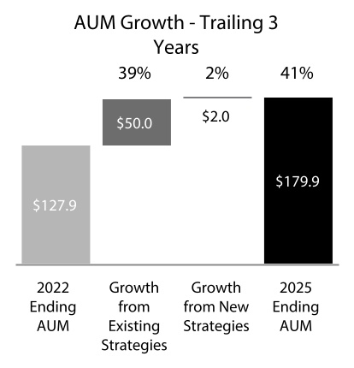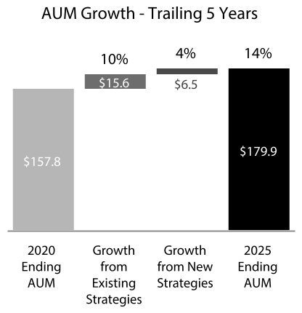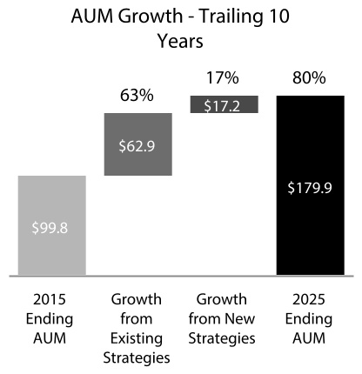
In billions. "New Strategies" refers to strategies launched during the indicated periods.

▪Revenue Growth Trends. The firm derives essentially all of its revenue from investment advisory fees, the vast majority of which are based on average AUM. As a result, changes in our AUM for whatever reason have a direct and significant impact on our revenue.
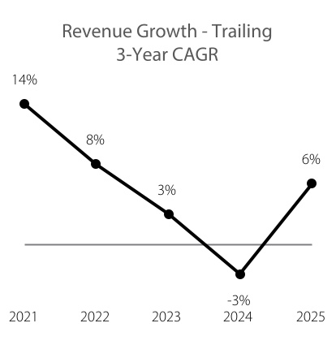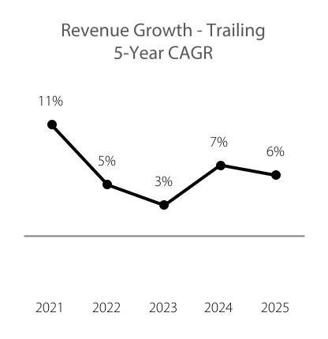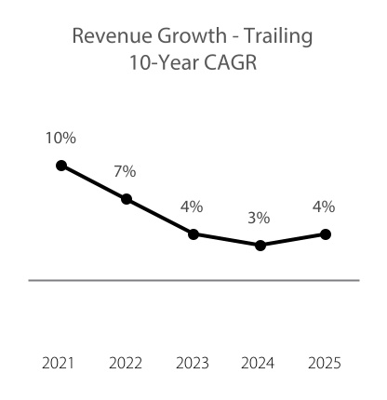
Each data point represents the CAGR for the trailing 3-, 5- or 10-year period, as applicable, measured as of the fiscal year-end indicated (2021-2025).
▪Organic Growth Trends. The organic growth rate represents flows of client assets into and out of the firm’s investment strategies and vehicles. In recent years, market trends and other forces have created
29

headwinds for many asset management firms. Passive and alternative investment options continue to grow organically while traditional active equity strategies have experienced net outflows. In response, we have continued to expand our credit and alternative capabilities and increase degrees of investment freedom within our existing investment strategies. We actively evaluate potential new investment teams, talent and strategies to enhance and expand our investment platform further into areas where both opportunity and client demand exist, and in which we can differentiate our active management and add value for clients.

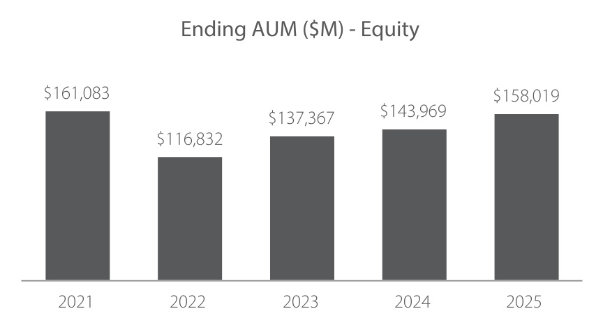
 |  |  | Investment Performance ($M) |  |  | $16,245 |  |  | $(34,318) |  |  | $25,351 |  |  | $14,228 |  |  | $31,254
 |  |  | Investment Performance (%) |  |  | 11% |  |  | (21)% |  |  | 22% |  |  | 10% |  |  | 22%
 |  |  | Net Flows ($M) |  |  | $(1,197) |  |  | $(9,650) |  |  | $(4,401) |  |  | $(6,841) |  |  | $(15,631)
 |  |  | Organic Growth Rate |  |  | (1)% |  |  | (6)% |  |  | (4)% |  |  | (5)% |  |  | (11)%
 |  |  | Number of Strategies |  |  | 15 |  |  | 16 |  |  | 16 |  |  | 16 |  |  | 17
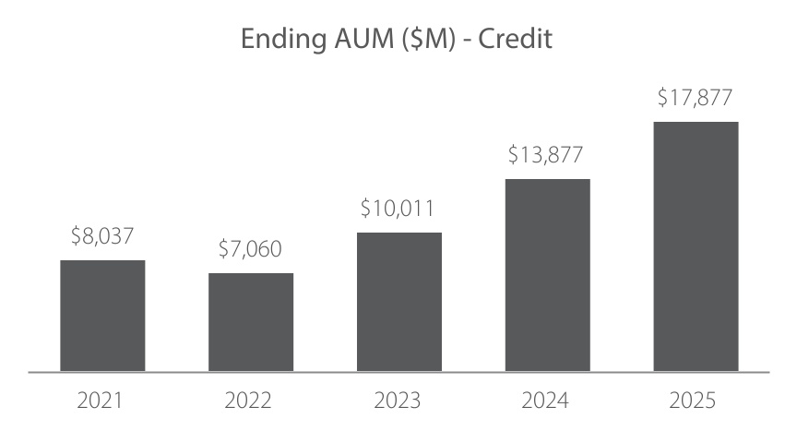
 |  |  | Investment Performance ($M) |  |  | $443 |  |  | $(786) |  |  | $1,233 |  |  | $953 |  |  | $1,538
 |  |  | Investment Performance (%) |  |  | 7% |  |  | (10)% |  |  | 17% |  |  | 10% |  |  | 11%
 |  |  | Net Flows ($M) |  |  | $1,569 |  |  | $19 |  |  | $1,987 |  |  | $3,274 |  |  | $2,841
 |  |  | Organic Growth Rate |  |  | 25% |  |  | 0% |  |  | 28% |  |  | 33% |  |  | 20%
 |  |  | Number of Strategies |  |  | 2 |  |  | 4 |  |  | 4 |  |  | 4 |  |  | 5

30

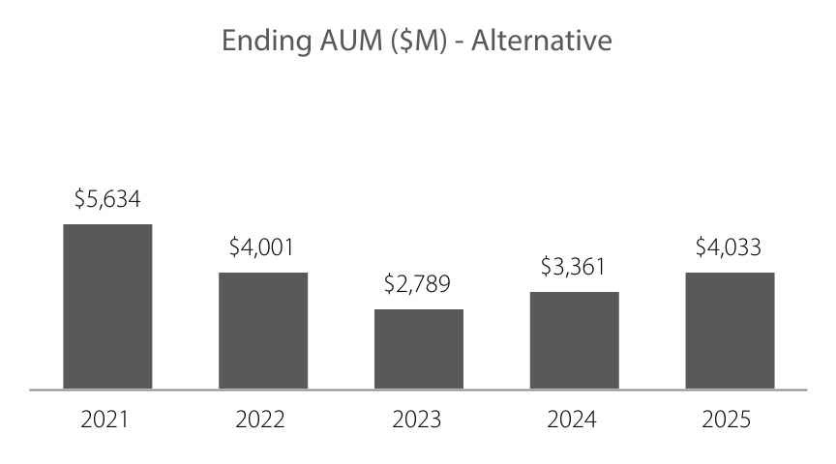
Investment Performance ($M) |  |  | $907 |  |  | $(1,447) |  |  | $451 |  |  | $752 |  |  | $573
Investment Performance (%) |  |  | 25% |  |  | (26)% |  |  | 11% |  |  | 27% |  |  | 17%
Net Flows ($M) |  |  | $1,305 |  |  | $(182) |  |  | $(1,662) |  |  | $(133) |  |  | $128
Organic Growth Rate |  |  | 37% |  |  | (3)% |  |  | (42)% |  |  | (5)% |  |  | 4%
Number of Strategies |  |  | 4 |  |  | 5 |  |  | 5 |  |  | 5 |  |  | 5

Stability and Predictability Measures
▪Adjusted Operating Margin. We seek to maintain healthy operating margins reflective of the firm’s highly variable cost structure. This cost structure is an essential component of our transparent and predictable financial model, which provides consistency and stability, even in times of market volatility. Investments in strategic growth initiatives generally cause the portion of expenses that are fixed to increase causing operating margins to decline. These declines may be amplified when combined with challenging market conditions that lead to a decrease in revenue. However, we are committed to reinvesting in the business, in alignment with our strategic priorities, to support our long-term growth.
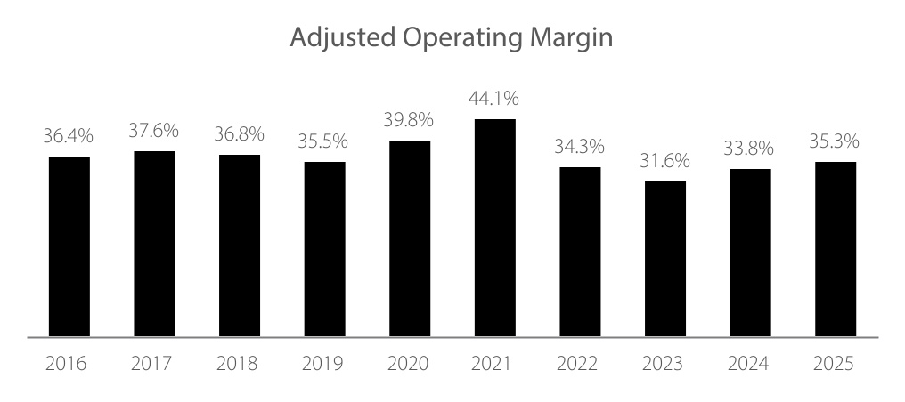
Change |  |  | 1.2% |  |  | -0.8% |  |  | -1.3% |  |  | 4.3% |  |  | 4.3% |  |  | -9.8% |  |  | -2.7% |  |  | 2.2% |  |  | 1.5%
31

Adjusted operating margin is calculated by dividing adjusted operating income by total revenues. GAAP operating margin was 32.5%, 36.0%, 36.8%, 35.5%, 39.8%, 44.0%, 34.6%, 31.1%, 33.0% and 33.4% for 2016, 2017, 2018, 2019, 2020, 2021, 2022, 2023, 2024 and 2025, respectively. Adjusted measures are non-GAAP measures. See Annex A for non-GAAP reconciliations.
▪Weighted Average Fee. Over time, our weighted average fee has declined, primarily as a result of changes in the investment strategies and investment vehicles across which our AUM is managed. However, in general the firm has been successful in maintaining an attractive overall rate of fee due to the strength of our investment performance and our focus on limited capacity, high value-added investment strategies.
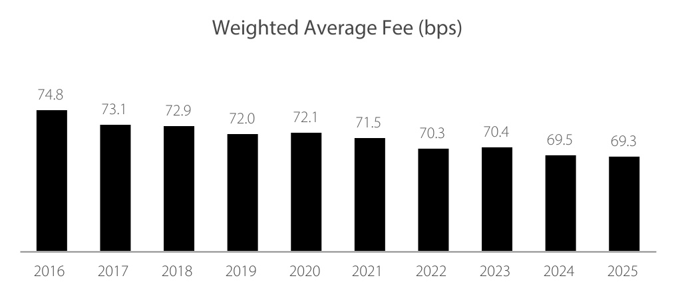
Change |  |  | -1.7 |  |  | -0.2 |  |  | -0.9 |  |  | 0.1 |  |  | -0.6 |  |  | -1.2 |  |  | 0.1 |  |  | -0.9 |  |  | -0.2
We compute our weighted average fee rate by dividing annualized investment advisory fees, including performance fees, by average AUM for the applicable period. Prior to December 31, 2025, we presented our weighted average management fee, which excluded performance fees. This change was made to better reflect our fee rate as performance fees have become a more meaningful component of our revenues over time. Historical figures have been recast for comparability.
Investment Performance. We evaluate the performance of our investment strategies in a variety of ways, always focusing on the long-term results generated for our clients. Among other measures and methodologies, we assess the performance of each Artisan investment strategy relative to its respective benchmark (i.e., value-added) and we consider the percentage of our AUM that is managed in strategies for which the average annual gross composite return exceeded its benchmark return.
32

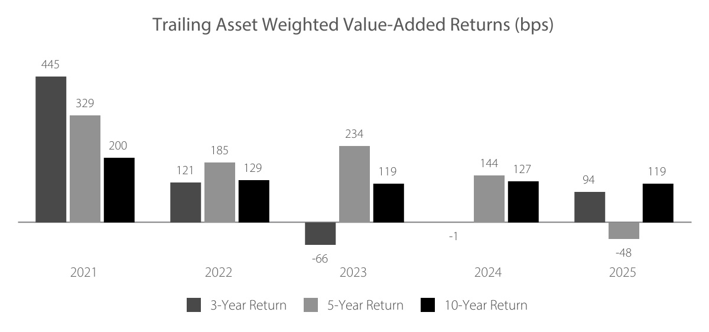
Represents the amount in basis points by which the average annual gross composite returns of Artisan investment strategies, in the aggregate, outperformed or underperformed their respective benchmarks, over the time periods indicated. Trailing Asset Weighted Value-Added Returns is calculated based on the monthly gross composite performance of each Artisan strategy against its respective benchmark and weighted by the beginning of period AUM. Additional information regarding the calculation of investment performance can be found in Annex A.
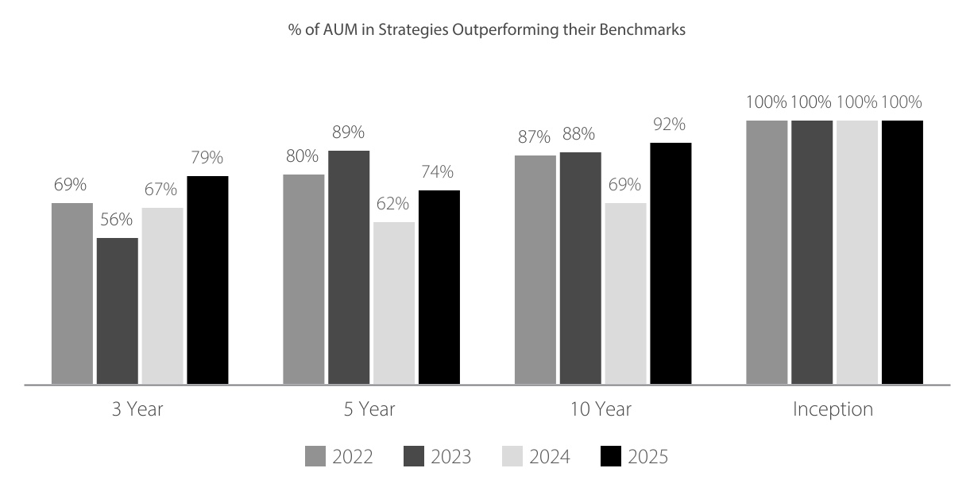
Represents the percentage of our assets under management managed in strategies for which the average annual gross composite return exceeded the strategy's respective benchmark. Performance is measured for the average annual periods ended on the indicated dates. Includes assets under management in all strategies in operation throughout the indicated period.
During 2025, our assets under management increased to $179.9 billion, an increase of $18.7 billion, or 11.6%, compared to $161.2 billion at December 31, 2024. Average assets under management for 2025 were $173.0 billion, an increase of 8.0% from the average of $160.2 billion for the prior year. Tracking
33

the increase in average assets under management, we earned $1,196.7 million in revenue for 2025, a 7.6% increase from revenues of $1,111.8 million for 2024. Adjusted operating margin improved to 35.3%
In 2025, we experienced an increase in net client cash outflows year-over-year, driven primarily by our Global Opportunities, U.S. Mid-Cap Growth and Non-U.S. Small-Mid Growth strategies. However, our credit and alternative asset classes each generated net inflows and we continued to make progress towards expanding the breadth and depth of our platforms into those asset classes in 2025. In addition, long-term investment performance across our platform remained strong.
Based on the process described above, the Compensation Committee determined the total amount of performance-based compensation for each NEO as follows:
Name |  |  | 2025 Total Performance-Based  Compensation ($)
Jason A. Gottlieb |  |  | $5,191,614
Eric R. Colson |  |  | $6,713,708
Charles J. Daley, Jr. |  |  | $2,676,439
Christopher J. Krein |  |  | $2,728,470
Eileen L. Kwei |  |  | $2,218,070
Samuel B. Sellers |  |  | $2,336,631
Over the years, this process has ensured that executive compensation is aligned with the firm's operating and financial results and is appropriate in light of prevailing market and economic conditions impacting our business. Given how rapidly these conditions can change, and the sensitivity of our results to any such change, it is critical to retain the ability to make well-reasoned, timely adjustments—without being constrained by predetermined formulas. Our proven approach gives the Compensation Committee the measured discretion needed to recalibrate compensation when necessary, and past practice shows it produces outcomes that are well aligned with performance and appropriate in light of then-current conditions.
Determine Mix of Performance-Based Pay ü
Once the amount of performance-based compensation was set, the Compensation Committee determined the appropriate mix of equity and cash for each executive officer. In making this determination, the Compensation Committee considered (i) the amount of equity available to be granted to executive officers and (ii) the alignment of executive officers’ interests with the firm’s clients, stockholders and key investment professionals.
34

The amount of equity available to be granted to executive officers is impacted by the firm’s long-standing philosophy on the allocation of long-term incentive awards. Artisan Partners is a people business. The firm’s success is dependent upon the talented investment professionals who manage its investment strategies and have been primarily responsible for the strong investment returns achieved for clients. Therefore, we believe it is critically important that we provide compensation that attracts, motivates and retains these investment professionals and aligns their long-term economics with those of the firm’s clients and stockholders in a way that is sustainable over time. To that end, the vast majority of long-term incentive awards (generally 85% to 90%) are awarded to the firm’s investment professionals—none of whom are executive officers. The remaining award, in the form of equity, is then allocated to key leaders and members of the firm’s management team, including the executive officers. |  |  |  |  |  | Annual Long-Term Incentive Award  Our annual long-term incentive award consists of equity-based awards (described below) and franchise capital awards. Franchise capital awards are cash awards granted to investment professionals that are subject to the same long-term vesting and forfeiture provisions as our equity-based awards. Prior to vesting, franchise capital awards are generally invested in one or more of the investment strategies managed by the grantee’s investment team, thereby enhancing the alignment between our investment professionals and clients. When determining the size of the annual long-term incentive award, we first establish the amount of the investment teams' franchise capital award, which we currently expect to equal approximately 4% of the prior year's management fee revenue, in the aggregate. The balance of the long-term incentive award—an amount that is largely determined by the firm's performance—consists of equity-based awards granted to certain of our associates, including certain investment team professionals, executive officers, and other key leaders.
This approach results in a limited amount of equity available to be granted to executive officers each year and, generally, a larger proportion of performance-based compensation being paid in cash. This outcome has several advantages. Receiving a significant performance-based cash award each year mitigates the incentives executive officers may otherwise have to sell equity upon vesting for liquidity or tax reasons. Instead, the majority of equity awards continue to be held by executive officers long after they vest. In addition, larger performance-based cash bonuses provide executive officers with the capital required to make meaningful investments in the firm’s investment strategies—a practice that is strongly encouraged in order to increase alignment with clients and investment professionals.
The Compensation Committee believes that executive officers should hold a significant amount of equity in the firm relative to their total annual compensation and that a substantial portion of that equity should remain at risk throughout their career with the firm. The amount of equity considered significant varies for each executive officer depending on his or her specific circumstances and it may take a number of years for an executive to reach an amount that is truly significant. Executive officers with a long tenure at the firm already have a significant amount of equity at risk given the long-duration nature of the firm’s equity awards. When allocating equity, such an executive officer may receive a larger proportion of their annual performance-based compensation as a cash award so that a larger amount of equity can be awarded to those executive officers that are still building an equity stake in the firm.
The Compensation Committee determined that 31% of Mr. Gottlieb’s and 29% of Mr. Colson’s 2025 performance-based compensation would be awarded in equity, with the balance paid in cash. For the other NEOs, the percentage of performance-based compensation awarded in equity ranged from 32% to 37% with the balances paid in cash.
In January 2026, the Compensation Committee recommended, and the Board approved, an aggregate long-term incentive award with a grant date fair value of approximately $71.8 million, consisting of $21.2
35

million of equity-based awards and $50.6 million of franchise capital awards exclusively for investment professionals. The equity portion of the long-term incentive award consisted of 481,623 restricted share-based awards, of which a total of 155,252 awards (10% of the total long-term incentive award and 32% of the total equity grant) were awarded to our NEOs. The balance of each NEO’s performance-based compensation was paid in cash in February 2026.
 |  |  | Equity Award
 |  |  | Standard Award ($) |  |  |  |  |  | Career Award ($) |  |  |  |  |  | Performance-Based Cash Award ($) |  |  |  |  |  | Total Performance-Based Compensation ($)
Jason A. Gottlieb |  |  | 810,807 |  |  |  |  |  | 810,807 |  |  |  |  |  | 3,570,000 |  |  |  |  |  | 5,191,614
Eric R. Colson |  |  | 976,354 |  |  |  |  |  | 976,354 |  |  |  |  |  | 4,761,000 |  |  |  |  |  | 6,713,708
Charles J. Daley, Jr. |  |  | 427,344 |  |  |  |  |  | 427,344 |  |  |  |  |  | 1,821,750 |  |  |  |  |  | 2,676,438
Christopher J. Krein |  |  | 501,610 |  |  |  |  |  | 501,610 |  |  |  |  |  | 1,725,250 |  |  |  |  |  | 2,728,470
Eileen L. Kwei |  |  | 353,035 |  |  |  |  |  | 353,035 |  |  |  |  |  | 1,512,000 |  |  |  |  |  | 2,218,070
Samuel B. Sellers |  |  | 344,065 |  |  |  |  |  | 344,065 |  |  |  |  |  | 1,648,500 |  |  |  |  |  | 2,336,630
Our equity awards are described in more detail within “Elements of Our Named Executive Officers’ Compensation”.
Skin in the Game
In addition to having significant equity in the firm, Artisan’s executive officers have historically made, and continue to make, significant investments of their own after-tax capital in the strategies managed by the firm’s investment teams. We encourage these investments because we believe that it further aligns executive officers' financial interests with those of the clients that invest in Artisan’s investment strategies and the investment professionals that are responsible for the strategies’ success. Furthermore, the firm relies upon executive officers’ investments to provide seed capital that supports the launch of new strategies and products. These early investments in new investment strategies and products demonstrate management’s conviction in the firm’s talented investment professionals and the investment performance we believe they can achieve.
Through ownership of both equity in the firm and investments in Artisan’s strategies, executive officers generally have a considerable amount of their net worth invested in the success of the firm. This exposure to firm equity and Artisan investments together result in significant skin in the game.

PAYOUT OF PERFORMANCE SHARE UNITS GRANTED IN 2022
During the first quarter of 2025, the Compensation Committee assessed the achievement of the performance conditions with respect to the 35,976 performance share units granted to each of Mr. Colson and Mr. Gottlieb and the 23,988 performance share units granted to Mr. Krein in 2022. The Compensation Committee determined that each of the service, relative adjusted operating margin, and relative total shareholder return conditions were met for the January 1, 2022 through December 31, 2024 performance period and therefore 53,964, or 150%, of the PSUs granted to each of Mr. Colson and Mr. Gottlieb, and 35,982, or 150%, of the PSUs granted to Mr. Krein, became eligible to vest. One-half of the eligible PSUs, or 26,982 for each of Mr. Colson and Mr. Gottlieb and 17,991 for Mr. Krein, vested and the underlying shares were delivered in February 2025. The remaining one-half of the PSUs remain subject to career vesting conditions that, with certain exceptions, means the PSUs will vest and the underlying shares will be delivered only upon a qualifying retirement as described below. See “Compensation Discussion and Analysis—Elements of our Named Executive Officers’ Compensation” for a detailed description of the PSUs. The Compensation Committee does not consider the vesting and payout of PSUs granted in 2022 to be compensation with respect to 2025.

36

ELEMENTS OF OUR NAMED EXECUTIVE OFFICERS' COMPENSATION
The elements of our NEO compensation program include:

Pay Element |  |  | Type |  |  | Purpose
Fixed Base Salary |  |  | Cash |  |  | ▪Provide a degree of financial certainty and stability that does not depend on performance
Variable Performance-Based Compensation |  |  | Equity Award |  |  | ▪Incent and reward long-term value creation and sustainable growth  ▪Enhance the alignment of executive officers’ interests with interests of long-term stockholders  ▪Encourage retention and well-planned succession with career vesting awards
 |  |  | Cash Award |  |  | ▪Incent and reward long-term value creation and sustainable growth  ▪Provide a source of capital for executive officers' investments in the firm's investment strategies, which aligns executives' interests with those of clients and investment professionals

Base Salary
Our NEOs’ base salaries represent a relatively small portion of their overall total direct compensation. We believe that the majority of their pay should be variable and based on performance.
For 2025, the base salary for our executive officers was $300,000, except for Mr. Colson, whose base salary was reduced from $500,000 to $300,000 effective upon his transition to Executive Chair in June 2025. These base salaries are below the peer median and have not been increased since 2018. Throughout the firm’s history, executive salaries have only been increased one time—the 2018 increase.

Performance-Based Compensation—Equity Awards
Equity awards are determined after the end of each year consistent with the process detailed above.
The equity granted to our NEOs is subject to long-term time vesting conditions and generally one-half of all equity awarded to our NEOs is further subject to career vesting conditions.  Subjecting one-half of each equity award to career vesting conditions results, over the long-term, in a substantial portion of executive officers’ equity being at risk for the duration of their career. This result is achieved while issuing fewer shares to executives, resulting in less dilution for the firm’s stockholders. |  |  |  |  |  | The firm’s pre-IPO equity interests illustrated the benefits of a keen focus on long-term interest alignment, advance notice of retirement to facilitate well-planned succession, and a deeply ingrained equity ownership mindset. Therefore, since the firm’s IPO, long-term incentives have been designed with those features in mind.
The Case for Career Awards
Relative to the typical equity awards used by public companies, we believe our career awards provide much better alignment of executive officers’ long-term financial interests with those of the firm’s clients and stockholders. To illustrate, assume our CEO receives a $1 million equity award each year, with one-half of each award subject to career vesting terms and the other half subject to a five-year time-vesting schedule. Assume the CEO of a hypothetical peer also receives a $1 million equity award over the same time period, but subject only to a three-year time-vesting condition, which is generally the average vesting period amongst our public company peers. At year five, our CEO has over $4.2 million of equity at risk,
37

while the CEO of the hypothetical peer has less than $2.1 million at risk. At year ten, the CEO of the hypothetical peer still has less than $2.1 million at risk, while our CEO has nearly $7.3 million at risk.

 |  |  | Total Equity at Risk
 |  |  | Year One |  |  | Year Two |  |  | Year Three |  |  | Year Four |  |  | Year Five |  |  | ... |  |  | Year Ten
Artisan |  |  | $1.00 |  |  | $1.93 |  |  | $2.78 |  |  | $3.54 |  |  | $4.22 |  |  | ... |  |  | $7.29
% of total compensation |  |  | 14% |  |  | 28% |  |  | 40% |  |  | 51% |  |  | 60% |  |  |  |  |  | 104%
Hypothetical Peer |  |  | $1.00 |  |  | $1.69 |  |  | $2.04 |  |  | $2.04 |  |  | $2.04 |  |  | ... |  |  | $2.04
% of total compensation |  |  | 14% |  |  | 24% |  |  | 29% |  |  | 29% |  |  | 29% |  |  |  |  |  | 29%
Dollars in millions. Equity at risk assumes a 3% growth rate. Percent of total compensation assumes total annual compensation of $7 million.

Although our hypothetical peer may award more equity as a percentage of total annual compensation, its CEO is incentivized to manage for short-term results and to mitigate their exposure to risk by selling equity as it vests. Conversely, our relatively smaller equity awards that are subject to career vesting terms incentivize our CEO (and other executive officers) to manage for the creation of sustainable, long-term value. And our relatively larger performance-based cash awards may mitigate their incentives to sell equity upon vesting for liquidity reasons and provide executives with the capital required to make meaningful after-tax investments in Artisan’s investment strategies.
We believe our career vesting awards are the ultimate performance-based awards given the long-duration alignment created. Our continued use of these awards illustrates the unique and differentiated way in which we approach executive compensation—avoiding generic "check-the-box" exercises in favor of a tailored approach that remains true to our long-term orientation and the fundamental principles that represent Who We Are.
38

Restricted Stock. Restricted stock awarded to our NEOs consists of standard restricted shares and career shares. Our standard restricted shares vest pro-rata over the five years following the year of grant, subject to continued employment. With certain exceptions, career shares will only vest once they have become eligible to vest and a qualifying retirement occurs, as follows:
▪Vesting Eligibility: 20% of each career share award becomes eligible to vest in each of the five years following the year of grant.
▪Qualifying Retirement: Requires that the award recipient (i) has been employed by us for at least 10 years at the time of retirement; (ii) has provided, for NEOs, 18 months’ notice of retirement (subject to our right to accept a shorter period of notice); and (iii) has remained at the Company through the retirement notice period.
If a NEO has a qualifying retirement (as described above) and has attained a combination of years of service plus age of at least 70 as of the retirement date, the restricted stock granted in January 2024 and any subsequent years will vest, without regard to the pro rata vesting eligibility condition detailed above. Career shares and standard restricted shares will also vest upon a termination of employment due to death or disability and after a change in control if the Company terminates a NEO without cause or they resign for good reason, in either case, within two years of the change in control. In addition, after the fifth anniversary of the grant date, if the Company terminates an award recipient without cause, eligible career shares will vest, provided that the recipient has at least 10 years of service with the Company at the time of termination.
Performance Share Units (PSUs). Certain of our NEOs received PSUs in 2020, 2021 and 2022 in lieu of restricted stock awards. PSUs had a three-year performance period, after which achievement of the performance conditions was assessed by the Compensation Committee.
PSUs were eligible to vest if performance conditions were met, as determined by the Compensation Committee after completion of the performance period, as follows:
▪50% of the PSUs were eligible to vest if the recipient remained employed by Artisan through the performance period.
▪100% of the PSUs were eligible to vest if the recipient satisfied the service condition and either (i) the firm’s adjusted operating margin during the performance period exceeded the median for a defined peer group2 or (ii) the firm’s total shareholder return during the performance period exceeded the median of the peer group.
▪150% of the PSUs were eligible to vest if the recipient satisfied the service condition and both the adjusted operating margin and total shareholder return performance conditions.
Once the Compensation Committee determined the number of PSUs that were eligible to vest with respect to a performance period, one-half of the total PSUs eligible to vest did vest and the underlying shares were delivered. The other half of PSUs eligible to vest remained subject to career vesting conditions that, with certain exceptions, means the PSUs will vest and the underlying shares will be delivered only upon a qualifying retirement as described above with respect to career shares.
Similar to the restricted stock, PSUs also vest upon a termination of employment due to death or disability and after a change in control if the Company terminates a NEO without cause or they resign for good reason, in either case, within two years of the change in control. In addition, after the fifth anniversary of the grant date, if the Company terminates an award recipient without cause, all of their remaining career
2 For purposes of the PSU performance conditions, “adjusted operating margin” represented adjusted (non-GAAP) operating margin, if reported. If adjusted operating margin was not reported, GAAP margin was used. If no operating margin was reported, consolidated revenues and consolidated expenses were used to calculate an operating margin. Additional adjustments were made to the calculation of adjusted operating margin by the Compensation Committee as needed to improve the comparability amongst Artisan and the peer group. Adjusted measures are non-GAAP measures. See Annex A for the Company's non-GAAP reconciliations.
39

PSUs will vest, provided that the recipient has at least 10 years of service with the Company at the time of termination.
The peer group for purposes of the 2022 PSUs, which vested or became eligible to vest in 2025, consisted of the following publicly traded asset management companies.
AllianceBernstein |  |  | Franklin Resources |  |  | T. Rowe Price Group
Affiliated Managers Group |  |  | Invesco |  |  | Victory Capital
BlackRock |  |  | Janus Henderson Investors |  |  | Virtus Investment Partners
Federated Hermes |  |  | Lazard
The peer group identified above is different from the executive reference group assembled by McLagan, the compensation consultant, which includes both public and private firms.
Partnership Units. From time to time, the Board may approve an award of Class B limited partnership units of Artisan Partners Holdings LP (together with a corresponding number of Class B shares of the Company, which have no economic value but carry voting rights) to certain associates in connection with being designated partners of the firm. We believe the partner designation reinforces an ownership mindset, strengthens alignment and further supports retention.
Because partnership units are used primarily to confer partner status, they generally vest upon grant and are subject to a minimum holding period. Partnership unit awards typically comprise a relatively small portion of an associate’s equity award, with the remaining equity issued as restricted stock. One-half of an associate’s aggregate equity award, including any partnership unit awards, is subject to career vesting.
We intend to continue to grant annual equity awards to our NEOs. However, the size and structure of the equity awards previously granted may not be indicative of future awards. We generally expect that one-half of the equity awarded to our NEOs will continue to include career vesting conditions.
Performance-Based Incentive Plan Compensation—Cash Award
As described in detail above under “2025 Executive Compensation Process and Decisions”, each year the Compensation Committee first considers the amount of performance-based incentive plan compensation for each executive officer after assessing the achievement of the firm’s key priorities and aligning performance-based compensation amounts with the Company’s financial and operating results. The amount of equity available to be awarded to each executive officer is determined and the balance of performance-based incentive plan compensation for each executive officer is paid as a performance-based cash award.
Retirement Benefits
We believe that providing a cost-effective retirement benefit for the Company’s employees is an important recruitment and retention tool. Accordingly, the Company maintains, and each of the NEOs participates in, a contributory defined contribution retirement plan for all U.S.-based employees, and matches 100% of each employee’s contributions (other than catch-up contributions by employees age 50 and older) up to the annual limit which, for 2025, was $23,500. We also maintain retirement plans or make retirement plan contributions (or equivalent cash payments) for our employees based outside the U.S. The opportunity to participate in a retiree health plan, at the sole expense of the retiree, is available to employee-partners and career share award recipients who have at least 10 years of service with us at the time of retirement.
Other Benefits
Our NEOs participate in the employee health and welfare benefit programs we maintain, including medical, group life and long-term disability insurance, and health care savings accounts, on the same basis as all U.S. employees, subject to satisfying any eligibility requirements and applicable law. We also
40

generally provide employer-paid parking or transit assistance and, for our benefit and convenience, on-site food and beverages, benefits which our NEOs enjoy on the same terms as all of our employees.

OTHER COMPENSATION POLICIES AND PRACTICES
Equity Ownership Guidelines. Executive officers are expected to own shares of the Company’s common stock and Class B partnership units of Artisan Partners Holdings LP, in the aggregate, equal in value to a multiple of their base salary. For the Chief Executive Officer, the multiple is eight times base salary and for all other executive officers, the multiple is three times base salary. Any individual becoming an executive officer will have a period of five years from the time of his or her designation as an executive officer to comply with the guidelines. As of December 31, 2025, each of our NEOs held equity in excess of their base salary as follows: 35 times base salary for Mr. Gottlieb; 118 times base salary for Mr. Colson; 21 times base salary for Mr. Daley; 18 times base salary for Mr. Krein; 9 times base salary for Ms. Kwei; and 6 times base salary for Mr. Sellers.
Compensation Recovery Policy. The Board maintains a Compensation Recovery Policy, which provides for the mandatory recovery of erroneously awarded incentive-based compensation following accounting restatements from persons who served as an executive officer of the Company at any time during the performance period for such incentive-based compensation and who received such compensation during the three fiscal years preceding the date on which the Company is required to prepare an accounting restatement. The incentive-based compensation to be recovered is the amount in excess of what otherwise would have been paid based on the restated results. Recovery will be required on a “no fault” basis, without regard to whether any misconduct occurred and without regard to whether an executive officer was responsible for the erroneous financial statements.
Hedging and Pledging Policies. Our code of ethics and insider trading policies prohibit our directors and employees, including our executive officers, from engaging in hedging transactions involving any derivative security relating to Company securities, whether or not the instrument is issued by the Company. Our directors and employees are also restricted from pledging Company securities when they are in possession of material, nonpublic information or otherwise are not permitted to trade in Company securities, such as during any black-out period.

RISK MANAGEMENT AND OUR COMPENSATION PROGRAM
We have identified two primary risks relating to compensation: the risk that compensation will not be sufficient in amount or appropriately structured to attract and to retain talent, and the risk that compensation may provide unintended short-term incentives. To combat the risk that our compensation might not be sufficient or be inappropriately structured, we strive to use a compensation structure, and set compensation levels, for all employees in a way that we believe promotes retention. To avoid unintended short-term incentives, we make equity awards subject to multi-year vesting schedules and, for certain employees (including all of our NEOs), provide for career vesting conditions on one-half of the equity awards received. In addition, our executive officers are subject to equity ownership guidelines and a compensation recovery policy. We believe that both the structure and levels of compensation have aided us in attracting and retaining key personnel. And we believe that the long duration nature of our equity awards prioritizes long-term value creation and sustainable growth. We have not seen any employee behaviors motivated by our compensation policies and practices that create increased risks for our stockholders.
Based on the foregoing, we do not believe that our compensation policies and practices motivate imprudent risk taking. Consequently, we are satisfied that any potential risks arising from our employee compensation policies and practices are not reasonably likely to have a material adverse effect on the Company. Our Compensation Committee will continue to monitor the effects of its compensation decisions to determine whether risks are being appropriately managed.

41

COMPENSATION COMMITTEE REPORT
The Compensation Committee has reviewed and discussed the Compensation Discussion and Analysis required by Item 402(b) of Regulation S-K with management and, based upon such review and discussion, has recommended to the Board that the Compensation Discussion and Analysis be included in the Company’s proxy statement and incorporated by reference into the Company’s Annual Report on Form 10-K for the year ended December 31, 2025.

Compensation Committee:
Jeffrey A. Joerres, Chair
Jennifer A. Barbetta
Kane Brenan

42

Executive Compensation Tables

SUMMARY COMPENSATION TABLE
The following table provides information regarding the compensation of each of our NEOs. Applicable SEC rules require that for purposes of the Summary Compensation Table, the value of an equity award be reported in the year of grant rather than the year with respect to which the award was made. Accordingly, stock awards reported for 2025, 2024 and 2023 reflect the awards made in January of each of those years. Because we consider the value of the equity awards we make each January to be a part of each NEO’s compensation for the prior year, we have included those values in the row for the prior year in the table at the beginning of the Compensation Discussion and Analysis, as well as in the table immediately following the Summary Compensation Table.
Name & Principal Position |  |  | Year |  |  | Salary ($) |  |  | Stock Awards ($) (1) |  |  | Non-Equity Incentive Plan Compensation ($) (2) |  |  | All Other Compensation ($) (3) |  |  | Total ($)
Jason A. Gottlieb  Chief Executive Officer |  |  | 2025 |  |  | 300,000 |  |  | 1,548,400 |  |  | 3,570,000 |  |  | 63,736 |  |  | 5,482,136
 |  |  | 2024 |  |  | 300,000 |  |  | 1,506,868 |  |  | 3,400,000 |  |  | 63,127 |  |  | 5,269,995
 |  |  | 2023 |  |  | 300,000 |  |  | 1,413,596 |  |  | 3,200,000 |  |  | 56,524 |  |  | 4,970,120
Eric R. Colson  Executive Chair |  |  | 2025 |  |  | 385,000 |  |  | 1,891,879 |  |  | 4,761,000 |  |  | 206,376 |  |  | 7,244,255
 |  |  | 2024 |  |  | 500,000 |  |  | 1,506,868 |  |  | 4,600,000 |  |  | 182,741 |  |  | 6,789,609
 |  |  | 2023 |  |  | 500,000 |  |  | 1,994,080 |  |  | 4,000,000 |  |  | 176,205 |  |  | 6,670,285
Charles J. Daley, Jr.  Chief Financial Officer |  |  | 2025 |  |  | 300,000 |  |  | 816,493 |  |  | 1,821,750 |  |  | 117,980 |  |  | 3,056,223
 |  |  | 2024 |  |  | 300,000 |  |  | 808,653 |  |  | 1,735,000 |  |  | 114,600 |  |  | 2,958,253
 |  |  | 2023 |  |  | 300,000 |  |  | 805,540 |  |  | 1,613,000 |  |  | 102,441 |  |  | 2,820,981
Christopher J. Krein  Head of Global Distribution |  |  | 2025 |  |  | 300,000 |  |  | 995,754 |  |  | 1,725,250 |  |  | 61,696 |  |  | 3,082,700
 |  |  | 2024 |  |  | 300,000 |  |  | 889,048 |  |  | 1,675,000 |  |  | 60,169 |  |  | 2,924,217
 |  |  | 2023 |  |  | 300,000 |  |  | 884,127 |  |  | 1,650,000 |  |  | 56,060 |  |  | 2,890,187
Eileen L. Kwei  Chief Administrative Officer |  |  | 2025 |  |  | 300,000 |  |  | 697,045 |  |  | 1,512,000 |  |  | 63,527 |  |  | 2,572,572
 |  |  | 2024 |  |  | 300,000 |  |  | 622,854 |  |  | 1,340,000 |  |  | 60,247 |  |  | 2,323,101
 |  |  | 2023 |  |  | 300,000 |  |  | 619,883 |  |  | 1,250,000 |  |  | 58,621 |  |  | 2,228,504
Samuel B. Sellers  Chief Operating  Officer (4) |  |  | 2025 |  |  | 300,000 |  |  | 627,323 |  |  | 1,648,500 |  |  | 60,370 |  |  | 2,636,193
(1) Amounts reported represent the grant date fair value of the equity granted to each NEO in the year indicated. The values reported for restricted shares represent the grant date fair value in accordance with FASB ASC Topic 718 based upon the price of our common stock at the grant date. See the Grants of Plan-Based Awards During 2025 table for more information about the equity awards granted in 2025.
(2) Amounts earned by our NEOs for 2025, 2024 and 2023 were paid in February 2026, February 2025 and February 2024, respectively. See the Grants of Plan-Based Awards During 2025 table below for more information about the 2025 cash awards.
(3) Amounts in this column represent the aggregate dollar amount of all other compensation received by our NEOs. All other compensation includes, but is not limited to (a) Company matching contributions to contributory defined contribution plan accounts equal to 100% of their pre-tax contributions (excluding catch-up contributions for NEOs age 50 and older) up to the limitations imposed under applicable tax rules, which contributions totaled $23,500 for each NEO in 2025; (b) health and vision insurance premiums and HSA contributions paid by the Company for plans that are offered to all eligible employees on a nondiscriminatory basis in the aggregate amount of approximately $36,000 for each NEO in 2025; and (c) reimbursement for 2025 self-employment payroll tax expense as follows: $136,720 for Mr. Colson and $56,362 for Mr. Daley and (d) costs incurred by the company for family travel to Artisan events. In 2025, family airfare cost for Mr. Colson was $10,085. Each of the NEOs invest, from time to time, in funds managed by an affiliate of the Company on terms described under Relationships and Related Party Transactions—Investments in our Funds.
(4) Mr. Sellers became a NEO in 2025. Amounts for 2024 and 2023 have therefore been omitted.

43

As noted above, the Summary Compensation Table reflects the value of the equity awarded to each NEO in the year in which it was granted, as required by SEC disclosure rules. The supplemental table below reflects the value of the equity awarded to each NEO for the year with respect to which it was granted.
Name |  |  | Year |  |  | Salary ($) |  |  | Stock Awards ($) (1) |  |  | Non-Equity Incentive Plan Compensation ($) |  |  | All Other Compensation ($) |  |  | Total ($)
Jason A. Gottlieb |  |  | 2025 |  |  | 300,000 |  |  | 1,621,614 |  |  | 3,570,000 |  |  | 63,736 |  |  | 5,555,350
 |  |  | 2024 |  |  | 300,000 |  |  | 1,548,400 |  |  | 3,400,000 |  |  | 63,127 |  |  | 5,311,527
 |  |  | 2023 |  |  | 300,000 |  |  | 1,506,868 |  |  | 3,200,000 |  |  | 56,524 |  |  | 5,063,392
Eric R. Colson |  |  | 2025 |  |  | 385,000 |  |  | 1,952,708 |  |  | 4,761,000 |  |  | 206,376 |  |  | 7,305,084
 |  |  | 2024 |  |  | 500,000 |  |  | 1,891,879 |  |  | 4,600,000 |  |  | 182,741 |  |  | 7,174,620
 |  |  | 2023 |  |  | 500,000 |  |  | 1,506,868 |  |  | 4,000,000 |  |  | 176,205 |  |  | 6,183,073
Charles J. Daley, Jr. |  |  | 2025 |  |  | 300,000 |  |  | 854,689 |  |  | 1,821,750 |  |  | 117,980 |  |  | 3,094,419
 |  |  | 2024 |  |  | 300,000 |  |  | 816,493 |  |  | 1,735,000 |  |  | 114,600 |  |  | 2,966,093
 |  |  | 2023 |  |  | 300,000 |  |  | 808,653 |  |  | 1,613,000 |  |  | 102,441 |  |  | 2,824,094
Christopher J. Krein |  |  | 2025 |  |  | 300,000 |  |  | 1,003,220 |  |  | 1,725,250 |  |  | 61,696 |  |  | 3,090,166
 |  |  | 2024 |  |  | 300,000 |  |  | 995,754 |  |  | 1,675,000 |  |  | 60,169 |  |  | 3,030,923
 |  |  | 2023 |  |  | 300,000 |  |  | 889,048 |  |  | 1,650,000 |  |  | 56,060 |  |  | 2,895,108
Eileen L. Kwei |  |  | 2025 |  |  | 300,000 |  |  | 706,070 |  |  | 1,512,000 |  |  | 63,527 |  |  | 2,581,597
 |  |  | 2024 |  |  | 300,000 |  |  | 697,045 |  |  | 1,340,000 |  |  | 60,247 |  |  | 2,397,292
 |  |  | 2023 |  |  | 300,000 |  |  | 622,854 |  |  | 1,250,000 |  |  | 58,621 |  |  | 2,231,475
Samuel B. Sellers |  |  | 2025 |  |  | 300,000 |  |  | 688,131 |  |  | 1,648,500 |  |  | 60,370 |  |  | 2,697,001
(1) Represents equity awarded with respect to each of fiscal years 2025, 2024 and 2023. Equity awards granted to the NEOs in January 2026 with respect to 2025 consisted of a 50/50 mix of standard restricted shares and career shares. Ms. Kwei and Mr. Sellers each received $100,000 of Class B partnership units of Artisan Partners Holdings LP, which proportionately reduced the amount of standard restricted shares they otherwise would have received.

44

GRANTS OF PLAN-BASED AWARDS DURING 2025
The following table provides information regarding plan-based awards granted to each of our NEOs in the year ended December 31, 2025. In accordance with SEC rules, the table does not include equity awards that were granted in 2026, which we consider to be part of 2025 compensation. See above for information regarding those awards.
 |  |  |  |  |  | Estimated Future Payouts Under Non-Equity Incentive Plan Awards (1) |  |  |  |  |  |  |  |  |  |  |  | All Other Stock Awards: Number of Shares of Stock or Units (#) (2) |  |  | Grant Date Fair Value of Stock Awards ($) (3)
Name |  |  | Grant Date |  |  | Threshold ($) |  |  | Target ($) |  |  | Maximum ($)
Jason A. Gottlieb |  |  |  |  |  | — |  |  | 3,400,000 |  |  | 9,896,800
 |  |  | 1/29/2025 |  |  |  |  |  |  |  |  |  |  |  |  |  |  | 35,000 |  |  | 1,548,400
Eric R. Colson |  |  |  |  |  | — |  |  | 4,600,000 |  |  | 12,983,760
 |  |  | 1/29/2025 |  |  |  |  |  |  |  |  |  |  |  |  |  |  | 42,764 |  |  | 1,891,879
Charles J. Daley, Jr. |  |  |  |  |  | — |  |  | 1,735,000 |  |  | 5,102,986
 |  |  | 1/29/2025 |  |  |  |  |  |  |  |  |  |  |  |  |  |  | 18,456 |  |  | 816,493
Christopher J. Krein |  |  |  |  |  | — |  |  | 1,675,000 |  |  | 5,341,508
 |  |  | 1/29/2025 |  |  |  |  |  |  |  |  |  |  |  |  |  |  | 22,508 |  |  | 995,754
Eileen L. Kwei |  |  |  |  |  | — |  |  | 1,340,000 |  |  | 4,074,090
 |  |  | 1/29/2025 |  |  |  |  |  |  |  |  |  |  |  |  |  |  | 15,756 |  |  | 697,045
Samuel B. Sellers |  |  |  |  |  | — |  |  | 1,320,000 |  |  | 3,894,646
 |  |  | 1/29/2025 |  |  |  |  |  |  |  |  |  |  |  |  |  |  | 14,180 |  |  | 627,323
(1) The Compensation Committee granted the 2025 non-equity incentive plan awards under the Cash Incentive Compensation Plan. Under the Plan, in January 2025, the Board approved strategic objectives and key priorities for the executive officers and the Compensation Committee established (i) a maximum amount of performance-based compensation for executive officers as a group and (ii) a maximum performance-based cash incentive award for each executive officer. When determining 2025 performance-based compensation amounts, the Compensation Committee applied negative discretion to the maximum cash incentive award amounts after assessing the achievement of key priorities and aligning performance-based compensation amounts with the Company’s financial and operating results. The amount of performance-based compensation not awarded in equity was then paid as a cash award under the Plan. See “Compensation Discussion and Analysis—2025 Executive Compensation Process and Decisions” for more information. The Compensation Committee has the ability to award no bonus under the Plan, therefore there is no minimum or threshold amount payable even if all key priorities are accomplished. The target amount reflects the prior year's payout amount. Actual amounts are reported in the Summary Compensation Table.
(2) Represents the number of restricted shares of our Class A common stock granted in 2025. One-half of each award consisted of standard restricted shares and the other half consisted of career shares. Standard restricted shares vest pro-rata over the five years following the year of grant, subject to continued employment. With certain exceptions, career shares will only vest once they have become eligible to vest and a qualifying retirement occurs. See “Compensation Discussion and Analysis—Elements of our Named Executive Officers' Compensation” for additional information regarding the vesting conditions, including circumstances in which vesting may be accelerated. Restricted shares of Class A common stock entitle the holder to dividends, which are paid at the same time, and in the same amounts, as dividends are paid on our other outstanding shares of Class A common stock.
(3) In accordance with FASB ASC Topic 718, grant date fair value of restricted stock awards is computed based upon the price of our common stock at the grant date.

45

OUTSTANDING EQUITY AWARDS AT DECEMBER 31, 2025
The following table provides information about the outstanding unvested equity awards held by each of our NEOs as of December 31, 2025.
Name |  |  | Number of Shares or Units of Stock That Have Not Vested (#) (1) |  |  | Market Value of Shares or Units of Stock That Have Not Vested ($) (2)
Jason A. Gottlieb |  |  | 189,854 |  |  | 7,734,652
Eric R. Colson |  |  | 235,486 |  |  | 9,593,700
Charles J. Daley, Jr. |  |  | 91,163 |  |  | 3,713,981
Christopher J. Krein |  |  | 94,941 |  |  | 3,867,896
Eileen L. Kwei |  |  | 53,397 |  |  | 2,175,394
Samuel B. Sellers |  |  | 40,529 |  |  | 1,651,151
(1) Includes (i) unvested restricted shares of Class A common stock and (ii) PSUs that have met the requisite performance conditions but remained subject to a qualifying retirement vesting condition.

Name |  |  | Vest Date |  |  | Restricted Stock (#) |  |  | Performance Share Units (#)
Jason A. Gottlieb |  |  | February 2026 |  |  | 11,131
 |  |  | February 2027 |  |  | 11,131
 |  |  | February 2028 |  |  | 11,131
 |  |  | February 2029 |  |  | 7,092
 |  |  | February 2030 |  |  | 3,500
 |  |  | Qualified Retirement |  |  | 82,281 |  |  | 63,588
Eric R. Colson |  |  | February 2026 |  |  | 13,566
 |  |  | February 2027 |  |  | 13,566
 |  |  | February 2028 |  |  | 13,567
 |  |  | February 2029 |  |  | 7,868
 |  |  | February 2030 |  |  | 4,277
 |  |  | Qualified Retirement |  |  | 119,054 |  |  | 63,588
Charles J. Daley, Jr. |  |  | February 2026 |  |  | 8,694
 |  |  | February 2027 |  |  | 7,754
 |  |  | February 2028 |  |  | 6,075
 |  |  | February 2029 |  |  | 3,774
 |  |  | February 2030 |  |  | 1,846
 |  |  | Qualified Retirement |  |  | 63,020
Christopher J. Krein |  |  | February 2026 |  |  | 6,896
 |  |  | February 2027 |  |  | 6,897
 |  |  | February 2028 |  |  | 6,897
 |  |  | February 2029 |  |  | 4,370
 |  |  | February 2030 |  |  | 2,251
 |  |  | Qualified Retirement |  |  | 42,599 |  |  | 25,031
46

Name |  |  | Vest Date |  |  | Restricted Stock (#) |  |  | Performance Share Units (#)
Eileen L. Kwei |  |  | February 2026 |  |  | 8,962
 |  |  | February 2027 |  |  | 7,836
 |  |  | February 2028 |  |  | 4,831
 |  |  | February 2029 |  |  | 3,061
 |  |  | February 2030 |  |  | 1,576
 |  |  | Qualified Retirement |  |  | 27,131
Samuel B Sellers |  |  | February 2026 |  |  | 5,558
 |  |  | February 2027 |  |  | 4,618
 |  |  | February 2028 |  |  | 3,548
 |  |  | February 2029 |  |  | 2,496
 |  |  | February 2030 |  |  | 1,418
 |  |  | Qualified Retirement |  |  | 22,891
(2) Awards were valued based on the closing price of our Class A common stock on the NYSE on December 31, 2025, which was $40.74.

EQUITY AWARDS VESTED DURING THE YEAR ENDED DECEMBER 31, 2025
The following table provides information about the value realized by each of our NEOs during the year ended December 31, 2025, upon the vesting of equity awards.
Name |  |  |  |  |  | Number of Shares Acquired on Vesting (#) |  |  |  |  |  | Value Realized on Vesting ($) (1)
Jason A. Gottlieb |  |  |  |  |  | 34,613 |  |  |  |  |  | 1,537,856
Eric R. Colson |  |  |  |  |  | 36,272 |  |  |  |  |  | 1,611,565
Charles J. Daley, Jr. |  |  |  |  |  | 7,298 |  |  |  |  |  | 324,250
Christopher J. Krein |  |  |  |  |  | 23,786 |  |  |  |  |  | 1,056,812
Eileen L. Kwei |  |  |  |  |  | 7,386 |  |  |  |  |  | 328,160
Samuel B. Sellers |  |  |  |  |  | 4,538 |  |  |  |  |  | 201,623
(1) The value of the restricted shares of Class A common stock that vested during 2025 is based on the stock price of our Class A common stock on the respective vesting date.

CEO PAY RATIO - 21:1
Our CEO pay ratio compares our CEO’s annual total compensation in 2025 to that of the median of the annual total compensation of all other Company employees (the “Median Employee”) for the same period. The calculation of annual total compensation of all other employees was determined in the same manner as the “Total Compensation” shown for our CEO in the Summary Compensation Table above and therefore includes each employee’s base, bonus, equity-based awards and the value of certain Company-paid benefit plans that are offered to all eligible employees on a non-discriminatory basis. We included all employees as of December 31, 2025 in our analysis.
The annual total compensation for 2025 for our CEO was $5,482,136 and for the Median Employee was $266,805. The resulting ratio of our CEO’s pay to the pay of our Median Employee for 2025 is 21 to 1.

47

PAY VERSUS PERFORMANCE
As required by Section 953(a) of the Dodd-Frank Wall Street Reform and Consumer Protection Act, and Item 402(v) of Regulation S-K, we are providing the following information about the relationship between “compensation actually paid” (as defined by SEC rules) and certain aspects of financial performance of the Company. The amounts in the table below are calculated in accordance with SEC rules and do not represent amounts actually earned or realized by our NEOs during the indicated years.
The following tables set forth certain information regarding the compensation of our Chief Executive Officer (“PEO”) and other NEOs for the years ended December 31, 2025, 2024, 2023, 2022 and 2021, as well as certain information regarding aspects of our financial performance for each year.

Year |  |  | Summary Compensation  Table Total for PEO |  |  |  |  |  |  |  |  | Compensation Actually Paid to PEO |  |  |  |  |  | Average Summary Compensation Table Total for Non-PEO NEOs ($) (1) |  |  | Average Compensation Actually Paid to Non-PEO NEOs ($) (2) |  |  | Value of Initial Fixed $100 Investment Based on: |  |  |  |  |  | Net Income ($M) |  |  | Company-Selected Measure: Revenue ($M)
 |  |  | Eric Colson  ($) (1) |  |  | Jason Gottlieb ($) (1) |  |  |  |  |  | Eric Colson  ($) (2) |  |  | Jason Gottlieb ($) (2) |  |  |  |  |  |  |  |  | Total Shareholder Return ("TSR") ($) (3) |  |  | Peer Group TSR ($) (3)
2025 |  |  | 7,244,256 |  |  | 5,482,136 |  |  |  |  |  | 7,521,460 |  |  | 5,714,237 |  |  | 2,836,922 |  |  | 2,909,715 |  |  | 121.69 |  |  | 196.10 |  |  | 290.3 |  |  | 1,196.7
2024 |  |  | 6,789,609 |  |  | — |  |  |  |  |  | 7,266,233 |  |  | — |  |  | 3,368,892 |  |  | 3,588,347 |  |  | 118.46 |  |  | 186.85 |  |  | 259.7 |  |  | 1,111.8
2023 |  |  | 6,670,285 |  |  | — |  |  |  |  |  | 10,281,051 |  |  | — |  |  | 3,227,448 |  |  | 4,759,834 |  |  | 113.03 |  |  | 135.39 |  |  | 222.3 |  |  | 975.1
2022 |  |  | 6,756,387 |  |  | — |  |  |  |  |  | 4,298,330 |  |  | — |  |  | 3,481,157 |  |  | 2,468,774 |  |  | 70.56 |  |  | 110.22 |  |  | 206.8 |  |  | 993.3
2021 |  |  | 8,106,549 |  |  | — |  |  |  |  |  | 7,877,028 |  |  | — |  |  | 3,671,354 |  |  | 3,603,201 |  |  | 102.7 |  |  | 140.62 |  |  | 336.5 |  |  | 1,227.2
(1) The PEO and non-PEO NEOs for each year shown are reflected in the table below:
Year |  |  | PEOs |  |  |  |  |  | Non-PEO NEOs
2025 |  |  | Eric Colson and Jason Gottlieb |  |  |  |  |  | Charles J. Daley, Jr., Christopher Krein, Eileen Kwei and Samuel Sellers
2024 |  |  | Eric Colson |  |  |  |  |  | Charles J. Daley, Jr., Jason Gottlieb, Christopher Krein and Eileen Kwei
2023 |  |  | Eric Colson |  |  |  |  |  | Charles J. Daley, Jr., Jason Gottlieb, Christopher Krein and Eileen Kwei
2022 |  |  | Eric Colson |  |  |  |  |  | Charles J. Daley, Jr., Jason Gottlieb, Christopher Krein and Sarah Johnson
2021 |  |  | Eric Colson |  |  |  |  |  | Charles J. Daley, Jr., Jason Gottlieb, Christopher Krein and Sarah Johnson
(2) SEC rules require certain adjustments be made to "total compensation" as reported in the Summary Compensation Table to determine “compensation actually paid” as reported herein. In general, these adjustments relate to equity awards and dividends paid thereon. The following table details these adjustments:
Year |  |  | Executive(s) |  |  | Summary Compensation Table Total Compensation |  |  | Subtract: Summary Compensation Table Stock Awards |  |  | Add: Year-End Value of Unvested Equity Granted in Covered Year |  |  | Add: Change In Value of Prior Year Unvested Awards |  |  | Add: Change in Value of Equity Awards Vested in Covered Year |  |  | Add: Dividends Paid in Covered Year |  |  | Compensation Actually Paid
2025 |  |  | Eric Colson |  |  | 7,244,256 |  |  | (1,891,879) |  |  | 1,742,205 |  |  | (445,188) |  |  | 50,055 |  |  | 822,011 |  |  | 7,521,460
 |  |  | Jason Gottlieb |  |  | 5,482,136 |  |  | (1,548,400) |  |  | 1,425,900 |  |  | (357,713) |  |  | 47,766 |  |  | 664,548 |  |  | 5,714,237
 |  |  | Other NEOs |  |  | 2,836,922 |  |  | (784,154) |  |  | 722,117 |  |  | (120,773) |  |  | 14,838 |  |  | 240,765 |  |  | 2,909,715
2024 |  |  | Eric Colson |  |  | 6,789,609 |  |  | (1,506,868) |  |  | 1,546,012 |  |  | (173,093) |  |  | (41,760) |  |  | 652,333 |  |  | 7,266,233
 |  |  | Other NEOs |  |  | 3,368,892 |  |  | (956,856) |  |  | 981,712 |  |  | (71,471) |  |  | (24,429) |  |  | 290,499 |  |  | 3,588,347
2023 |  |  | Eric Colson |  |  | 6,670,285 |  |  | (1,994,080) |  |  | 2,517,818 |  |  | 2,432,598 |  |  | 171,234 |  |  | 483,196 |  |  | 10,281,051
 |  |  | Other NEOs |  |  | 3,227,448 |  |  | (930,787) |  |  | 1,175,254 |  |  | 1,016,914 |  |  | 62,979 |  |  | 208,025 |  |  | 4,759,834
2022 |  |  | Eric Colson |  |  | 6,756,387 |  |  | (1,924,716) |  |  | 1,360,852 |  |  | (2,356,206) |  |  | (42,466) |  |  | 504,479 |  |  | 4,298,330
 |  |  | Other NEOs |  |  | 3,481,157 |  |  | (1,147,092) |  |  | 811,892 |  |  | (862,686) |  |  | (40,324) |  |  | 225,827 |  |  | 2,468,774
2021 |  |  | Eric Colson |  |  | 8,106,549 |  |  | (1,934,599) |  |  | 1,626,306 |  |  | (425,984) |  |  | 15,641 |  |  | 489,114 |  |  | 7,877,028
 |  |  | Other NEOs |  |  | 3,671,354 |  |  | (1,054,970) |  |  | 901,643 |  |  | (139,873) |  |  | 12,949 |  |  | 212,098 |  |  | 3,603,201
48

(3) TSR represents the cumulative total shareholder return for the last five completed fiscal years based on an initial fixed investment of $100 in common stock on December 31, 2020. The TSR peer group consists of the Dow Jones U.S. Asset Managers Index, , which we also use in preparing the stock performance graph required by Item 201(e) of Regulation S-K for our Annual Report on Form 10-K .

The charts below show, for the prior five years, the relationship of the PEO and other NEOs’ “compensation actually paid” and (i) the Company’s TSR and the Peer Group TSR; (ii) the Company’s net income; and (iii) the Company’s revenue.

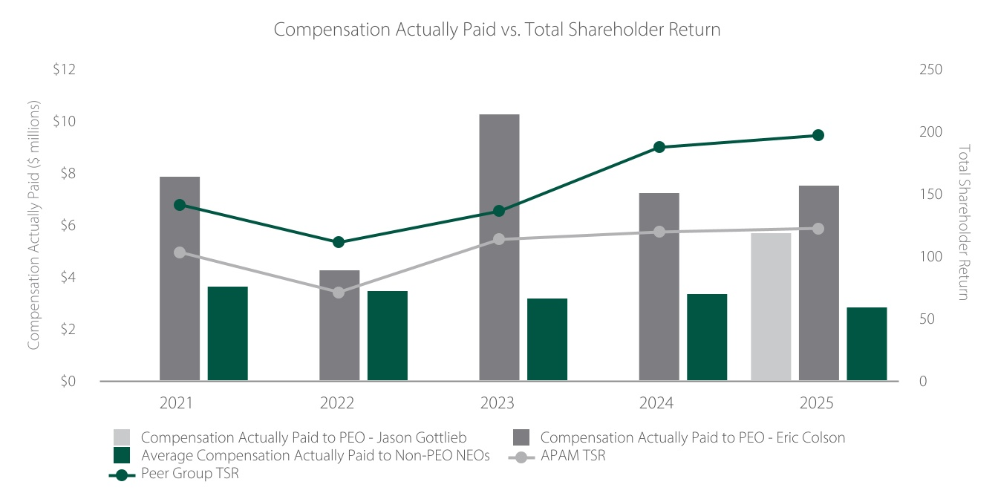
49

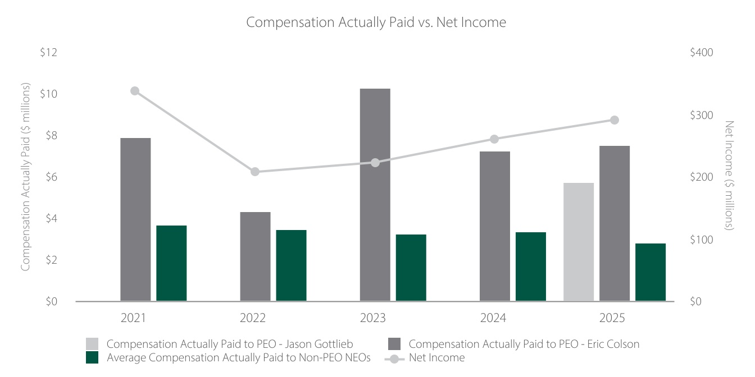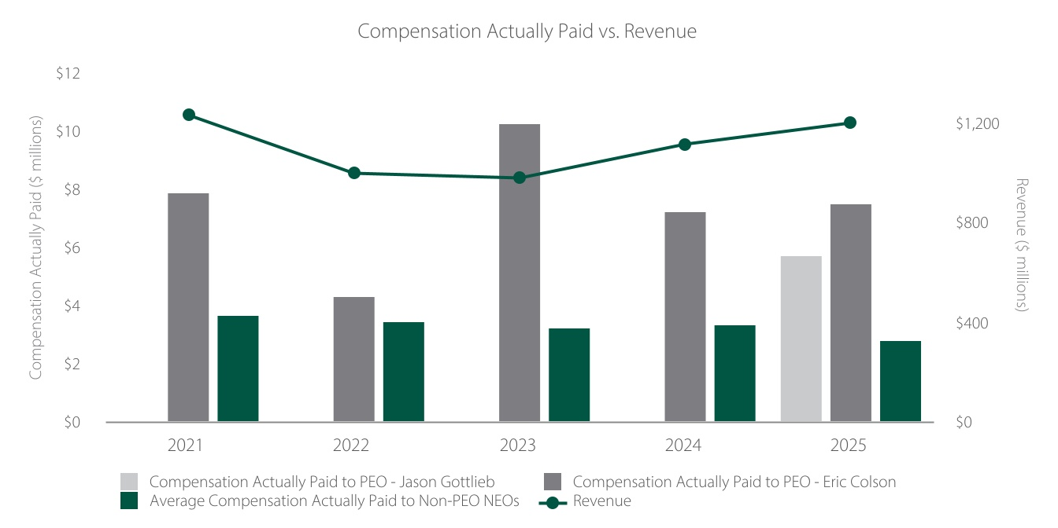

As required by SEC rules, the performance measures identified as the most important for 2025 executive compensation decisions are listed in the table below. A description of the compensation determination process and a discussion of how each of these measures is considered is provided in the Compensation Discussion and Analysis under “2025 Executive Compensation Process and Decisions”.
50

Most Important Performance Measures
Adjusted Operating Income* |  |  |  |  |  | Adjusted Operating Margin*
Revenue |  |  |  |  |  | Average Fee Rate
AUM Growth |  |  |  |  |  | Investment Performance
Organic Growth
*Adjusted measures are non-GAAP measures. See Annex A for information regarding our non-GAAP measures.

POTENTIAL PAYMENTS UPON TERMINATION OR CHANGE IN CONTROL
Our NEOs are all employed on an “at will” basis, which enables us to terminate their employment at any time. Our NEOs do not have agreements that provide severance benefits. We do not offer or have in place any formal retirement, severance or similar compensation programs providing for additional benefits or payments in connection with a termination of employment, change in job responsibility or change in control (other than our contributory defined contribution plan). Under certain circumstances, a NEO may be offered severance benefits to be negotiated at the time of termination.
Equity awards granted to our NEOs are evidenced by an award agreement that sets forth the terms and conditions of the award and the effect of any termination event on unvested awards. Equity awards generally consist of standard restricted shares and career shares. Standard restricted shares vest pro-rata over the five years following the year of grant, subject to continued employment. With certain exceptions, career shares will only vest once they have become eligible to vest and a qualifying retirement occurs, as follows:
▪Vesting Eligibility: 20% of each career share award becomes eligible to vest in each of the five years following the year of grant.
▪Qualifying Retirement: Requires that the award recipient (i) has been employed by us for at least 10 years at the time of retirement; (ii) has provided, for NEOs, 18 months’ notice of retirement (subject to our right to accept a shorter period of notice); and (iii) has remained at the Company through the retirement notice period.
If a NEO has a qualifying retirement (as described above) and has attained a combination of years of service plus age of at least 70 as of the retirement date, the restricted stock granted in January 2024 and any subsequent years will vest, without regard to the pro rata vesting eligibility condition detailed above.
All outstanding equity awards will vest upon a termination of employment due to death or disability and, in the context of a change of control, if the Company terminates a NEO without cause or he or she resigns for good reason, in either case, within two years of the change in control. In addition, if on or after the fifth anniversary of a grant date, the Company terminates the employment of a NEO without cause (as defined in the applicable award agreement) and the recipient has at least ten years of service with the Company as of the date of termination, those career awards granted five or more years prior to termination will vest in full as of the termination date.
Each of our NEOs has been granted the standard restricted shares and career shares described above. Mr. Gottlieb, Mr. Colson and Mr. Krein have also been granted performance share units, all of which currently remain subject to a qualifying retirement vesting condition.
All career award recipients, including each of our NEOs, have the opportunity to participate in a retiree health plan, at the sole expense of the retiree, after a qualified retirement from the Company.
The following table provides the value of the accelerated vesting and retirement vesting of equity that would have been realized for each of the NEOs if his or her employment had ended on December 31,
51

2025 under the circumstances indicated. The values are based on the closing price of our Class A common stock on the NYSE on December 31, 2025, which was $40.74 per share.
Name |  |  |  |  |  | Death or Disability ($) (1) |  |  |  |  |  | Qualifying Termination in Connection with Change in Control ($) (2) |  |  |  |  |  | Qualified Retirement ($) (3) |  |  |  |  |  | Involuntary Termination without Cause ($) (4)
Jason A. Gottlieb
Standard Restricted Shares |  |  |  |  |  | 1,791,949 |  |  |  |  |  | 1,791,949 |  |  |  |  |  | — |  |  |  |  |  | —
Career Shares |  |  |  |  |  | 3,352,128 |  |  |  |  |  | 3,352,128 |  |  |  |  |  | — |  |  |  |  |  | —
Career Performance Share Units |  |  |  |  |  | 2,590,575 |  |  |  |  |  | 2,590,575 |  |  |  |  |  | — |  |  |  |  |  | —
Eric R. Colson
Standard Restricted Shares |  |  |  |  |  | 2,152,865 |  |  |  |  |  | 2,152,865 |  |  |  |  |  | 1,456,333 |  |  |  |  |  | —
Career Shares |  |  |  |  |  | 4,850,260 |  |  |  |  |  | 4,850,260 |  |  |  |  |  | 269,436 |  |  |  |  |  | 2,086,744
Career Performance Share Units |  |  |  |  |  | 2,590,575 |  |  |  |  |  | 2,590,575 |  |  |  |  |  | 2,590,575 |  |  |  |  |  | 91,650
Charles J. Daley, Jr.
Standard Restricted Shares |  |  |  |  |  | 1,146,546 |  |  |  |  |  | 1,146,546 |  |  |  |  |  | 690,013 |  |  |  |  |  | —
Career Shares |  |  |  |  |  | 2,567,435 |  |  |  |  |  | 2,567,435 |  |  |  |  |  | 1,421,052 |  |  |  |  |  | 796,467
Christopher J. Krein
Standard Restricted Shares |  |  |  |  |  | 1,112,650 |  |  |  |  |  | 1,112,650 |  |  |  |  |  | — |  |  |  |  |  | —
Career Shares |  |  |  |  |  | 1,735,483 |  |  |  |  |  | 1,735,483 |  |  |  |  |  | 622,915 |  |  |  |  |  | 330,687
Career Performance Share Units |  |  |  |  |  | 1,019,763 |  |  |  |  |  | 1,019,763 |  |  |  |  |  | 1,019,763 |  |  |  |  |  | —
Eileen L. Kwei
Standard Restricted Shares |  |  |  |  |  | 1,070,077 |  |  |  |  |  | 1,070,077 |  |  |  |  |  | — |  |  |  |  |  | —
Career Shares |  |  |  |  |  | 1,105,317 |  |  |  |  |  | 1,105,317 |  |  |  |  |  | 277,562 |  |  |  |  |  | —
Samuel B. Sellers
Standard Restricted Shares |  |  |  |  |  | 718,572 |  |  |  |  |  | 718,572 |  |  |  |  |  | — |  |  |  |  |  | —
Career Shares |  |  |  |  |  | 932,579 |  |  |  |  |  | 932,579 |  |  |  |  |  | 309,380 |  |  |  |  |  | 134,401
(1) Amounts shown reflect the accelerated vesting of equity awards upon the holder’s death or disability.
(2) Amounts shown reflect the accelerated vesting of equity awards upon the Company’s termination of a NEO’s employment without cause or his or her resignation for good reason, in either case, within two years of a change in control, subject to continued employment through such occurrence. All restricted stock and performance share units granted to NEOs are double trigger awards.
(3) Amounts shown reflect the value of equity awards that would vest upon a qualified retirement. This includes career awards that have satisfied the pro-rata vesting and 10 years of service requirements as of December 31, 2025 and would therefore be eligible to vest had the NEO provided 18 months' advance notice (or such shorter period of notice acceptable to us) and retired as of that date. Also included are standard and career shares granted in 2024 and 2025 to NEOs who have attained a combination of years of service plus age of at least 70 as of December 31, 2025.
(4) Amounts shown reflect the value of career shares that will vest if, after the fifth anniversary of the grant date, the Company terminates the holder without Cause (as defined in the applicable award agreement), provided that he or she has at least 10 years of service with the Company at the time of termination.

OTHER BENEFITS
We do not sponsor or maintain any defined benefit pension or retirement plans for our NEOs, nor do we sponsor or maintain any nonqualified defined contribution or other nonqualified deferred compensation plans for our NEOs.

52

EMPLOYMENT AGREEMENTS
We do not have employment agreements with any of our NEOs. Upon commencement of employment, each NEO received an offer letter outlining the initial terms of employment. None of these terms affected compensation paid to our NEOs in 2025 and will not affect compensation paid in future years.
Each of our NEOs has agreed, pursuant to his or her equity award agreements, to certain restrictive covenants, including agreements not to compete with us or solicit our clients and employees, in each case for one year after he or she ceases to be employed by the Company. Enforcement of the restrictive covenants may be limited or even prohibited, depending on an individual’s particular facts and circumstances.
Equity Compensation Plan Information
The following table sets forth certain information as of December 31, 2025, with respect to shares of the Company’s common stock that may be issued under the Company’s existing equity incentive plans. None of the plans have outstanding options, warrants or rights other than restricted stock units and performance share units. All plans have been approved by our stockholders
Plan Category |  |  |  |  |  | (a) Number of Securities to be Issued Upon Exercise of Outstanding Options, Warrants and Rights (1) |  |  |  |  |  | (b) Weighted Average Exercise Price of Outstanding Options, Warrants and Rights |  |  |  |  |  | (c) Number of Securities Remaining Available for Future Issuance Under Equity Compensation Plans (Excluding Securities Reflected in Column (a)) (2)
Equity Compensation Plans Approved by Stockholders |  |  |  |  |  | 531,175 |  |  |  |  |  | — |  |  |  |  |  | 6,248,502
Equity Compensation Plans Not Approved by Stockholders |  |  |  |  |  | — |  |  |  |  |  | — |  |  |  |  |  | —
(1) Amount includes 378,968 outstanding restricted stock units and 152,207 outstanding performance share units. Unvested restricted shares of stock are excluded because they are issued and outstanding.
(2) Consists of 5,514,579 and 733,923 shares remaining available for issuance under the 2023 Omnibus Incentive Compensation Plan and the 2023 Non-Employee Director Plan, respectively, as of December 31, 2025.
53

Proposal 2: Advisory Vote to Approve Named Executive Officer Compensation
In accordance with the requirements of Section 14A of the Securities Exchange Act of 1934, as amended, our stockholders have the opportunity to annually vote to approve, on a nonbinding, advisory basis, the compensation of our NEOs as disclosed in this proxy statement in accordance with Item 402 of Regulation S-K.
We urge you to read the Compensation Discussion and Analysis section of this proxy statement for a comprehensive discussion of our executive compensation philosophy and approach, as well as the 2025 compensation decisions for our NEOs.
Because your vote is advisory, it will not be binding on the Company or our Board. However, our Board and the Compensation Committee will review the voting results and consider the outcome of the vote when making future decisions regarding our executive compensation program.
Accordingly, we ask our stockholders to approve the following resolution regarding our executive compensation program.
“RESOLVED, that the stockholders approve the compensation of the Company’s named executive officers, as disclosed in the Company’s proxy statement for the 2026 Annual Meeting of Stockholders pursuant to Item 402 of Regulation S-K, including the Compensation Discussion and Analysis, the compensation tables and related narrative discussion.”

RECOMMENDATION OF THE BOARD
The Board recommends that you vote FOR the proposal to approve the compensation awarded to our NEOs as disclosed in this proxy statement.
54

Security Ownership of Certain Beneficial Owners and Management
The following table sets forth information regarding the beneficial ownership of our common stock as of April 9, 2026, for:
▪each person known by us to beneficially own more than 5% of any class of our outstanding shares as of April 9, 2026, or such other date as indicated in the footnotes below;
▪each of our NEOs;
▪each of our directors; and
▪all of our executive officers and directors as a group.
Because we have disclosed the ownership of shares of our Class B common stock and Class C common stock (which correspond to partnership units that are exchangeable for Class A common stock), the shares of Class A common stock underlying partnership units are not separately reflected in the table below.
Applicable percentage ownership is based on 71,290,264 shares of Class A common stock (including 297,007 restricted stock units that are currently outstanding), 1,147,029 shares of Class B common stock and 8,917,476 shares of Class C common stock outstanding at April 9, 2026. The aggregate percentage of combined voting power represents voting power with respect to all shares of our common stock voting together as a single class and is based on 81,057,762 total votes attributed to 81,057,762 total shares of outstanding common stock, as each share of our common stock entitles its holder to one vote.
Beneficial ownership is determined in accordance with the rules of the SEC. These rules generally attribute beneficial ownership of securities to persons who possess sole or shared voting power or investment power with respect to such securities. Except as otherwise indicated, all persons listed below have sole voting and investment power with respect to the shares beneficially owned by them, subject to applicable community property laws.
Except as otherwise indicated, the address for each stockholder listed below is c/o Artisan Partners Asset Management Inc., 875 E. Wisconsin Avenue, Suite 800, Milwaukee, Wisconsin 53202.

55

Aggregate
% of
Combined
Voting
Power
 |  |  | Class A (1) |  |  |  |  |  | Class B |  |  |  |  |  | Class C
 |  |  | No. of  Shares |  |  | % of  Class |  |  | No. of  Shares |  |  | % of  Class |  |  | No. of  Shares |  |  | % of  Class
Directors and Named Executive Officers:
Stockholders Committee (2) |  |  | 6,282,330 |  |  | 8.8% |  |  | 1,147,029 |  |  | 100.0% |  |  | — |  |  | — |  |  | 9.2%
Eric R. Colson (3)(4) |  |  | 432,195 |  |  | * |  |  | 482,463 |  |  | 42.1% |  |  | — |  |  | — |  |  | —
Charles J. Daley, Jr. (3)(5) |  |  | 110,801 |  |  | * |  |  | 60,050 |  |  | 5.2% |  |  | — |  |  | — |  |  | *
Jason A. Gottlieb (3)(4) |  |  | 291,940 |  |  | * |  |  | — |  |  | — |  |  | — |  |  | — |  |  | —
Christopher J. Krein (3)(4) |  |  | 149,240 |  |  | * |  |  | — |  |  | — |  |  | — |  |  | — |  |  | —
Eileen L. Kwei (3) |  |  | 77,544 |  |  | * |  |  | 2,275 |  |  | * |  |  | — |  |  | — |  |  | —
Samuel B. Sellers (3) |  |  | 51,272 |  |  | * |  |  | 2,275 |  |  | * |  |  | — |  |  | — |  |  | —
Jennifer A. Barbetta (6)(7) |  |  | 27,727 |  |  | * |  |  | — |  |  | — |  |  | — |  |  | — |  |  | —
Matthew R. Barger (6)(8) |  |  | 73,657 |  |  | * |  |  | — |  |  | — |  |  | 1,242,002 |  |  | 13.9 |  |  | 1.5
Kane Brenan (6)(9) |  |  | 2,876 |  |  | * |  |  | — |  |  | — |  |  | — |  |  | — |  |  | —
Peter B. Crawford (6)(10) |  |  | 5,752 |  |  | * |  |  | — |  |  | — |  |  | — |  |  | — |  |  | —
Stephanie G. DiMarco (6)(11) |  |  | 155,089 |  |  | * |  |  | — |  |  | — |  |  | — |  |  | — |  |  | *
Jeffrey A. Joerres (6)(12) |  |  | 77,157 |  |  | * |  |  | — |  |  | — |  |  | — |  |  | — |  |  | *
Saloni S. Multani (6)(13) |  |  | 29,327 |  |  | * |  |  | — |  |  | — |  |  | — |  |  | — |  |  | —
Directors and executive officers as a group |  |  | 6,806,322 |  |  | 9.5% |  |  | 1,147,029 |  |  | 100.0% |  |  | 1,242,002 |  |  | 13.9% |  |  | 10.8%
5+% Stockholders:
MLY Holdings Corp. (3)(14) |  |  | — |  |  | — |  |  | 249,751 |  |  | 21.8% |  |  | — |  |  | — |  |  | —
Maria Negrete (3) |  |  | 46,500 |  |  | * |  |  | 109,033 |  |  | 9.5% |  |  | — |  |  | — |  |  | —
Gregory K. Ramirez (3)(15) |  |  | 116,194 |  |  | * |  |  | 69,784 |  |  | 6.1% |  |  | — |  |  | — |  |  | *
Artisan Investment Corporation (16) |  |  | — |  |  | — |  |  | — |  |  | — |  |  | 3,455,973 |  |  | 38.8% |  |  | 4.3%
Intellectual Capital Liquid LP (8) |  |  | — |  |  | — |  |  | — |  |  | — |  |  | 1,242,002 |  |  | 13.9% |  |  | 1.5%
Arthur Rock 2000 Trust |  |  | — |  |  | — |  |  | — |  |  | — |  |  | 1,153,280 |  |  | 12.9% |  |  | 1.4%
Big Fish Partners LLC |  |  | — |  |  | — |  |  | — |  |  | — |  |  | 484,385 |  |  | 5.4% |  |  | *
Blackrock Inc. (17) |  |  | 10,230,418 |  |  | 14.4% |  |  | — |  |  | — |  |  | — |  |  | — |  |  | 12.5%
Kayne Anderson Rudnick Investment Management LLC (18) |  |  | 5,716,957 |  |  | 8.0% |  |  | — |  |  | — |  |  | — |  |  | — |  |  | 5.8%
*Less than 1%.
(1) Subject to certain exceptions, the persons who hold shares of our Class B and Class C common stock (which correspond to partnership units that generally are exchangeable for Class A common stock) are currently deemed to have beneficial ownership over a number of shares of our Class A common stock equal to the number of shares of our Class B and Class C common stock reflected in the table above, respectively. Because we have disclosed the ownership of shares of our Class B and Class C common stock, the shares of Class A common stock underlying partnership units are not separately reflected in the table above.
(2) Each of our employees to whom we have granted equity has entered into a stockholders agreement pursuant to which they granted an irrevocable voting proxy with respect to all shares of our common stock they have acquired from us and any shares they may acquire from us in the future to a stockholders committee currently consisting of Mr. Gottlieb, Mr. Colson and Mr. Daley. All shares subject to the stockholders agreement are voted in accordance with the majority decision of those three members. Shares cease to be subject to the agreement when sold by the employee or upon the termination of the employee’s employment with us. The number of shares of Class A and Class B common stock in this row includes all shares of Class A and Class B common stock that we have granted to current employees and that have not yet been sold by those employees. As members of the stockholders committee, Mr. Gottlieb, Mr. Colson and Mr. Daley share voting power over all of these shares. Other than as shown in the row applicable to each of them individually, none of Mr. Gottlieb, Mr. Colson or Mr. Daley has investment power with respect to any of the shares subject to the stockholders agreement, and each disclaims beneficial ownership of such shares.
56

(3) Pursuant to the stockholders agreement, Mr. Colson, Mr. Daley, Mr. Gottlieb, Mr. Krein, Ms. Kwei, Mr. Sellers, MLY Holdings Corp., Ms. Negrete and Mr. Ramirez each granted an irrevocable voting proxy with respect to all of the shares of our common stock he or she has acquired from us and any shares he or she may acquire from us in the future to the stockholders committee described in footnote (2) above. Each retains investment power with respect to the shares of our common stock he or she holds, which are the shares reflected in the row applicable to each person. Certain shares belonging to Mr. Daley and Mr. Ramirez are not subject to the stockholders agreement.
(4) The amount shown includes 63,588 earned performance share units (“PSUs”) for each of Mr. Colson and Mr. Gottlieb and 25,031 earned PSUs for Mr. Krein that have met the performance conditions but remain subject to a qualified retirement vesting provision.
(5) Includes 200 shares of Class A common stock held by Mr. Daley’s daughter.
(6) Includes the shares of Class A common stock underlying restricted stock units granted to our non-employee directors. The underlying shares will be delivered on the earlier to occur of (i) a change in control of Artisan and (ii) assuming the restricted stock units have vested, the termination of such person’s service as a director. Restricted stock units do not have voting rights.
(7) Consists of 27,727 restricted stock units.
(8) Includes 62,689 restricted stock units held by a revocable trust and 10,968 restricted stock units held directly. The Class C shares reflected in the row applicable to Mr. Barger individually are owned by Intellectual Capital Liquid LP, the partnership interests of which are held by entities owned or controlled by Mr. Barger.
(9) Consists of 2,876 restricted stock units.
(10) Consists of 5,752 restricted stock units.
(11) Includes (i) 49,964 restricted stock units held directly, (ii) 20,308 shares of Class A common stock held by a charitable trust and (iii) 50,770 shares of Class A common stock and 34,047 restricted stock units held by a living trust. Ms. DiMarco is a trustee of each trust and has voting and investment authority over the shares held by the trusts.
(12) Includes 73,657 restricted stock units.
(13) Consists of 29,327 restricted stock units.
(14) MLY Holdings Corp. is a Delaware corporation through which Mark L. Yockey holds his shares of Class B common stock. Mr. Yockey is the sole director of MLY Holdings Corp.
(15) Mr. Ramirez is an executive officer of the Company and therefore his shares are also included in the totals for Directors and executive officers as a group in the table above.
(16) Artisan Investment Corporation is controlled by Andrew A. Ziegler, a former member of our Board, and his wife, Carlene M. Ziegler, who together founded the firm.
(17) This information has been derived from the Schedule 13G filed with the SEC on April 29, 2025 by BlackRock, Inc. which states that BlackRock had sole voting power over 10,154,337 shares and sole dispositive power over 10,230,418 shares of Class A common stock as of March 31, 2025. The address of BlackRock, Inc. is 50 Hudson Yards, New York, New York 10001.
(18) This information has been derived from the Schedule 13G filed with the SEC on February 13, 2026 by Kayne Anderson Rudnick Investment Management, LLC which states that Kayne Anderson Rudnick Investment Management had sole voting power over 3,673,165 shares, sole dispositive power over 4,660,570 shares and shared voting and dispositive power over 1,056,387 shares of Class A common stock as of December 31, 2025. The address of Kayne Anderson Rudnick Investment Management is 2000 Avenue of the Stars, Suite 1110, Los Angeles, California 90067.

57

Relationships and Related Party Transactions

TRANSACTIONS IN CONNECTION WITH OUR IPO
In March 2013, in connection with our IPO, we entered into the agreements described below with the limited partners of Artisan Partners Holdings (“Holdings”), including the following persons and entities:
▪Those of our executive officers who owned Class B common units of Holdings at the time of the IPO.
▪Artisan Investment Corporation (“AIC”), an entity controlled by Andrew A. Ziegler, a former member of our Board, and Carlene M. Ziegler who together founded the Company. AIC owns all of the Class D common units of Holdings.
▪Mr. Barger, who owns Class A common units of Holdings.
▪Two trusts of which Tench Coxe, a former director, is a co-trustee. Mr. Coxe’s term on the Board expired at our 2025 Annual Meeting on June 4, 2025.
▪Several other persons or entities who own Class A common units of Holdings and greater than 5% of the outstanding shares of our Class C common stock.
▪Several of our employees, or entities controlled by an employee, who own (or owned) Class B common units of Holdings and greater than 5% of the outstanding shares of our Class B common stock.
The rights of each of the persons and entities listed above under the agreements discussed below are, in general, the same as the rights of each other holder of the same class of partnership units. The descriptions of the transactions and agreements below, including the rights and ownership interests of the persons and entities listed above, are as of April 9, 2026, unless otherwise indicated.
Exchange Agreement
Under the exchange agreement, subject to certain restrictions (including those intended to ensure that Holdings is not treated as a “publicly traded partnership” for U.S. federal income tax purposes), holders of partnership units have the right to exchange common units (together with an equal number of shares of our Class B or Class C common stock, as applicable) for shares of our Class A common stock on a one-for-one basis. A partnership unit cannot be exchanged for a share of our Class A common stock without a share of our Class B or Class C common stock, as applicable, being delivered together at the time of exchange for cancellation.
Holders of partnership units have the right to exchange units in a number of circumstances that are generally based on, but in several respects are not identical to, the “safe harbors” contained in the U.S. Treasury Regulations dealing with publicly traded partnerships. In accordance with the terms of the exchange agreement, partnership units are exchangeable: (i) in connection with the first underwritten offering in any calendar year pursuant to the resale and registration rights agreement; (ii) on a specified date each fiscal quarter; (iii) in connection with the holder’s death, disability or mental incompetence; (iv) as part of one or more exchanges by the holder and any related persons during any 30-calendar day period representing in the aggregate more than 2% of all outstanding partnership units (generally disregarding interests held by us); (v) if the exchange is of all of the partnership units held by AIC in a single transaction; (vi) in connection with a tender offer, share exchange offer, issuer bid, take-over bid, recapitalization or similar transaction with respect to our Class A common stock that is effected with the consent of our Board or in connection with certain mergers, consolidations or other business combinations; or (vii) if we permit the exchanges after determining that Holdings would not be treated as a “publicly traded partnership” under Section 7704 of the Internal Revenue Code as a result. We may provide for exchanges in addition to those described above.
58

As the holders of limited partnership units exchange their units for Class A common stock, we receive a number of general partnership units, or GP units, of Holdings equal to the number of shares of our Class A common stock that they receive, and an equal number of limited partnership units are canceled.
From January 1, 2025 through April 9, 2026, holders of Class A, Class B and Class E common units exchanged an aggregate of 231,614 units for Class A common stock, and an equal number of shares of our Class B or Class C common stock, as applicable, were canceled.
Resale and Registration Rights Agreement
Under the resale and registration rights agreement, we are required, upon the request of AIC, to file, and use our reasonable best efforts to cause the SEC to declare effective, a shelf registration statement registering secondary sales of Class A common stock issuable upon exchange of units by AIC.
As of April 9, 2026, AIC owned 3,455,973 Class D common units exchangeable for an equal number of shares of our Class A common stock. There is no limit on the number of shares of our Class A common stock AIC may sell. AIC has the right to use a resale shelf registration statement to sell shares of Class A common stock, including the right to an unrestricted number of brokered transactions and, subject to certain limitations and qualifications, marketed and unmarketed underwritten shelf takedowns.
We have paid and will continue to pay all expenses incident to our performance of any registration or marketing of securities pursuant to the resale and registration rights agreement, including reasonable fees and out-of-pocket costs and expenses of selling stockholders. We have also agreed to indemnify any selling stockholder, solely in their capacity as selling stockholders, against any losses or damages resulting from any untrue statement, or omission of material fact in any registration statement, prospectus or free writing prospectus pursuant to which they may sell shares of our Class A common stock, except to the extent the liability arose from their misstatement or omission of a material fact, in which case they have similarly agreed to indemnify us.
Amended and Restated Limited Partnership Agreement of Artisan Partners Holdings
As a holding company, we conduct all of our business activities through our direct subsidiary, Artisan Partners Holdings, an intermediate holding company, which wholly owns Artisan Partners Limited Partnership, our principal operating subsidiary. The rights and obligations of Holdings’ partners are set forth in its amended and restated limited partnership agreement.
As the general partner of Holdings, we control its business and affairs and are responsible for the management of its business, subject to the voting rights of the limited partners as described below. No limited partners of Holdings, in their capacity as such, have any authority or right to control the management of Holdings or to bind it in connection with any matter.
Holdings has outstanding GP units and common units. Net profits and net losses and distributions of profits of Holdings are allocated and made to partners pro rata in accordance with the number of partnership units they hold. Holdings is obligated to distribute to us and its other partners cash payments for the purposes of funding tax obligations of ours and theirs as partners of Holdings. In order to make a share of our Class A common stock represent the same percentage economic interest, disregarding corporate-level taxes and payments with respect to the tax receivable agreements, in Holdings as a common unit of Holdings, we always hold a number of GP units equal to the number of shares of Class A common stock issued and outstanding.
As the general partner of Holdings, we hold all GP units and control the business of Holdings. Our approval, acting in our capacity as the general partner, along with the approval of holders of a majority of each class of limited partnership units (except the Class E common units), voting as a separate class, will be required to engage in a material corporate transaction; with certain exceptions, redeem or reclassify partnership units or interests in any subsidiary, issue additional partnership units or interests in any
59

subsidiary, or create additional classes of partnership units or interests in any subsidiary; or make any in-kind distributions. If any of the foregoing affects only certain classes of partnership units, only the approval of us and the affected classes would be required. The approval rights of each class of partnership units will terminate when the holders of the respective class of units directly or indirectly cease to own units constituting at least 5% of the outstanding units of Holdings.
The amended and restated limited partnership agreement may be amended with the consent of the general partner and the holders of a majority of the Class A, Class B and Class D common units, each voting as a separate class, provided that the general partner may, without the consent of any limited partner, make amendments that do not materially and adversely affect any limited partners. To the extent any amendment materially and adversely affects only certain classes of limited partners, only the holders of a majority of the units of the affected classes have the right to approve such amendment.
Holdings will indemnify AIC, as its former general partner, us, as its current general partner, the former members of its pre-IPO advisory committee, the members of our stockholders committee and our directors and officers against any losses, damages, costs or expenses (including reasonable attorneys’ fees, judgments, fines and amounts paid in settlement) actually incurred in connection with any threatened, pending or completed action, suit or proceeding, whether civil, criminal or administrative (including any action by or on behalf of Holdings) arising as a result of the capacities in which they serve or served Holdings to the maximum extent that any of them could be indemnified if Holdings were a Delaware corporation and they were directors of such corporation. In addition, Holdings will pay the costs or expenses (including reasonable attorneys’ fees) incurred by the indemnified parties in advance of a final disposition of such matters so long as the indemnified party undertakes to repay the expenses if the party is adjudicated not to be entitled to indemnification.
Holdings will also indemnify its officers and employees and officers and employees of its subsidiaries against any losses, damages, costs or expenses (including reasonable attorneys’ fees, judgments, fines and amounts paid in settlement) actually incurred in connection with any threatened, pending or completed action, suit or proceeding, whether civil, criminal or administrative arising as a result of their being an employee of Holdings (or their serving as an officer or fiduciary of any of Holdings’ subsidiaries or benefit plans or any entity of which Artisan is sponsor or adviser), provided that no employee will be indemnified or reimbursed for any claim, obligation or liability adjudicated to have arisen out of or been based upon such employee’s intentional misconduct, gross negligence, fraud or knowing violation of law.
Stockholders Agreement
Our employees (including our employee-partners) to whom we have granted equity have entered into a stockholders agreement pursuant to which they granted an irrevocable voting proxy with respect to all shares of our common stock they have acquired from us and any shares they may acquire from us in the future to a stockholders committee currently consisting of Jason A. Gottlieb (Chief Executive Officer and President), Eric R. Colson (Executive Chair and Chair of the Board) and Charles J. Daley, Jr. (Executive Vice President, Chief Financial Officer and Treasurer). Any shares of our common stock that we issue to our employees in the future will be subject to the stockholders agreement so long as the agreement has not been terminated. Shares subject to the stockholders agreement will be voted in accordance with the majority decision of the three members of the stockholders committee. As of April 9, 2026, shares subject to the stockholders agreement represented 9.2% of the combined voting power of our common stock.
The members of the stockholders committee must be Artisan employees and holders of shares subject to the agreement. If a member of the stockholders committee ceases to act as a member of the committee, our Chief Executive Officer (if he or she is a holder of shares subject to the stockholders agreement and is not already a member of the committee) will become a member of the committee. Otherwise, the two remaining members of the stockholders committee will jointly select a third member of the committee.
60

Each member of the stockholders committee is entitled to indemnification from Artisan in his or her capacity as a member of the committee.
The stockholders agreement provides that in connection with our election of directors, the members of the stockholders committee will vote the shares subject to the agreement in support of the following:
▪Matthew R. Barger, or, unless Mr. Barger is removed from the Board for cause, a successor selected by Mr. Barger who holds Class A common units, so long as the holders of the Class A common units beneficially own at least 5% of our outstanding capital stock. As of April 9, 2026, the holders of the Class A common units beneficially owned approximately 5.4% of our outstanding capital stock.
▪A director nominee, initially Mr. Colson, designated by the stockholders committee who is an employee-partner.
Under the terms of the stockholders agreement, we are required to use our best efforts to elect the nominees described above, which efforts must include soliciting proxies for, and recommending that our stockholders vote in favor of, the election of each. Other than as provided above, under the terms of the stockholders agreement, the stockholders committee may in its discretion vote, or abstain from voting, all or any of the shares subject to the agreement on any matter on which holders of shares of our common stock are entitled to vote. The committee is specifically authorized to vote for its members as directors under the terms of the stockholders agreement.
If and when the stockholders committee is no longer obligated to vote in favor of a director nominee who is a Class A common unit holder, parties to the stockholders agreement holding at least two-thirds of the shares subject to the agreement may terminate the agreement.
Tax Receivable Agreement (Exchanges)
We are party to a tax receivable agreement with each current or former holder of limited partnership units or their assignees (the “TRA”) that generally provides for the payment by us to each of them or their assignees of 85% of the applicable cash savings, if any, of U.S. federal, state and local income taxes that we actually realize (or are deemed to realize in certain circumstances) as a result of (i) certain tax attributes of partnership units sold to us or exchanged (for shares of Class A common stock or other consideration) and that are created as a result of such sales or exchanges, and (ii) tax benefits related to imputed interest.
For purposes of this TRA, cash savings in tax are calculated by comparing our actual income tax liability to the amount we would have been required to pay had we not been able to utilize any of the tax benefits subject to the TRA, unless certain assumptions apply. The TRA will continue until all tax benefits have been utilized or expired, unless we exercise our right to terminate the agreement or we materially breach any of our material obligations under the agreement, in which cases our obligations under the agreement will accelerate. The actual increase in tax basis, as well as the amount and timing of any payments under this agreement, will vary depending upon a number of factors, including the timing of purchases or exchanges of partnership units, the price of our Class A common stock at the time of such purchases or exchanges, the extent to which such transactions are taxable, the amount and timing of the taxable income we generate in the future and the tax rate then applicable and the portion of our payments under the TRA constituting imputed interest or depreciable or amortizable basis. In addition, in the case of a change of control, our obligations will be based on different assumptions that may affect the amount of the payments required under the TRA.
As of December 31, 2025, we recorded a $300.2 million liability, representing amounts payable under the TRA equal to 85% of the tax benefit we expect to realize from our purchase of Class A common units in connection with the IPO; our purchase of common units since the IPO; and the exchanges made by limited partners pursuant to the exchange agreement. The amount assumes no material changes in the
61

related tax law and that we earn sufficient taxable income to realize all tax benefits subject to the TRA. Additional purchases or exchanges of units of Holdings will cause the liability to increase.
During 2025, we made payments under the TRA totaling approximately $37.6 million in the aggregate. Of that amount, $0.8 million was paid to certain of our non-employee directors or entities associated with such directors that hold or held Class C common stock; $11.3 million was paid to our employee-partners, of which $4.5 million was paid to certain of our currently-serving executive officers and several employee-partners, or entities controlled by employee-partners, who own, or at the time of the payment owned, greater than 5% of the outstanding shares of our Class B common stock; and $5.6 million to other persons or entities who own Class A or Class E common units of Holdings and greater than 5% of the outstanding shares of our Class C common stock.
Assuming no material changes in the relevant tax law and that we earn sufficient taxable income to realize all tax benefits that are subject to the TRA, we expect that the reduction in tax payments for us associated with (i) the purchase or exchange of partnership units from March 2013 through December 31, 2025; and (ii) projected future purchases or exchanges of partnership units would aggregate to approximately $444.1 million over generally a minimum of 15 years, assuming the future purchases or exchanges described in clause (ii) occurred at a price of $40.74 per share of our Class A common stock, which was the closing price of our Class A common stock on December 31, 2025.
Under such scenario we would be required to pay the other parties to the TRA 85% of such amount, or approximately $416.9 million, over generally a minimum of 15 years. The actual amount may materially differ from this hypothetical amount, as potential future reductions in tax payments for us and TRA payments by us will be calculated using the market value of our Class A common stock at the time of purchase or exchange and the prevailing tax rates applicable to us over the life of the TRA and will be dependent on us generating sufficient future taxable income to realize the benefit.

INDEMNIFICATION AGREEMENTS
We have entered into an indemnification agreement with each of our executive officers, directors and the members of our stockholders committee that provides, in general, that we will indemnify them to the fullest extent permitted by Delaware law in connection with their service in such capacities. Due to the nature of the indemnification agreements, they are not the type of agreements that are typically entered into with or available to unaffiliated third parties.

INVESTMENTS IN OUR FUNDS
Our directors, executive officers and eligible employees, or entities that each may own or control, may invest in Artisan-sponsored private funds (“Artisan Private Funds”). The opportunity to make these investments is generally available to employees whom we have determined have a status that reasonably permits us to offer them these types of investments in compliance with applicable laws.
We encourage our directors, executive officers and certain eligible employees to make such investments because we believe it further aligns their interests with those of our clients and firm, and demonstrates their conviction in our investment strategies. Furthermore, we often rely upon these investments to provide seed capital that supports the launch of new strategies and products. These investments are generally entered into in the ordinary course of business on substantially the same terms as those prevailing at the time for investments made by similarly situated investors and shareholders, except that, as is common in the investment management industry, we typically do not charge management or incentive fees or make incentive allocations on seed capital investments in Artisan Private Funds. From January 1, 2025 through March 1, 2026, our directors, or entities they each may own or control, invested an aggregate of $3 million in Artisan Private Funds.
62

Our directors, executive officers and employees may also invest in our mutual funds or Artisan-branded collective investment trusts. These investments are entered into in the ordinary course of business on substantially the same terms as those prevailing at the time for investments made by similarly situated investors and shareholders.
From time to time, Artisan Partners may facilitate the aggregation of third party investments, including investments made by directors, executive officers and eligible employees, in private investment opportunities. Artisan Partners may play an immaterial administrative role in connection with such investments but does not have any authority or control over investment decisions. Artisan Partners does not collect any fees for the administrative services it provides in connection with such investments.

REVIEW AND APPROVAL OF TRANSACTIONS WITH RELATED PERSONS
We have adopted a written policy regarding the approval of any transaction or series of transactions in which we are a participant, the amount involved exceeds $120,000, and a “related party” (a director, director nominee, executive officer, or a person known to us to be the beneficial owner of more than 5% of any class of our voting securities, or any immediate family member of any of the foregoing) has a direct or indirect material interest (a “related party transaction”). Under the policy, all potential related party transactions must be brought to the attention of the Chief Legal Officer who will evaluate the facts and circumstances of the transaction and determine whether it constitutes a related party transaction. If the Chief Legal Officer determines that a transaction is a related party transaction, the material terms of the transaction will be presented for consideration and approval or ratification at the Audit Committee’s next regularly scheduled meeting. If the Chief Legal Officer determines that it is impractical or undesirable to wait until the next Audit Committee meeting, the matter will be presented to the Chair of the Audit Committee for review and approval or ratification on behalf of the Audit Committee. Any related party transaction approved or ratified by the Chair will be reported to the Audit Committee at its next regularly scheduled meeting. The Chief Legal Officer may also determine to submit the related party transaction to the disinterested and independent members of the Board for review and approval or ratification.
A related party transaction may be approved or ratified if, after considering all relevant factors, it is determined in good faith that the transaction is not inconsistent with the best interests of the Company and its stockholders. When reviewing a related party transaction that commenced without approval, all available options, including ratification, amendment and termination of the transaction, will be considered. Under the policy, any director who has an interest in a related party transaction will recuse himself or herself from any formal action with respect to the transaction as deemed appropriate by the Audit Committee or the disinterested and independent members of the Board.

Audit Committee Report
The Audit Committee oversees the Company’s financial reporting process on behalf of the Board. The duties and responsibilities of the Audit Committee are more fully described in the committee’s written charter, which is available under the Corporate Governance link on our website at www.apam.com.
The Audit Committee consists of Peter B. Crawford (Chair), Matthew R. Barger and Saloni S. Multani. The Board has determined that each member of the Audit Committee is “independent” and financially literate, and that each member has accounting or other related financial management expertise, in each case as such qualifications are defined by the SEC and under NYSE listing standards, and as interpreted by the Board in its business judgment. The Board has also determined that each member of the Audit Committee qualifies as an “audit committee financial expert” as defined by the SEC.
In fulfilling its oversight responsibilities, the Audit Committee has reviewed and discussed with management the audited financial statements of the Company for the fiscal year ended December 31, 2025.
63

The Audit Committee has discussed with the Company’s independent auditors, PricewaterhouseCoopers LLP, the matters required to be discussed by the applicable requirements of the Public Company Accounting Oversight Board (“PCAOB”) and the SEC.
The Audit Committee has received the written disclosures and letter from PricewaterhouseCoopers as required by the applicable requirements of the PCAOB regarding PricewaterhouseCoopers’ communications with the Audit Committee concerning independence, and has discussed with PricewaterhouseCoopers its independence.
Based on the review and discussions referred to above in this report, the Audit Committee recommended to the Board that the audited financial statements be included in the Company’s Annual Report on Form 10-K for the year ended December 31, 2025 for filing with the SEC.
Submitted by the Audit Committee of the Board of Directors:
Peter B. Crawford, Chair
Matthew R. Barger
Saloni S. Multani
64

Proposal 3: Ratification of the Appointment of PricewaterhouseCoopers LLP for the Fiscal Year Ending December 31, 2026
Our Audit Committee, in accordance with its charter and authority delegated to it by the Board, has appointed PricewaterhouseCoopers LLP to serve as our independent registered public accounting firm for the fiscal year ending December 31, 2026, and the Board has directed that such appointment be submitted to our stockholders for ratification at the Annual Meeting.
PricewaterhouseCoopers LLP has audited our financial statements since 2011 and has audited the financial statements of Artisan Partners Holdings since 1995, and is considered by our Audit Committee to be well qualified. Our organizational documents do not require that our stockholders ratify the selection of PricewaterhouseCoopers LLP as our independent registered public accounting firm. We are doing so because we believe it is a matter of good corporate governance. If the stockholders do not ratify the appointment of PricewaterhouseCoopers LLP, the Audit Committee will reconsider the appointment but may still retain PricewaterhouseCoopers LLP. Even if the appointment is ratified, the Audit Committee may in its discretion select a different independent registered public accounting firm at any time during the year if it determines that such a change would be in the best interests of the Company and its stockholders.
Representatives of PricewaterhouseCoopers LLP will be present at the Annual Meeting and will have an opportunity to make a statement if they desire to do so. They also will be available to respond to appropriate questions from stockholders.

RECOMMENDATION OF THE BOARD
The Board and the Audit Committee recommend that you vote FOR the ratification of the appointment of PricewaterhouseCoopers LLP as our independent registered public accounting firm for the fiscal year ending December 31, 2026.

FEES PAID TO THE INDEPENDENT REGISTERED PUBLIC ACCOUNTING FIRM
Aggregate fees for professional services rendered for us by PricewaterhouseCoopers LLP as of and for the fiscal years ended December 31, 2025 and 2024 are set forth below. The aggregate fees included in the Audit Fees and the Audit-Related Fees categories are fees for services performed for those fiscal years. The aggregate fees included in the Tax Fees and All Other Fees categories are fees for services performed in those fiscal years.
 |  |  | Fiscal Year 2025 |  |  |  |  |  |  |  |  |  |  |  | Fiscal Year 2024
Audit Fees |  |  | $ | 1,473,000 |  |  |  |  |  |  |  |  |  |  | $ | 1,441,000
Audit Related Fees (1) |  |  | 301,000 |  |  |  |  |  |  |  |  |  |  |  | 239,000
Tax Fees (2) |  |  | 1,366,000 |  |  |  |  |  |  |  |  |  |  |  | 1,237,000
All Other Fees |  |  | 2,000 |  |  |  |  |  |  |  |  |  |  |  | 2,000
Total |  |  | $ | 3,142,000 |  |  |  |  |  |  |  |  |  |  | $ | 2,919,000
(1) For the years ended December 31, 2025 and 2024, audit-related fees includes $165,000 and $117,000, respectively, for audit services provided to our sponsored investment products, including consolidated investment products.
(2) Tax fees for the years ended December 31, 2025 and 2024, includes $375,000 and $323,000, respectively, of fees related to tax return compliance and preparation. For the years ended December 31, 2025 and 2024, tax fees also includes $660,000 and $559,000, respectively, of fees for tax services provided to our sponsored investment products, including consolidated investment products.
65

Audit Fees for the fiscal years ended December 31, 2025 and 2024 were for professional services rendered for the audits of our annual financial statements, reviews of quarterly financial statements and services that are customarily provided in connection with statutory or regulatory filings.
Audit-Related Fees for the fiscal years ended December 31, 2025 and 2024 were for audit services provided to our sponsored investment products and attest services related to our compliance with the Global Investment Performance Standards (GIPS).
Tax Fees for the fiscal years ended December 31, 2025 and 2024 were for domestic and foreign tax return compliance, including review of partner capital accounts, and consultations related to technical interpretations, applicable laws and regulations and tax accounting.
Other Fees for the fiscal years ended December 31, 2025 and 2024 were license fees for professional publications.

POLICY ON AUDIT COMMITTEE PRE-APPROVAL OF AUDIT AND NON-AUDIT SERVICES
The Audit Committee is required to pre-approve, or adopt appropriate procedures to pre-approve, all audit and non-audit services to be provided by the independent auditors. The Audit Committee will typically pre-approve specific types of audit, audit-related, tax and other services on an annual basis, and will pre-approve all other services on an individual basis throughout the year as the need arises. The Audit Committee has delegated to its chair the authority to pre-approve independent auditor engagements between meetings of the Audit Committee. Any such pre-approvals will be reported to the entire Audit Committee at its next regular meeting.
All services for fiscal years 2025 and 2024 were pre-approved by the Audit Committee. In all cases, the Audit Committee concluded that the provision of such services by PricewaterhouseCoopers LLP was compatible with the maintenance of PricewaterhouseCoopers LLP’s independence.

Additional Information
Certain statements in this proxy statement, and other written or oral statements made by or on behalf of the Company, are “forward-looking statements” within the meaning of the federal securities laws. Statements regarding future events and future performance, as well as management’s current expectations, beliefs, plans, estimates or projections relating to the future, are forward-looking statements within the meaning of these laws. These forward-looking statements are only predictions based on current expectations and projections about future events. These forward-looking statements are subject to a number of risks and uncertainties, and there are important factors that could cause actual results, level of activity, performance, actions or achievements to differ materially from the results, level of activity, performance, actions or achievements expressed or implied by the forward-looking statements. These factors include: the loss of key investment professionals or senior management, adverse market or economic conditions for whatever reason, poor performance of our investment strategies, change in the legislative and regulatory environment in which we operate, operational or technical errors or other matters that cause damage to our reputation, and other factors disclosed in the Company’s filings with the Securities and Exchange Commission, including those factors listed under the caption entitled “Risk Factors” in Item 1A of the Company’s Annual Report on Form 10-K for the fiscal year ended December 31, 2025, filed with the SEC on February 20, 2026, as such factors may be updated from time to time. Our periodic and current reports are accessible on the SEC’s website at www.sec.gov. The Company undertakes no obligation to update any forward-looking statements in order to reflect events or circumstances that may arise after the date of this release.
This proxy statement and our Annual Report on Form 10-K for the fiscal year ended December 31, 2025 are available on our transfer agent’s website at www.astproxyportal.com/ast/18158. Stockholders are
66

directed to the 2025 Form 10-K for financial and other information about us. The 2025 Form 10-K is not part of this proxy statement and does not form any part of the material for the solicitation of proxies.
We are required to file annual, quarterly and current reports, proxy statements and other reports with the SEC. Copies of these filings are available through our website at www.apam.com or the SEC’s website at www.sec.gov. We will furnish copies of our SEC filings (without exhibits), including this proxy statement and our 2025 Form 10-K, without charge, to any stockholder upon request made to Artisan Partners Asset Management Inc., 875 East Wisconsin Avenue, Suite 800, Milwaukee, Wisconsin 53202, Attn: Investor Relations, telephone: (866) 632-1770, e-mail: ir@artisanpartners.com.
Additional information about the Company, including the charters of our standing committees, our Corporate Governance Guidelines and our Code of Business Conduct, can be found on our website at www.apam.com. We will provide a printed copy of these documents to stockholders upon request.
67

ANNEX A

NON-GAAP RECONCILIATIONS
Our management uses non-GAAP measures (referred to as “adjusted” measures) of net income to evaluate the profitability and efficiency of the underlying operations of our business and as a factor when considering net income available for distributions and dividends. These adjusted measures remove the impact of (1) net gain (loss) on the tax receivable agreements (if any), (2) compensation expense (reversal) related to market valuation changes in compensation plans, (3) net investment gain (loss) of investment products, (4) non-recurring expenses and (5) the adjustment to deferred taxes as a result of the enactment of the One Big Beautiful Bill Act (“OBBBA”). These adjusted measures also remove the non-operational complexities of our structure by adding back noncontrolling interests and assuming all income of Artisan Partners Holdings is allocated to APAM. Management believes these non-GAAP measures provide meaningful information to analyze our profitability and efficiency between periods and over time. We have included these non-GAAP measures to provide investors with the same financial metrics used by management to manage the Company.
Non-GAAP measures should be considered in addition to, and not as a substitute for, financial measures prepared in accordance with GAAP. Our non-GAAP measures may differ from similar measures used by other companies, even if similar terms are used to identify such measures. Our non-GAAP measures are as follows:
▪Adjusted net income represents net income excluding the impact of (1) net gain (loss) on the tax receivable agreements (if any), (2) compensation expense (reversal) related to market valuation changes in compensation plans, (3) net investment gain (loss) of investment products, and (4) non-recurring expenses and (5) the adjustment to deferred taxes as a result of the OBBBA enactment. Adjusted net income also reflects income taxes assuming the vesting of all unvested Class A share-based awards and as if all outstanding limited partnership units of Artisan Partners Holdings had been exchanged for Class A common stock of APAM on a one-for-one basis. Assuming full vesting and exchange, all income of Artisan Partners Holdings is treated as if it were allocated to APAM, and the adjusted provision for income taxes represents an estimate of income tax expense at an effective rate reflecting APAM’s current federal, state and local income statutory tax rates. The adjusted tax rate was 24.7% for all periods presented.
▪Adjusted net income per adjusted share is calculated by dividing adjusted net income by adjusted shares. The number of adjusted shares is derived by assuming the vesting of all unvested Class A share-based awards and the exchange of all outstanding limited partnership units of Artisan Partners Holdings for Class A common stock of APAM on a one-for-one basis.
▪Adjusted operating income represents the operating income of the consolidated company excluding compensation expense related to market valuation changes in compensation plans and non-recurring expenses.
▪Adjusted operating margin is calculated by dividing adjusted operating income by total revenues.
Net gain (loss) on the tax receivable agreements represents the income (expense) associated with the change in estimate of amounts payable under the tax receivable agreements entered into in connection with APAM’s initial public offering and related reorganization.
Compensation expense (reversal) related to market valuation changes in compensation plans represents the expense (income) associated with the change in the long-term incentive award liability resulting from investment returns of the underlying investment products. Because the compensation expense impact of
68

the investment market exposure is economically hedged, management believes it is useful to reflect the expected net income offset in the calculation of adjusted operating income and adjusted net income. The related investment gain (loss) on the underlying investments is included in the adjustment for net investment gain (loss) of investment products.
Net investment gain (loss) of investment products represents the non-operating income (expense) related to the Company’s investments, in both consolidated investment products and nonconsolidated investment products, including investments held to economically hedge compensation plans. Excluding these non-operating market gains or losses on investments provides greater transparency to evaluate the profitability and efficiency of the underlying operations of the business. Interest income generated on cash and cash equivalents is considered part of normal operations, and therefore, is not excluded from adjusted net income.
Non-recurring expenses represents non-recurring professional fees that are not reflective of core operations.
The adjustment to income tax expense as a result of the OBBBA enactment relates to the remeasurement of deferred tax assets upon its enactment, specifically associated with new compensation deduction limitation rules effective for the Company starting in 2027.
The following tables are reconciliations between the presented non-GAAP measures and the most directly comparable U.S. GAAP measures. These measures are also described in the Company’s Form 10-K for the year indicated.
69

 |  |  |  |  |  | For the Years Ended December 31,
 |  |  |  |  |  | 2025 |  |  |  |  |  | 2024
Net income attributable to Artisan Partners Asset Management Inc. (GAAP) |  |  |  |  |  | $ | 290.3 |  |  |  |  | $ | 259.7
Add back: Net income attributable to noncontrolling interests - APH |  |  |  |  |  | 58.2 |  |  |  |  |  | 52.9
Add back: Provision for income taxes |  |  |  |  |  | 111.3 |  |  |  |  |  | 90.9
Add back: Compensation expense (reversal) related to market valuation changes in compensation plans |  |  |  |  |  | 23.0 |  |  |  |  |  | 7.8
Add back: Net (gain) loss on the tax receivable agreements |  |  |  |  |  | (0.6) |  |  |  |  |  | 0.5
Add back: Net investment (gain) loss of investment products attributable to APAM |  |  |  |  |  | (58.0) |  |  |  |  |  | (31.9)
Add back: Non-recurring expenses |  |  |  |  |  | — |  |  |  |  |  | 1.6
Less: Adjusted provision for income taxes |  |  |  |  |  | 104.8 |  |  |  |  |  | 94.2
Adjusted net income (Non-GAAP) |  |  |  |  |  | $ | 319.4 |  |  |  |  | $ | 287.3
Adjusted shares outstanding
Class A common shares |  |  |  |  |  | 65.6 |  |  |  |  |  | 64.9
Assumed vesting or exchange of:
Unvested restricted share-based awards |  |  |  |  |  | 5.3 |  |  |  |  |  | 5.5
Artisan Partners Holdings LP units outstanding (non-controlling interest) |  |  |  |  |  | 10.2 |  |  |  |  |  | 10.5
Adjusted shares |  |  |  |  |  | 81.1 |  |  |  |  |  | 80.9
Basic earnings per share (GAAP) |  |  |  |  |  | $ | 4.05 |  |  |  |  | $ | 3.66
Diluted earnings per share (GAAP) |  |  |  |  |  | $ | 4.05 |  |  |  |  | $ | 3.66
Adjusted net income per adjusted share (Non-GAAP) |  |  |  |  |  | $ | 3.93 |  |  |  |  | $ | 3.55
Operating income (GAAP) |  |  |  |  |  | $ | 399.6 |  |  |  |  | $ | 366.6
Add back: Compensation expense (reversal) related to market valuation changes in compensation plans |  |  |  |  |  | 23.0 |  |  |  |  |  | 7.8
Add back: Non-recurring expenses |  |  |  |  |  | — |  |  |  |  |  | 1.6
Adjusted operating income (Non-GAAP) |  |  |  |  |  | $ | 422.6 |  |  |  |  | $ | 376.0
Operating expense (GAAP) |  |  |  |  |  | $ | 797.1 |  |  |  |  | $ | 745.2
Less: Compensation expense (reversal) related to market valuation changes in compensation plans |  |  |  |  |  | 23.0 |  |  |  |  |  | 7.8
Add back: Non-recurring expenses |  |  |  |  |  | — |  |  |  |  |  | 1.6
Adjusted operating expense (Non-GAAP) |  |  |  |  |  | $ | 774.1 |  |  |  |  | $ | 739.0
Operating margin (GAAP) |  |  |  |  |  | 33.4% |  |  |  |  |  | 33.0%
Adjusted operating margin (Non-GAAP) |  |  |  |  |  | 35.3% |  |  |  |  |  | 33.8%
 |  |  | For the Years Ended December 31,
 |  |  | 2023 |  |  |  |  |  | 2022 |  |  |  |  |  | 2021 |  |  |  |  |  | 2020 |  |  |  |  |  | 2019 |  |  |  |  |  | 2018 |  |  |  |  |  | 2017
Operating income (GAAP) |  |  | $ | 303.6 |  |  |  |  | $ | 344.1 |  |  |  |  | $ | 540.5 |  |  |  |  | $ | 358.3 |  |  |  |  | $ | 283.5 |  |  |  |  | $ | 304.9 |  |  |  |  | $ | 286.4
Add back: Pre-offering related compensation - share-based awards |  |  | — |  |  |  |  |  | — |  |  |  |  |  | — |  |  |  |  |  | — |  |  |  |  |  | — |  |  |  |  |  | — |  |  |  |  |  | 12.7
Add back: Compensation expense (reversal) related to market valuation changes in compensation plans |  |  | 4.8 |  |  |  |  |  | (3.8) |  |  |  |  |  | 0.3 |  |  |  |  |  | — |  |  |  |  |  | — |  |  |  |  |  | — |  |  |  |  |  | —
Adjusted operating income (Non-GAAP) |  |  | $ | 308.4 |  |  |  |  | $ | 340.3 |  |  |  |  | $ | 540.8 |  |  |  |  | $ | 358.3 |  |  |  |  | $ | 283.5 |  |  |  |  | $ | 304.9 |  |  |  |  | $ | 299.1
Operating margin (GAAP) |  |  | 31.1 |  | % |  |  |  | 34.6 |  | % |  |  |  | 44.0 |  | % |  |  |  | 39.8 |  | % |  |  |  | 35.5 |  | % |  |  |  | 36.8 |  | % |  |  |  | 36.0 |  | %
Adjusted operating margin (Non-GAAP) |  |  | 31.6 |  | % |  |  |  | 34.3 |  | % |  |  |  | 44.1 |  | % |  |  |  | 39.8 |  | % |  |  |  | 35.5 |  | % |  |  |  | 36.8 |  | % |  |  |  | 37.6 |  | %
70

OTHER DISCLOSURES
Assets Under Management (AUM) refers to the assets of pooled investment vehicles and accounts for which Artisan Partners provides investment services. Artisan Partners’ AUM as reported herein includes assets for which Artisan Partners provides non-discretionary model portfolios to managed account sponsors, and for which we earn only investment-related service fees. Non-discretionary assets are reported on a delay.
Results for any investment strategy described herein, and for different investment products within a strategy, are affected by numerous factors, including different material market or economic conditions; different investment management fee rates, brokerage commissions and other expenses; and the reinvestment of dividends or other earnings. The returns for any strategy may be positive or negative, and past performance does not guarantee future results.
We measure investment performance based upon the results of our “composites”, which represent the aggregate performance of all discretionary client accounts (including pooled investment vehicles) invested in the same strategy, except those accounts with respect to which we believe client-imposed investment restrictions may have a material impact on portfolio construction and those accounts managed in a currency other than U.S. dollars. The results of these excluded accounts, which represented approximately 18% of our assets under management at December 31, 2025, are maintained in separate composites the results of which are not presented herein. Unless otherwise noted, composite returns have been presented gross of investment advisory fees applied to client accounts, but include applicable trade commissions and transaction costs.
Composites / Indexes used for the comparison calculations described are: Non-U.S. Growth Strategy / International Value Strategy-MSCI EAFE Index; Global Equity Strategy / Global Opportunities Strategy / Global Value Strategy / Franchise Strategy-MSCI All Country World Index; Global Discovery Strategy: MSCI All Country World Small Mid Cap Index; Non-U.S. Small-Mid Growth Strategy-MSCI All Country World Index Ex USA Small Mid Index; U.S. Mid-Cap Growth Strategy-Russell Midcap Growth® Index; U.S. Mid-Cap Value Strategy-Russell Midcap Value® Index; U.S. Small-Cap Growth Strategy-Russell 2000 Growth® Index; Value Equity Strategy-Russell 1000 Value® Index; Developing World Strategy / Sustainable Emerging Markets Strategy-MSCI Emerging Markets Index; High Income Strategy-ICE BofA U.S. High Yield Index; Credit Opportunities Strategy-ICE BofA U.S. Dollar 3-Month Deposit Offered Rate Constant Maturity Index; Antero Peak Strategy / Antero Peak Hedge Strategy / Select Equity Strategy / Value Income Strategy-S&P 500® Market Index; International Explorer Strategy-MSCI All Country World Index Ex USA Small Cap; Floating Rate Strategy-S&P UBS Leveraged Loan Index; Global Unconstrained Strategy-ICE BofA 3-Month U.S. Treasury Bill Index; Global Special Situations Strategy-ICE BofA Global High Yield Index; Emerging Markets Debt Opportunities Strategy-J.P. Morgan EMB Hard Currency/Local Currency 50-50; Emerging Markets Local Opportunities Strategy-J.P. Morgan GBI-EM Global Diversified Index. Where applicable, composite returns have been included for the following discontinued strategies and their indexes: Global Small-Cap Growth Strategy (Jul 1, 2013-Dec 31, 2016)-MSCI ACWI Small Cap Index; U.S. Small-Cap Value Strategy (Jun 1, 1997-Apr 30, 2016)-Russell 2000® Index; Non-U.S. Small-Cap Growth Strategy (Jan 1, 2002-Nov 30, 2018)-MSCI EAFE Small Cap Index. Index returns do not reflect the payment of fees and expenses. An investment cannot be made directly in an Artisan Partners composite or a market index and the aggregated results are hypothetical.
None of the information in these materials constitutes either an offer or a solicitation to buy or sell any fund securities, nor is any such information a recommendation for any fund security or investment service.

71

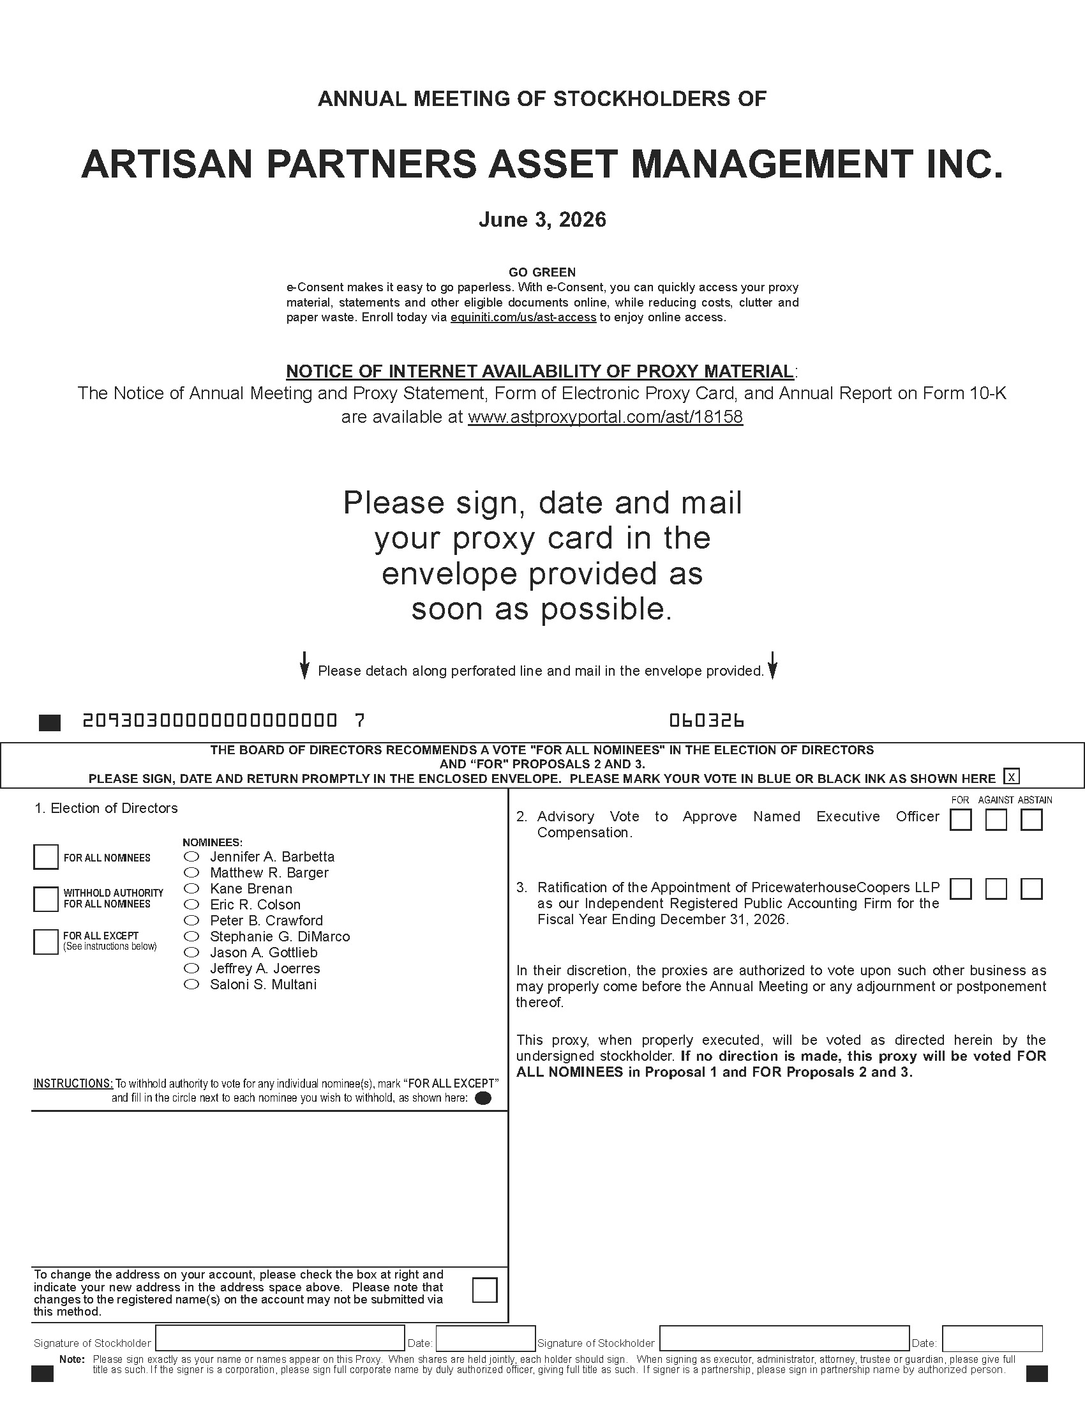

ARTISAN PARTNERS ASSET MANAGEMENT INC.
Proxy for Annual Meeting of Stockholders on June 3, 2026 Solicited on Behalf of the Board of Directors

The undersigned hereby appoints Laura E. Simpson and Charles J. Daley, Jr., and each of them, with full power of substitution and power to act alone, as proxies to vote all the shares of the Company’s common stock which the undersigned would be entitled to vote if personally present and acting at the Annual Meeting of Stockholders of ARTISAN PARTNERS ASSET MANAGEMENT INC., to be held at 11:00 a.m. CT on June 3, 2026, via live webcast at edge.media-server.com/mmc/p/mddmoibn (password: ), and at any adjournment or postponement thereof, as indicated on the reverse side:
(Continued and to be signed on the reverse side.)

1.1 14475

